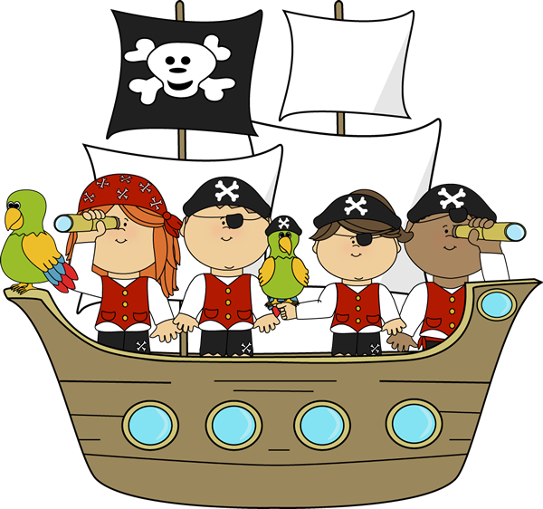

**Fun with Phonics**

**✓ Learn how phonics supports reading and writing**

**✓ Find out how your child learns at school**

**✓ Work together with your child**

**✓ Make resources to use at home**

**Take part in fun activities with your child based on a pirate theme**

**Children join in last part of every session**

**Free 4 week course**

**starting Thursday 1 May 9-11am**

**at St John’s C of E Primary**

**Book your place by filling in the form at**

**https://bit.ly/FLPhonics25**

**Due to health and safety we are unable to accommodate younger siblings in the session**