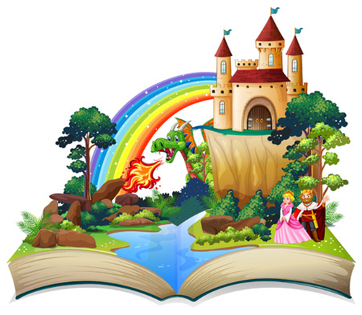

**Twisted Tales course**

**for Year 3 families**

**Plan, write and create a story with your child using IT**

**✓ Find out what English your child learns at school**

**✓ Support your child’s learning by working together**

**✓ Use a tablet to make an animated story/film**

**Children join in last part of every session**

**Free 5 week course**

**Thursday 6th March 9-11am**

**St John’s C of E Primary**

**Due to health and safety we are unable to accommodate younger siblings in the session**

**Book your place by filling in the form at https://bit.ly/FLTT25**

