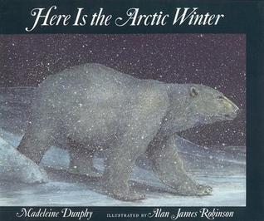
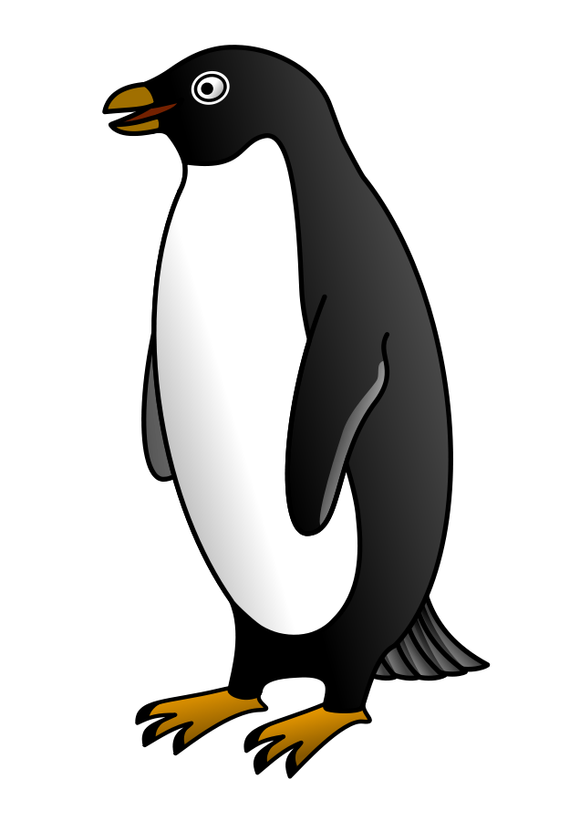
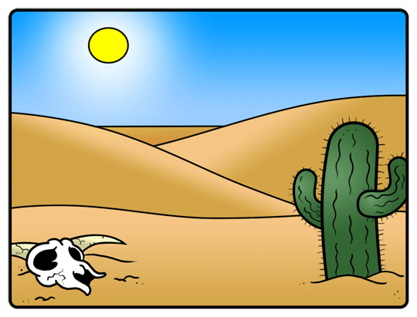
Arctic and Sahara Adventure ~ What’s the difference between hot and cold countries?

Class 1
English

Our class text will be
‘Here is the Arctic Winter’

Science
Identify and name a variety of common animals including fish, amphibians, reptiles, birds and mammals.
Identify and name a variety of common animals that are carnivores, herbivores and omnivores.
Describe and compare the structure of a variety of common animals (fish, amphibians, reptiles, birds and mammals, and including pets).
Find out and describe how animals look different to one another.
Group together animals according to their different features.
Recognise similarities between animals: - structure: head, body, way of moving, senses, body covering, tail.
Animals have senses to explore the world around them and to help them to survive.
Recognise that animals need to be treated with care and sensitivity to keep them alive and healthy.
Animals are alive; they move, feed, grow, use their senses and reproduce.

Geography/History
- Use world map to locate hot and cold regions, land and sea on maps
- Compare and contrast Polar/Desert Regions with UK – what where questions
- Compare polar regions to hot countries
- The Weather in both regions
- Locate 7 continents and 5 oceans
- Animals native to both regions
- Identify key physical and human features using correct Geographical vocabulary

RE – Jesus was Special
- Talk about how and why Jesus was special by looking closely at Bible stories-
- The Miraculous Catch of Fish
- Water into Wine
- Feeding the Five Thousand
- The Stilling of the Storm

