KS1 VE DAY HOMELEARNING PROJECT:
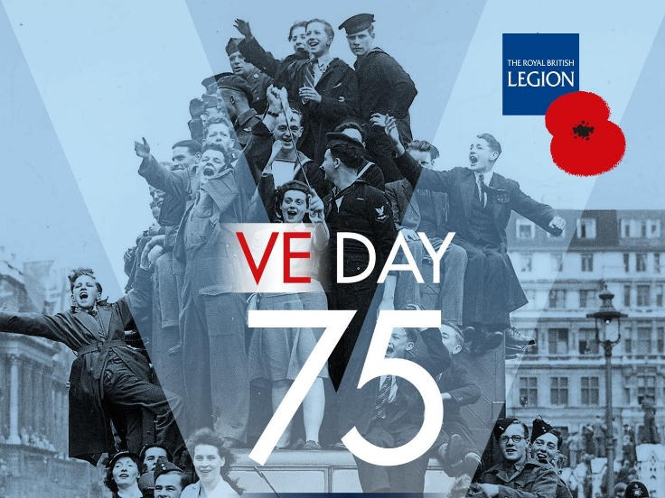
What is VE day?
When did it happen?
What happened on the day?
Why should we remember it?

-Please watch the video clip about V.E day:
https://www.youtube.com/watch?time_continue=17&v=NEavcsrMoMw&feature=emb_logo

-Now read the diary entry from someone who was there from the BBC archives.
https://www.bbc.co.uk/history/ww2peopleswar/stories/21/a1967321.shtml
What can you learn from reading this person’s experience?
-Please watch the history lesson about VE day:
https://www.mrtdoeshistory.com/ve-day-key-stage-1
Activities to try at home:
*Can you create your own timeline and put family members on to the timeline? You will notice that VE day is just within living memory, which means that the people who remember VE day are a lot older.
*Create a poster or draw a picture celebrating VE day (75th anniversary)
* Create your own VE day celebration for your family. What decorations will you include? Will you want them to learn something? What food will you want to eat? What will you wear?
*Use the colours of the Union Jack to create bunting for a street party.
*Compare the music of the time to modern music and identify similarities and differences between them. Learn to sing one of the songs and think about the meaning and the tone it should be sung with.
We would love to see your VE day homelearning and how you celebrate this special day on Friday!
Please e-mail photographs to info@st-john.blackpool.sch.uk

