KS2 VE DAY HOMELEARNING PROJECT:
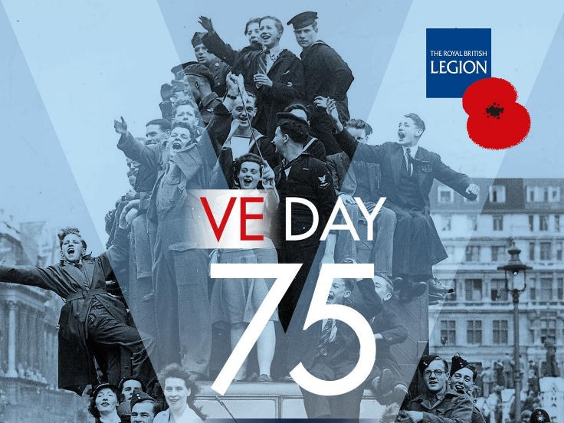
75th Anniversary-VE Day
What is VE day?
When did it happen?
An overview of the causes of the war
Some significant events on the Western Front
What happened on the day?
Why should we remember it?

-Please watch the video clip about V.E day:
https://www.youtube.com/watch?time_continue=17&v=NEavcsrMoMw&feature=emb_logo

-Now read the diary entry from someone who was there from the BBC archives.
https://www.bbc.co.uk/history/ww2peopleswar/stories/21/a1967321.shtml
What can you learn from reading this person’s experience?
-Please watch the history lesson about VE day:
https://www.mrtdoeshistory.com/ve-day-key-stage-2

Activities to try at home:
*Create a poster celebrating VE day (75th anniversary)
*Create a non-chronological report about VE day including facts, information, pictures/captions…
*Use the colours of the Union Jack to create bunting for a street party.

*Create your own VE day Powerpoint. Maybe include some questions or create your own quiz.
*Compare the music of the time to modern music and identify similarities and differences between them. Learn to sing one of the songs and think about the meaning and the tone it should be sung with.

* Watch the video of VE day in London and consider or list why people were celebrating and why it's important that we remember it today.

* Plan what you would serve for a street party to mark the end the war in Europe. To add additional challenge, learn about rationing and limit the food available to be used during the party.

We would love to see your VE day homelearning and how you celebrate this special day on Friday!
Please e-mail photographs to info@st-john.blackpool.sch.uk

