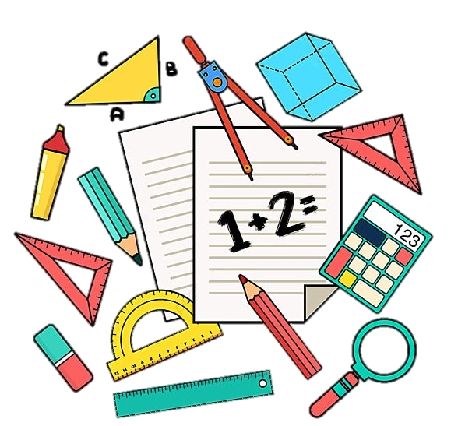

**Keep up with the Kids in Maths for Year 3 and 4 families**

**Take part in fun maths activities with your child**

**✓ Find out what maths your child learns at school**

**✓ Support your child’s learning by working together**

**✓ Make resources to use at home**

**Children join in last part of every session**

**Free 4 week course**

**starts Thursday 19th June 9-11am**

**at St John’s C of E Primary**

**Book your place by filling in the form at**

**https://bit.ly/FLMaths25**

**Due to health and safety we are unable to accommodate younger siblings in the session**