Autumn
The season is autumn
It is getting cooler
Can you see any signs of autumn?
Key Vocabulary
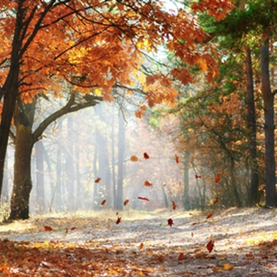  Falling leaves | Some leaves fall from the trees as the trees are having a rest in autumn.  you will see lots of different colour colour leaves. | 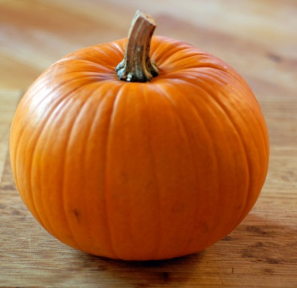  Pumpkin | A pumpkin is a large, round orange fruit. Some people carve pumpkins in autumn time.  Pumkins are ready to be picked in autumn.
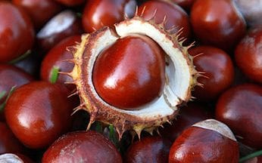  Conkers | A conker is a nut from the horse chestnut tree.. | 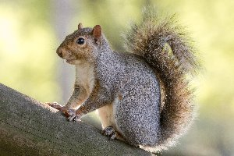  Squirrel | An animal which lives in trees and is furry with a bushy tail. They eat nuts and seeds.
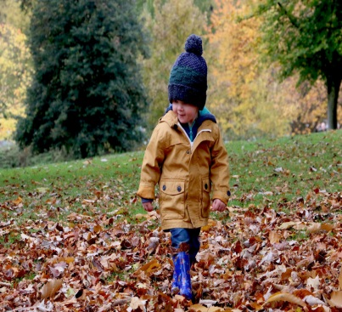  Weather | The weather can be cool and we need to wear our coats.  It starts to get a bit chilly outside. | 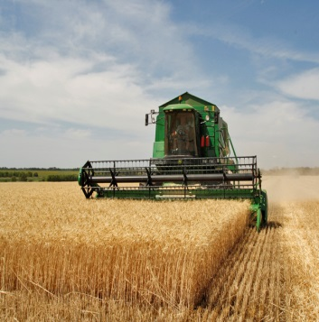  Harvest | Harvest is to collect what has been grown in the ground. It is usually done by farmers,  At school we celebrate the Harvest festival at church and share our food with others.
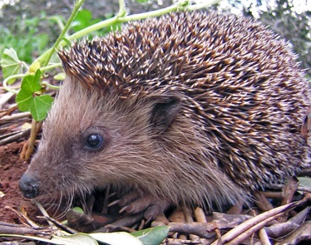  Hedgehog | A wild animal found in our gardens and parks. They have spikes on their back and are awake at night and sleep in the day | Can you go on a walk and look for signs of autumn in the park or talk about the things you notice on the way to and from school?

