Summer
The season is Summer
What would you do in summer?
Key Vocabulary
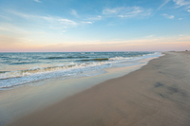  Shore | Where the sea and the land meet. You can walk along the shore. | 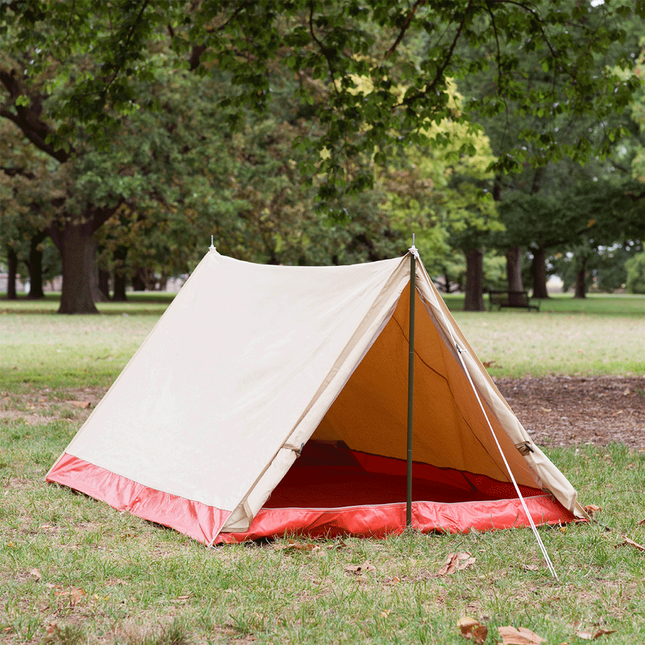  Camping | People sometimes go on holiday in the summer. Have you ever been on holiday and stayed in a tent or a caravan? Maybe you have stayed in a hotel.
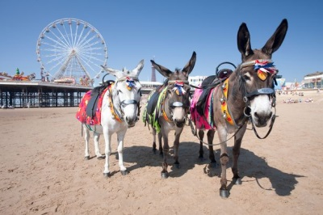  Donkey | A donkey belongs to the horse family, but has longer ears and makes a braying noise. You can have a donkey ride on the beach. | 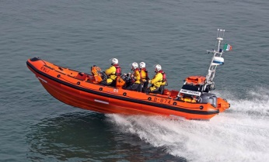  Lifeboat | The lifeboat rescues people who are in danger in the sea. We have a lifeboat station in Blackpool.
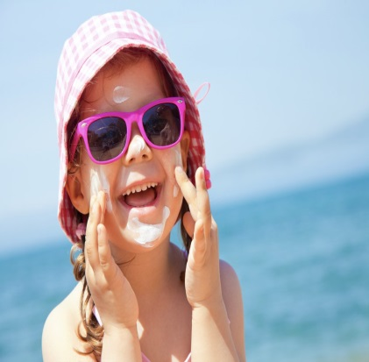  Sunglasses, sun cream, sun hat | We wear sunglasses, sun hat and sun cream to keep ourselves safe in the sun. Which parts do they protect? | 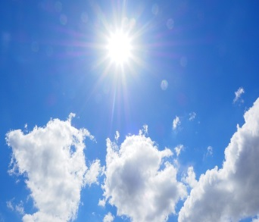  Sunshine | Summer is our hottest season. The sun shines much more in summer and we can wear our summer clothes. We need to drink plenty of water as we can get very hot! How do you keep cool in summer?
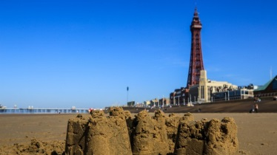  Seaside | We live in Blackpool. We live by the sea and so we live by the seaside. | If you have a trip to the beach see how many things you can find!  