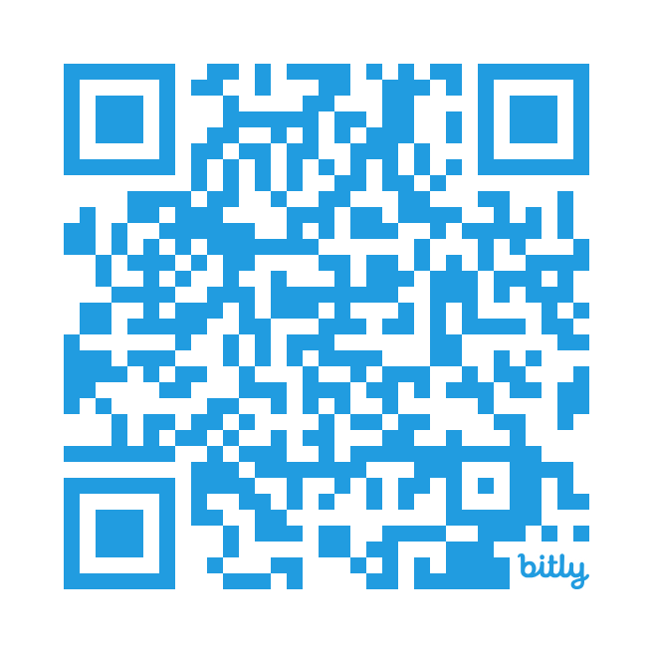

**Learn Together course**

**for Reception families**

**Take part in fun activities with your child**

**✓ Find out what your child learns at school**

**✓ Support your child’s learning by working together**

**✓ Make resources to use at home**

**Children join in last part of every session**

**Free 4 week course**

**Thursday 16th January 9-11am**

**St John’s C of E Primary**

**Book your place by filling in the form at**

**https://bit.ly/FLLT25**

**Due to health and safety we are unable to accommodate younger siblings in the session**