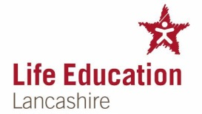

Life Education is coming to our school on

Monday 2nd and Tuesday 3rd October 2023
Life Education Centres is a charity providing unique health and drug education programmes which teaches children about the wonder of their bodies, how to take care of them, and how drugs (including medicines, alcohol and tobacco) can affect them.

All our children will have an opportunity to take part in the programme, which is specifically designed for their age group. The aim is to encourage the children to think about all aspects of health, and make positive decisions about themselves.

Specialist teachers will be visiting your child’s classroom for an interactive workshop.
We are asking for a £1.00 donation towards the cost of the Life Bus.

We would also like to invite you to visit school for a parent’s question and answer session, about life skills education in school.

The special session for parents and carers will take

place on: Tuesday 3rd October 8.50am to 9.10am

I enclose a £1.00 donation towards the cost of the Life Bus.

Name of child ___________________________ Class _____

Signed ___________________ Date

