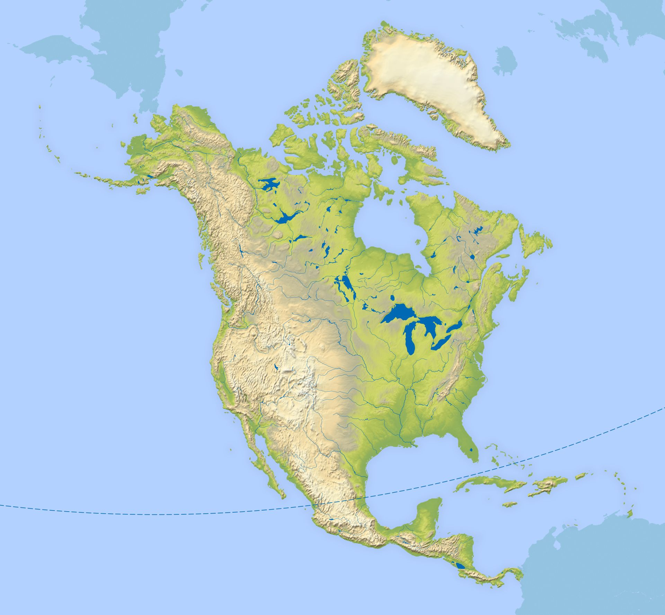

**Art**

Exploring the work of Georgia O’Keeffe.

To proportionately sketch skyscrapers using different dry media.

**P.E:**

Investigating the impact of exercise on the body.

**English**

SPAG and comprehension practice.

‘Holes’ by Louis Sachar

-Recount: Diary Entry

-Setting description.

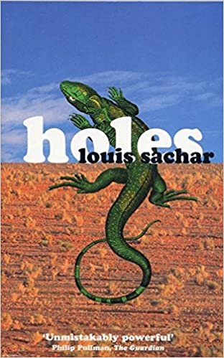

**A region in North America.**

**What makes Yellowstone National Park so special?**

**Science**

* recognise that light appears to travel in straight lines

*Investigate how light reflects into the eye.

*explore light sources to our eyes or objects.

*Investigate why shadows have the same shape as the objects that cast them.

**Geography**

*To locate North America and what it is like.

*Explore why the USA is the most powerful country in North America even though it’s not the largest?

*Locate Yellowstone National Park and its human and physical characteristics.

*Explore the issues affecting Yellowstone and what is being done to address them.

*To investigate what it is like to live in the northern gateway to Yellowstone.

