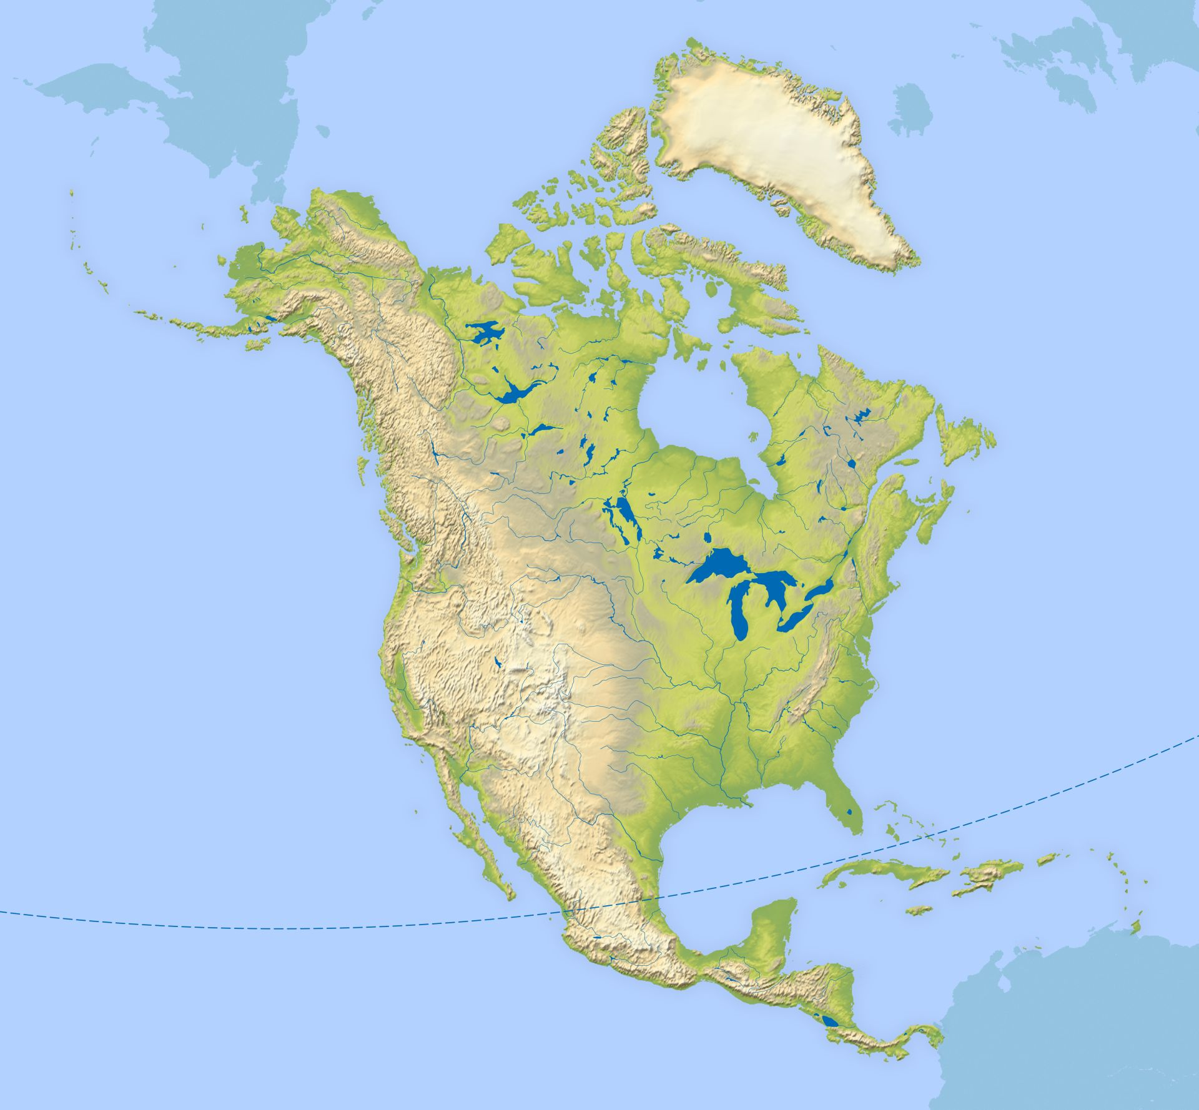

Yellowstone

States

Coastlines

Earthquakes

Biomes

National Park

Montana

Livingston

7 continents of the World.

Africa

Antarctica

Asia

Australia

Europe

North America

South America.

5 Oceans of the World

Arctic

Southern Ocean

Indian Ocean

Atlantic Ocean

Pacific Ocean

Central America

Caribbean

Climate

Rivers – Mississippi

Mountains – Rockies,

Danali

Volcanes – Mt St Helens

Latitude and longitude

Tropics of Cancer and Capricorn

Equator

Northern and Southern Hemisphere

Prime/Greenwich

Meridian

Time zones

Physical/human characteristics

Land Use

Industry

Agriculture

Natural resources

Energy

Minerals

North America