
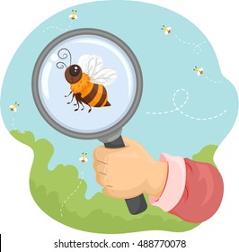
Nature Detectives course
for Year 2 families

✓ Find out what your child learns at school
✓ Support your child’s learning by working together
✓ Make a scrapbook with your child

Children join in last part of every session
Take part in fun activities with your child based on a nature theme

Free 4 week course
Starting Thursday 6th November 9am-11am
St John’s CE Primary

Book your place by filling in the form at
https://bit.ly/FLND25

Due to health and safety we are unable to accommodate younger siblings in the session

