Dear St John’s families
This time last year I wrote to you to say that the Summer term had been unlike one we could ever have known or imagined! I can’t believe that as we reach the end of the school year again., and supposedly coming to the end of the full lockdown, we are still in the grasp of Covid 19. For the first time in over a year, we had to close class Bubbles, and two Bubbles have had to close twice. This has been particularly upsetting for Year 6, who have missed their last three days in primary school. We wish them luck and send lots of good wishes as they move to high school.
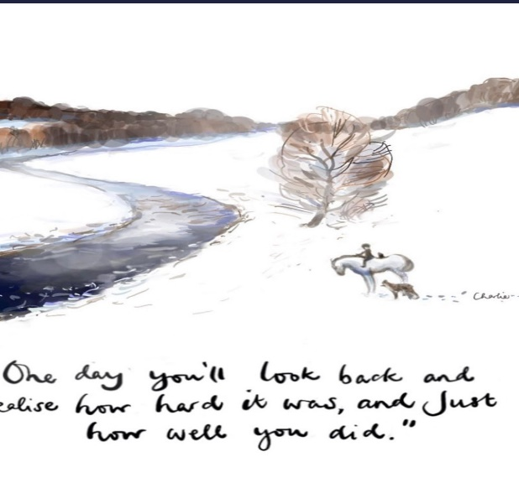
I would really like to thank everyone for their hard work and dedication to the boys and girls of St. John’s. Everyone has risen to the challenge and our whole school community have pulled together to provide the best support that we can in these difficult circumstances. We have all done something that most have never done before and weren’t trained for, despite being worried and anxious every day. Our school is like an orchestra; the whole school community, with everyone bringing a different sound, tone and timbre- but the symphony is created by all.
These really have been unprecedented times and there have been many highs and lows for everyone. All the staff have missed the daily interaction with the children across school and we long for normality to resume. All being well, we will return in September to a semblance of ‘normality’ and we will be able to abandon the Bubble system-but as with everything, I have learned to wait for any last minute changes from the government! Watch this space.
  - We hope, and are planning to have, the school open for the start of September. Thursday the 2nd of September is set to be the return date; we are preparing for all eventualities, but hope we all return in full in September. We will, of course, listen to all advice from the health authorities and put the health and safety of the children and staff first.
When I have more information to share, I will update the school facebook and website, so please keep checking it. In the meantime, if you have any questions or concerns, please email info@st-john.blackpool.sch.uk and I will do my very best to help.
I hope that you all have a wonderful summer break and I look forward to welcoming everyone back safely on September 2nd.
Mrs Galloway
Headteacher

Returning to School
- All the arrangements around enhanced cleaning rotas, regular and thorough hand washing, a ‘catch it, bin it, kill it’ approach to coughs and sneezes and minimal contact between children and staff will remain.
- Please continue to leave all unnecessary bags or equipment at home. Only school reading books, reading records and home learning books as appropriate should be brought to school. School reading book bags will be provided.
- Full School Uniform should be worn apart from PE days.
- On PE days, children should come to school dressed in plain black joggers/leggings, a white T-shirt, school sweatshirt and trainers or pumps. (black shorts can be worn in warm weather)
- No designer sportswear or football kits please.
A timetable will be sent home at the beginning of term and PE will start in the second week.

We will continue with the staggered starts and ends to the school day.
Doors will open between 8:45 to 9:00 for everyone. The register will be taken at 9am.
Reception and Y1 will use reception gates to be dropped off and collected.
All other year groups will enter and leave via the main playground.
Year Group | Finish time
Reception | 3pm
Year 1 | 3:05pm
Year 2 | 3:05pm
Year 3 | 3:05pm
Year 4 | 3:05pm
Year 5 | 3:10pm
Year 6 | 3:10pm

As we have done this year, if you have more than one child at St John’s, please collect them at the finishing time of the eldest child.

