St John’s news
THe Latest news from our school community
This Photo by Unknown Author is licensed under CC BY-SA  HAPPY HEARTS  Kindness  Chantelle & Martha  Isn’t it strange how being kind makes you feel so good? We asked some people about being kind, what they did and how did it make them feel. This is what we found out;  Miss Johnston was feeling very happy because she had organised a trip to the theatre for Year 6. It made her feel really good as the children in the class were so excited.  Mrs Taylor was very kind because she gave her friend some shampoo that she really liked. Her friend was very grateful and felt really special. Mrs Taylor loved watching her friend smile and felt like she’d received a gift too.  At playtime a child in year 6 was feeling cold as she had left her jumper in the classroom, her friend gave her a fleece to keep warm. They both felt the warmth.  You can be kind to someone just by smiling at them- it can make someone’s’ day! Try it – you’ll feel good for doing it!  This Photo by Unknown Author is licensed under CC BY-NC-ND  Kindness costs nothing but means everything! | 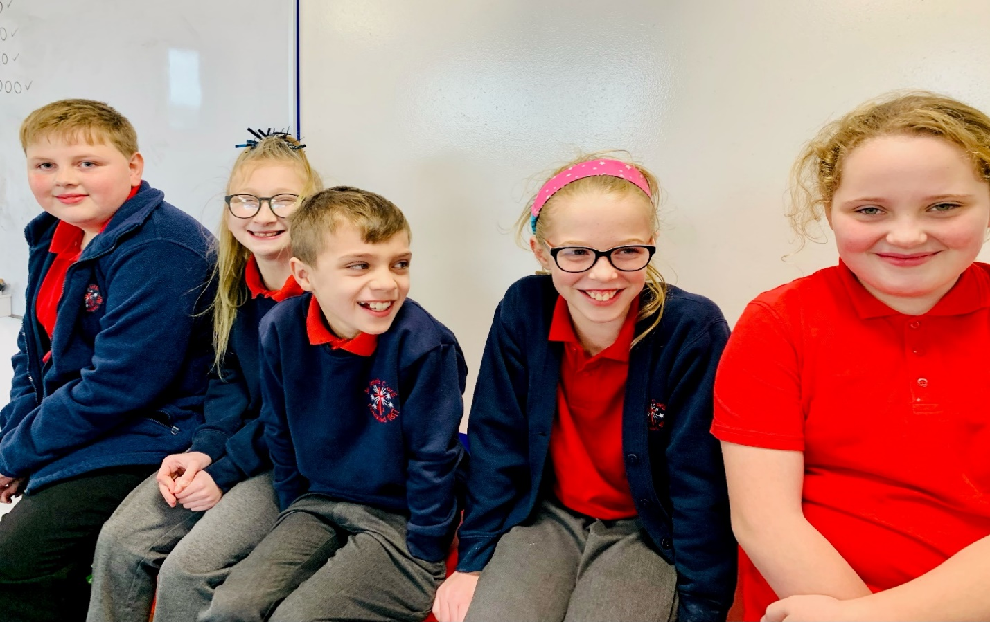  WELLBEING WARRIORS: Lacey, Martha, Theo, Chantelle and Richard  Everyday Super Hero’s
 | Mrs Tiribocchi  For anyone new to the school did you know we have a group of children who are our Wellbeing Warriors. They are called Theo, Lacey, Chantelle, Martha and Richard. Their job in school is to help children who might want to talk to someone who may be worried, fallen out with friends or just feeling a bit down. They have really good ideas and strategies on how to cope when things are not going so well. If they can’t help they will tell me so a grown up can help. To speak to a Wellbeing Warrior you can either leave a note in the Problem Letterbox or come along to lunch club on a Wednesday, Thursday or Friday to talk to us. Also just have a chat to them if you see them around school or sit on a Buddy Bench. The Wellbeing Warriors use lots of Resilient Moves to make themselves and their friends feel better. A Resilient Move is an action we can all take to improve our lives. | For example, get enough sleep. It’s awful coming to school when you feel tired. It’s hard to concentrate and you might feel grumpy. Our brains are not ready to learn and it feels like the longest day ever! However, by going to bed earlier makes us feel refreshed, positive and clear headed, guaranteeing a good day at school. Another easy Resilient Move is eating healthily and exercising. Alan, our PE Coach, teaches us all about the importance of putting the right fuel in our bodies to operate at our best performance. Try to save the junk food and sweet treats for special occasions!  Have a go at the Resilient wordsearch in Lunch Club to see if you can find more Resilient Moves.  Thank you Wellbeing Warriors for giving up your time and breaktimes to help other children in school. I hope you are proud of yourselves, I know I am! Well Done, Keep up the good work!
IN THIS ISSUE
RR 22 CONFERENCE | History of school | WW update
Roving Reporter  International Resilience Conference  Our Day Out |  |  |  | SELF SOOTHING  Lacey gives us tips on how we can make ourselves feel better.  Lacey  At the Conference we were shown ideas to self soothe. This is helpful when your mind is racing with thoughts or you are worrying about something or if you are feeling angry.  One idea is to draw an outline of your hand, then you write on your fingers;  - 5 things that you like doing  - 4 sounds you like  - 3 people you like  - 2 animals you like  - 1 of your favourite food  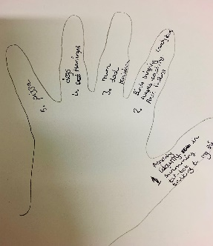  Another idea is to meditate by breathing.  Put your hand on your chest and breathe in through your nose (keeping your mouth closed) for 5 seconds, try and hold your breath for 5 seconds then breathe out through your mouth for 5 seconds , do this 5 times. You should feel your shoulders relax and your heartbeat slow down.  How about keeping a ‘Busy Book’ in your tray. It is just a notebook that you can use to scribble down your feelings, doodle pictures, make a list of goals you want to achieve. You could just use your book to make lists or even as a brain dump!
Harley Y5  On 24th March I went to the new Winter Gardens Centre where our Prime Minister, Boris Johnson had been the week before. I went with the Well Being Warriors and some Y5 children.  We were on a conference called Resilience Revolution 22. There were loads of other people and school children there too. We had a blast of a time, it was great fun.  First we listened to a speech about Resilience and what great things were going on in Blackpool to make people feel better about their lives.  After that we went to a cartoon workshop and met a creative artist called Harry Venning who draws cartoons for The Guardian Newspaper. I learned a new hobby which I love, I now carry a notebook around and draw cartoons of people- it’s so enjoyable. You just start with drawing 2 eyes and before you know it you have created a character and then you can create a story. I love drawing cartoons now, time goes so fast and I like showing my pictures to my friends.  We then went to hear about how another school called Baines Endowed have a resilient committee who do loads of great things. They listen to lots of music, they even have speakers on the playground- they know how important music is for making us feel good. We all had to dance- it was really funny. They showed us how to meditate and self sooth. After that the owner of Blackpool Tower told us about a new scheme called ‘Friend for School’- where grown ups have made friends with some children at Westminster school- it sounds really cool and they get to go on fun trips as well as getting ideas about jobs to do for grown ups.  We then had a delicious lunch and had chance to look at some displays from other schools. We saw the snakes and ladders game that our Wellbeing Warriors had created -it was great.  In the afternoon we heard about a scheme called Friend for Life, it’s where children in care literally have a friend for life which is a constant support when their lives are so changeable. |  | 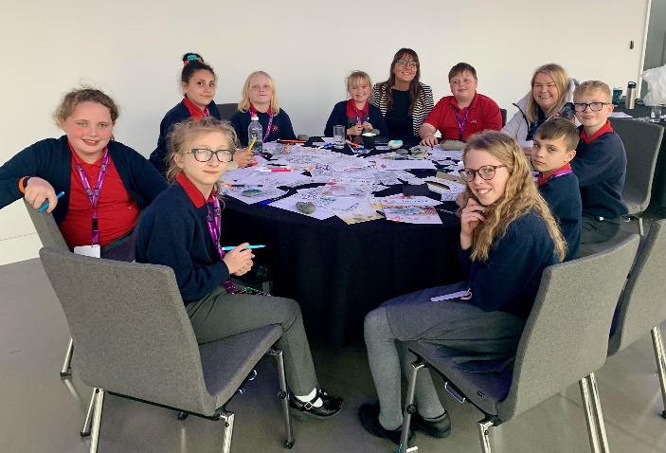  CREATING MEMORIES: painting pebbles and writing affirmations  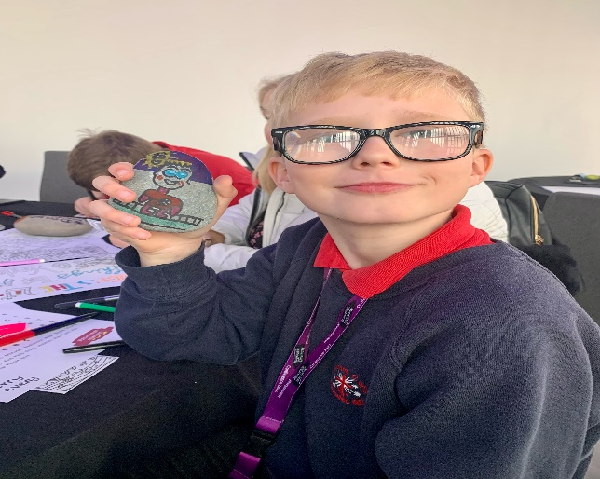  HARLEY THE CARTOONIST: painting his own avatar  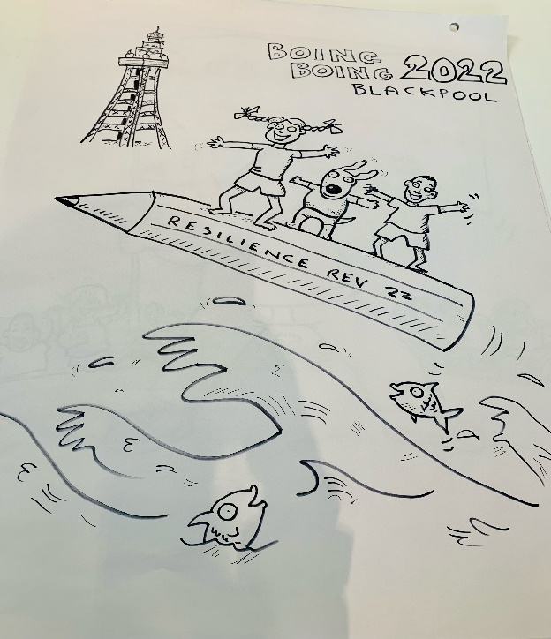  We heard lots of different stories from young people and their ‘friends’. It was quite emotional when we heard about the good changes it made. At the end they played the song from Toy Story and everyone was dancing and clapping- it was a great atmosphere.  To end the day we went to a creative room and painted pebbles to remind us of out day. Mine was an cartoon avatar of me. Thank you Mrs Capper and Mrs Tiribocchi for taking us I have learnt a lot about resilience and now I tell people to always have a good day even if you are feeling down you should try and have a great day!
Book Review by Logan - Reading is my ‘happy place’

A Series of Unfortunate Events by Lemony Snickett.

This story is about 3 children who became orphans and lived with this horrible man called Count Olaf. The man was horrid and his house was disgusting. Count Olaf wanted to get all the money that the children had and he realised that if he married the oldest daughter, Violet he would get all the money. However, he had to get rid of lots of obstacles first …
It is a fantastic book as it is full of twists and turns, good overcoming evil. It is so funny and I would definitely recommend you read this book. Good news is that there are 3 others to read too.

The Truth Behind St John’s CoE School by Alfie in Year 6

OK where to begin? This is an article behind the truth of St John's. Did you know the building we are in today looks nothing like the original building.
The original building was founded in 1817.So you're wondering why they knocked the school building down? I didn’t know either until I did some research.
Back in 1817 the layout of the old school was really weird. The founder John Gisborne built the original school behind lots of shops. Did you know it was the first school in Blackpool?

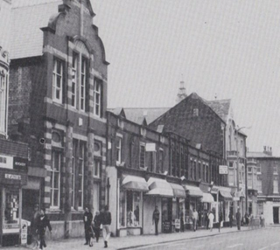

In Mrs Sharratt’s office there are the original registers and books which show all the children who used to come here and what high school they went to They are big leather books and look really old fashioned. Amazingly I have found my nanny’s name, Lynn Cadman who came here many years ago. Her number was 5262.She couldn’t believe that we found it- she even remembered some of her class friends! Next time you go in the office see if you can spot the original School Bell!
So much history in our school, I bet lots of your parents and grandparents came here too. In 2006 it was decided that the old building just was not big enough and it was cold, damp and needed completely rebuilding. When the new school was being built everyone had to go to the Salvation Army building on Raikes Parade- I wonder what that felt like?
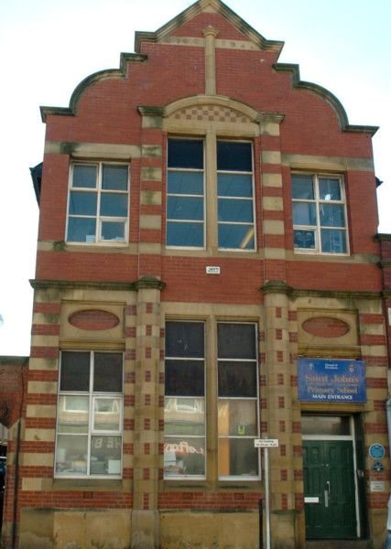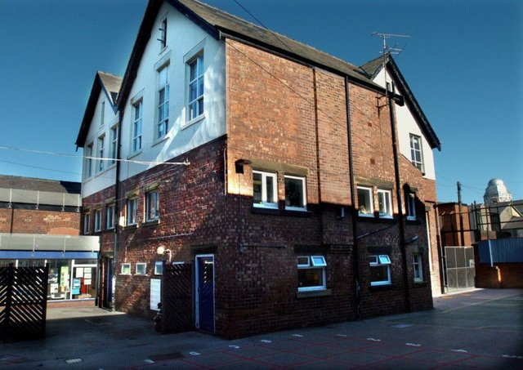
This is what school looked like in 2006!
Whilst at Salvation Army there was a competition to design the big stained glass window which we see at the front door. I wonder which student won - maybe they are an artist or designer now! Can you imagine how the children felt when they moved into the ultra modern new build- I bet it was so exciting! We are so lucky to be in a school in the middle of Blackpool town centre. When people visit our school and stand on the top playground they are shocked that we have such amazing views- it’s like being on New York Sky Scraper!
I wonder what the next 200 years will bring for St John’s Primary School?

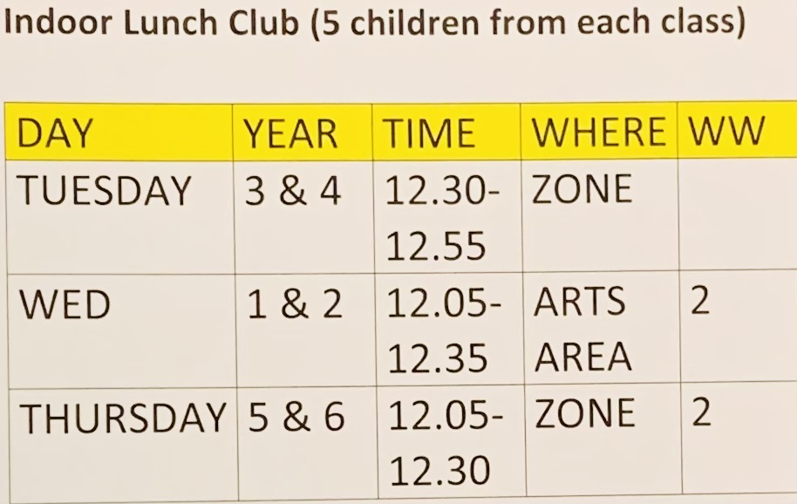  ROTA FOR LUNCH CLUB: |  |  | LUNCH CLUB  Wellbeing Warrior Update  Theo and Richard  We have been given some money to spend on making school even better. We decided to buy some outdoor play equipment for the playgrounds, we are thinking about getting wall mounted target games, a basket ball net , new clips for the football nets and a big blackboard so we can play noughts and crosses, hangman and play at being teachers at school! Also we have asked if we can put the little hut back on the ground floor which we loved playing in when we were in KS1. We have measured it and it will fit behind the new Hub.We can now use the Worship area as a ‘Reading Club’, however if children are not respectful we will not be able to do this.  As you know the Indoor Lunch Club is set up for children who might prefer a quieter lunch, you can come along to colour in, do jigsaws , play Lego or chat to one of us . Please look at the timetable to see when your class can go to Lunch Club. We are thnking about setting up a gardening club too.Let us know if you have any ideas!  Remember that if you sit on a Buddy Bench a Wellbeing Warrior will check you are OK if they are around. Also if you see someone on their own – do the right thing and say hello!

Mrs T’s Problem Page
I am worried as my mum and dad keep arguing. What if they split up?  Mrs T said that lots of parents argue and it can make you feel worried and unhappy. Remember it’s not your fault and try and keep out of the way. Maybe you could put some music on or do something to distract yourself. When things have calmed down perhaps you can speak to your mum and dad and tell them how hearing them argue makes you feel and ask them what is happening.  Although I am excited about going to High School I am quite nervous too. What if I get lost, what if I don’t know anyone, what if I get bullied?  Most children in Year 6 feel exactly the same. Many of you have been coming to this school for 7 years and you feel like it’s your second home. You know everyone and everyone knows you so it is natural to feel nervous. However over the next few weeks you will be spending time getting familiar with your new school. | It’s an exciting new adventure and you will always remember the happy memories you have made at St John’s.  I just don’t feel myself. I don’t know why, I am feeling sad and don’t enjoy doing things like I used to. I don’t want to talk to a grown up as they won’t understand  A lot of people feel like this sometimes. It is usually when we are feeling overwhelmed and we struggle to deal with our emotions. When I feel like this I try and do something that usually makes me feel good like walking or gardening, I also talk to my mum or write down how I am feeling. Everyday on my way to work I name 3 things that I am grateful for, doing this seems to cancel out my negative feelings. If you don’t want to talk to a grown up try talking to a friend or a Wellbeing Warrior, it’s sometimes easier to talk to someone your own age as they will probably know exactly how you feel. |  |  | 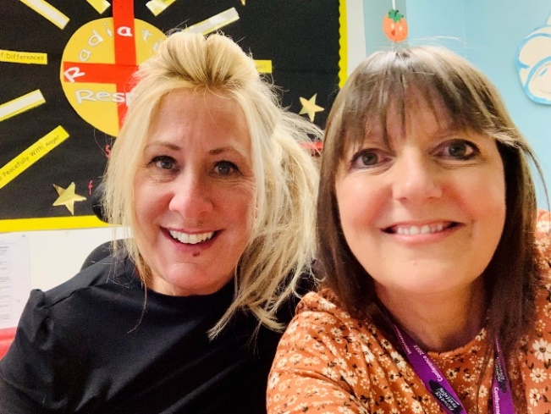  Mrs T and Mrs T

…and finally

Year 6
Mrs Tiribocchi  As we get ready for our final term I want to dedicate the back page to our awesome Year 6 children. It was way back in Year 3 that they had a full year that was not affected by Covid. Year 4 and 5 we had lockdowns and I think practically everyone in the class have had Covid this year. It’s been a really difficult time for the children with plans constantly changing, not being able to mix with other people and feeling a bit worried at times. But, as I’ve said before, not only are we history makers- we have got through it and learnt how to deal with difficult situations along the way! We have shown resilience and strength and this will galvanise us as we face life’s hurdles. | When I asked children about their experience at Primary school, the main theme was togetherness. Some quotes are:  -Growing up with all my friends,  - Sharing life experiences,  - It feels like my second home,  - I have a sense of belonging,  - Having a laugh and fun,  - Just being happy  What lovely memories you have shared with me (I won’t mention the staying up late and eating sweets at residential!)  We are all proud of you Year 6 ! Enjoy your last term, carry on making magic memories, be good role models, keep safe and be happy!
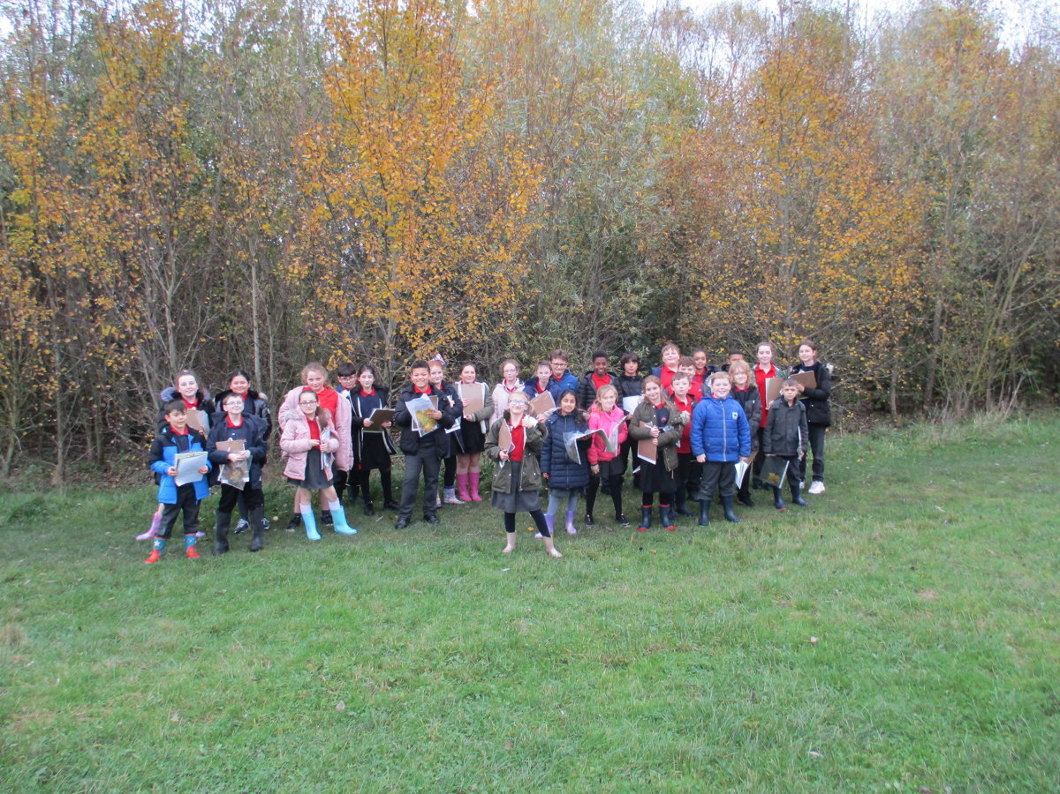
yEAR 6 Leavers

We had the time of our lives!

Class of 2022

