Learning Question

What makes Lancashire unique?

**Class 3 - Autumn Term 1**

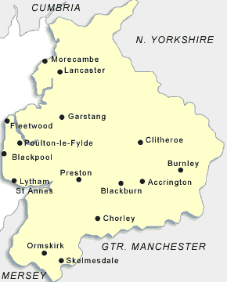

**The County of Lancashire**

**English**

**Reading**

Cinderella Skeleton

by Robert D San Souci

George’s Marvellous Medicine

by Roald Dahl

**Writing**

Traditional Story

Creating an alternative version of Cinderella

Non-Chronological Report

The Human Body

and the Food We Eat

Poetry

The Human Skeleton

**Geography**

**The UK – countries, counties, regions and cities**

To find out about the human and physical features of Lancashire.

To find out how diverse the landscape of Lancashire is.

To learn that there are nine regions in England.

To learn that these nine regions have regional differences such as: food, travel and trade.

**Science**

**Animals, including Humans**

Identify that animals and humans need the right types and amount of nutrition and that they get nutrition from what they eat.

Identify that humans and some other animals have skeletons and muscles for support, protection and movement.

**D.T.**

Food Technology: Making a healthy salad pitta pocket

