**Class 3 - Autumn Term 2**

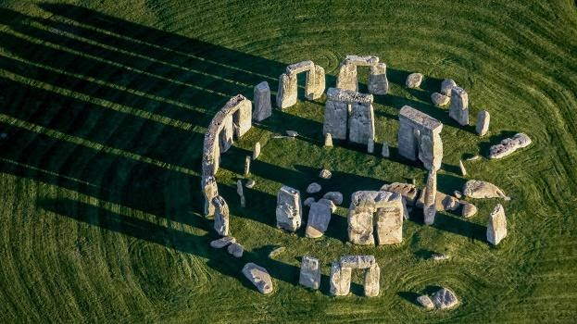

**Stone Age**

**English**

**Reading**

Stone Age Boy

by Satoshi Kitamura

How to wash a Woolly Mammoth

By Michelle Robinson

**Writing**

Instructional Writing

How to wash a …

Narrative

Adventure Story linked to the Stone Age

Informal Letter

A Stone Age discovery

Learning Question

How did life change during the Stone Age?

**History**

**Changes in Britain from the Stone Age to the Iron Age**

To find out about the three different periods of the Stone Age.

To find out how early man survived in a harsh environment.

To use case studies of Star Carr and Skara Brae.

To look at different theories around the building of Stonehenge.

**Science**

**Rocks and Soils**

Compare and group together different kinds of rocks.

Describe in simple terms how fossils are formed.

Investigate and devise tests to explore the properties of rocks and soils.

**Art**

**Drawing and Textiles**

**Research Stella McCartney**

**Stitching, Weaving, Printing**