**Class 3 - Autumn Term 2**

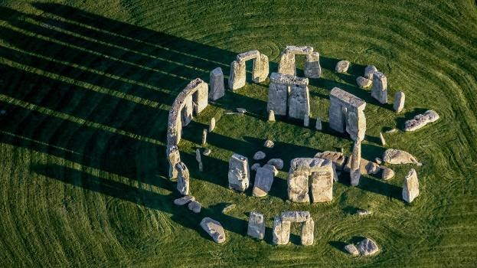

**Stone Age**

**English**

**Reading**

Stone Age Boy

by Satoshi Kitamura

Stig of the Dump

by Clive King

**Writing**

Black History themed week:

‘The Proudest Blue’

by Ibtihaj Muhammad

Alex Scott

Significant Black Icon

Narrative

Adventure Story linked to the Stone Age

Informal Letter

Discovery of a person from the Stone Age

Learning Question

How did life change during the

Stone Age?

**History**

**Changes in Britain from the Stone Age to the Iron Age**

To find out about the three different periods of the Stone Age.

To find out how early man survived in a harsh environment.

To use case studies of Star Carr and Skara Brae.

To look at different theories around the building of Stonehenge.

**Science**

**Rocks, Fossils and Soil**

Compare and group together different kinds of rocks based on their appearance and physical properties.

Identify how we use different rocks in everyday life.

Describe how fossils are formed.

Understand that soils are made from rocks and organic matter.

**Art**

**Drawing and Textiles**

**Research Stella McCartney**