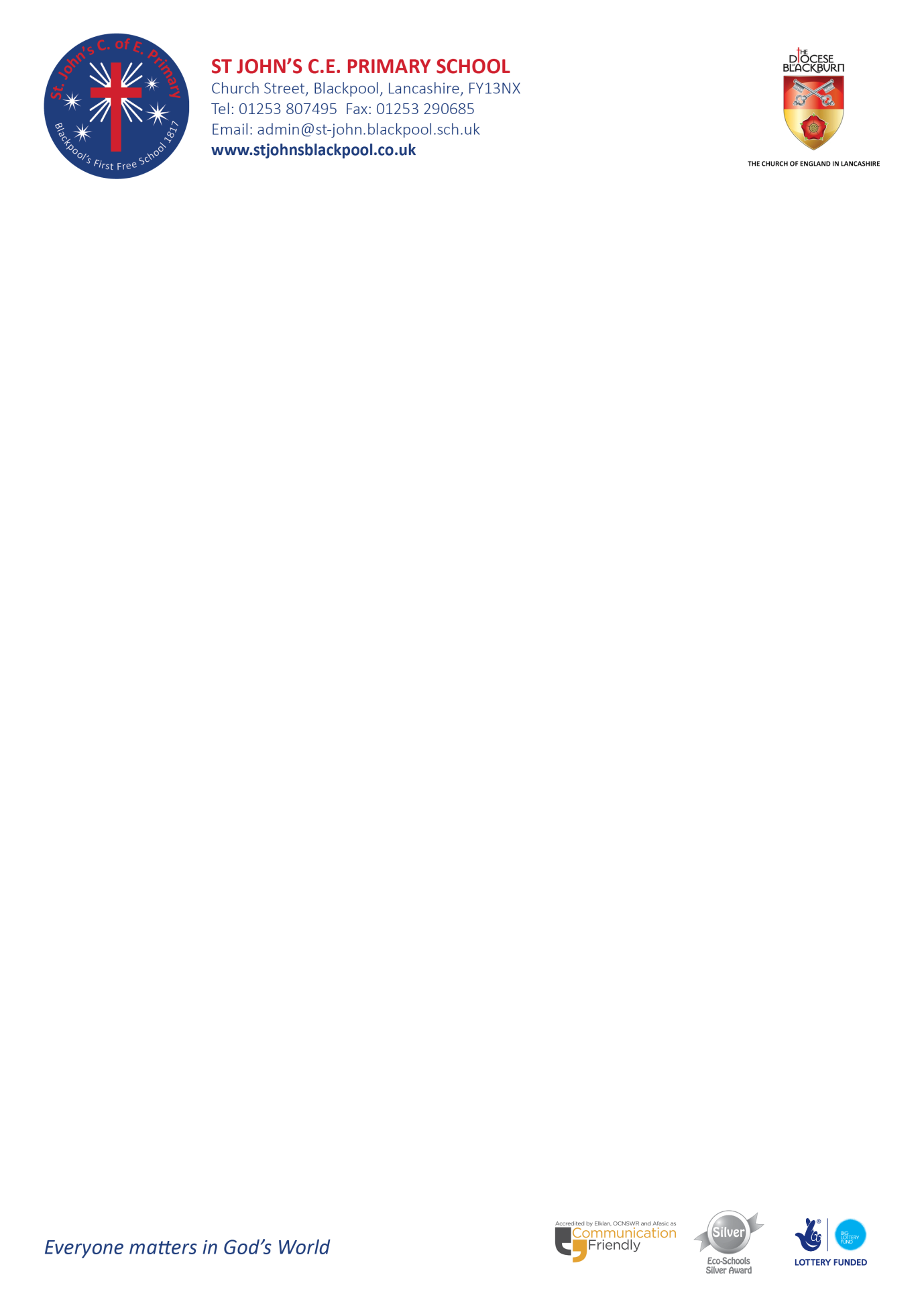
Dear St John’s Families
Re: Pharmacy First – an NHS service being offered from pharmacies across England for children and adults
I am emailing to let you know about an NHS service which pharmacies across England are offering for children (as well as adults) called Pharmacy First.
What is Pharmacy First?
This service enables children and adults to get quick access to healthcare advice as they can walk in to a pharmacy and access the service (some pharmacies also offer the service remotely as a video consultation). The person will then be offered a consultation with a pharmacist in a private consultation room. This service takes away the potential delay of having to wait for a GP appointment and may help ensure children get well and back to school as quickly as possible, as well as supporting parents/carers to also get better sooner if they are unwell.
The service supports primary school aged children in the below age groups who need help with:
- Earache (aged 1 to 17 years)
- Impetigo (aged 1 year and over)
- Infected insect bites (aged 1 year and over)
- Sore throats (aged 5 years and over)
The service also supports older children and adults (so is applicable to you as parents/carers) in the below age groups who need help with:
- Earache (aged 1 to 17 years)
- Impetigo (aged 1 year and over)
- Infected insect bites (aged 1 year and over)
- Sore throats (aged 5 years and over)
- Shingles (aged 18 years and over)
- Sinusitis (aged 12 years and over)
- Urinary tract infections (UTIs) in women (aged 16 to 64 years)
The pharmacist will provide advice and, if clinically necessary, offer an NHS medicine to treat the condition (these medicines are supplied free of charge to children under 16 years, with the normal NHS prescription charge rules applying to people aged 16 or over). The pharmacy will then send an electronic message to the person’s GP surgery so their health record can be updated.
Should the pharmacist be unable to help, they will direct the person to their GP surgery or other health professional as appropriate.
A summary of the service is available as an animation and more information can also be found at nhs.uk/thinkpharmacyfirst
Yours sincerely
Mrs N Galloway

Head Teacher

