Plants Vocabulary Mat
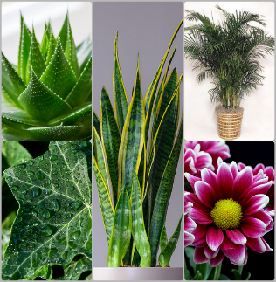
Plant
This Photo by Unknown Author is licensed under CC BY-SA-NC
Plants are living things and come in all shapes and sizes. They have petals, a stem, leaves and roots. They all need light, water and care to survive.

Evergreen  A tree that keeps it’s leaves all year round.  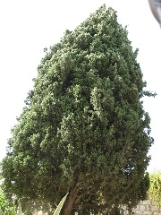 | Deciduous  A tree that loses its leaves in Autumn.  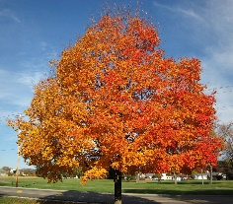 | Tree  A large plant with a trunk, bark and leaves. There are many different types.  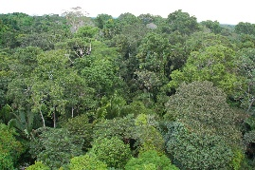
flower  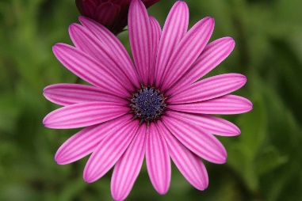 | stem  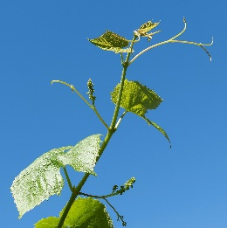 | petal  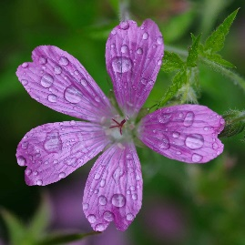
roots  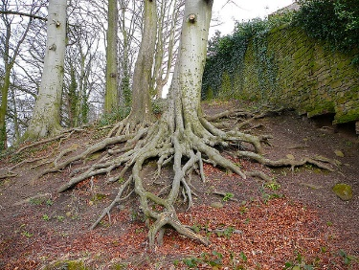 | stalk  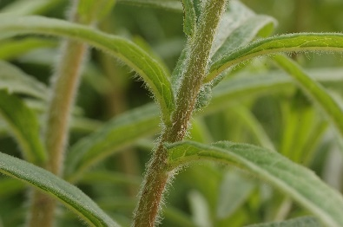 | fruit/vegetable

