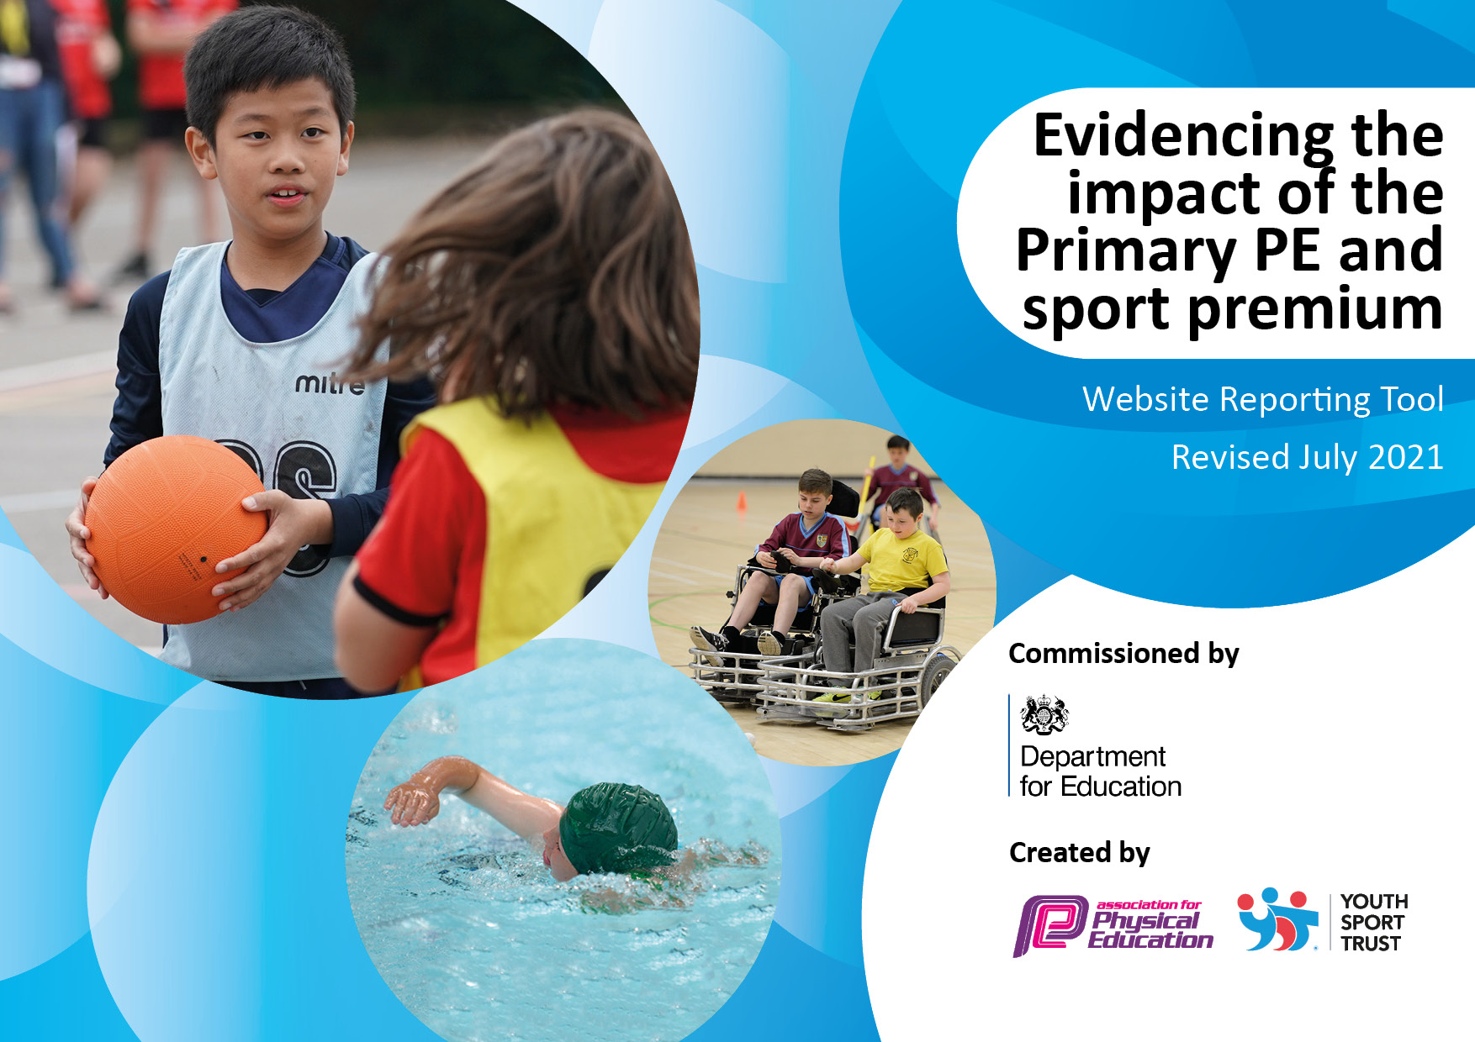
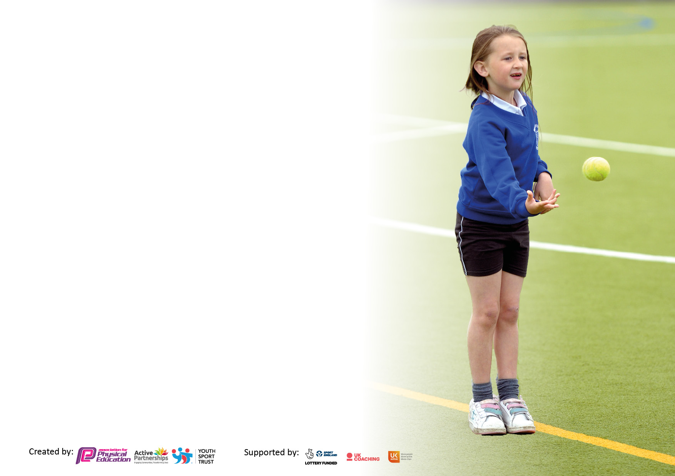

It is important that your grant is used effectively and based on school need. The Education Inspection Framework makes clear there will be a focus on ‘whether leaders and those responsible for governors all understand their respective roles and perform these in a way that enhances the effectiveness of the school’.

Under the Quality of Education Ofsted inspectors consider:
Intent - Curriculum design, coverage and appropriateness
Implementation - Curriculum delivery, Teaching (pedagogy) and Assessment
Impact - Attainment and progress

To assist schools with common transferable language this template has been developed to utilise the same three headings which should make your plans easily transferable between working documents.

Schools must use the funding to make additional and sustainable improvements to the quality of Physical Education, School Sport and Physical Activity (PESSPA) they offer. This means that you should use the Primary PE and sport premium to:

- Develop or add to the PESSPA activities that your school already offer
- Build capacity and capability within the school to ensure that improvements made now will benefit pupils joining the school in future years
- The Primary PE and sport premium should not be used to fund capital spend projects; the school’s budget should fund these.

Pleasevisitgov.ukfortherevisedDfEguidanceincludingthe5keyindicatorsacrosswhichschoolsshoulddemonstrate animprovement.Thisdocumentwillhelpyoutoreviewyourprovisionandtoreportyourspend.DfEencouragesschools to use this template as an effective way of meeting the reporting requirements of the Primary PE and sport premium.

We recommend you start by reflecting on the impact of current provision and reviewing the previous spend.

Schools are required to publish details of how they spend this funding, including any under-spend from 2019/2020, as well as on the impact it has on pupils’ PE and sport participation and attainment. All funding must be spent by 31st July 2022.

We recommend regularly updating the table and publishing it on your website throughout the year. This evidences your ongoing self-evaluation of how you are using the funding to secure maximum, sustainable impact. Final copy must be posted on your website by the end of the academic year and no later than the 31st July 2021. To see an example of how to complete the table please click HERE.

Details with regard to funding
Please complete the table below.

Total amount carried over from 2019/20 | £303
Total amount allocated for 2020/21 | £17,756
How much (if any) do you intend to carry over from this total fund into 2021/22? | £3,100
Total amount allocated for 2021/22 | £17,740
Total amount of funding for 2021/22. To be spent and reported on by 31st July 2022. | £20,840
Swimming Data
Please report on your Swimming Data below.

Meeting national curriculum requirements for swimming and water safety.

N.B. Complete this section to your best ability. For example you might have practised safe self-rescue techniques on dry land which you can then transfer to the pool when school swimming restarts.
Due to exceptional circumstances priority should be given to ensuring that pupils can perform safe self rescue even if they do not fully meet the first two requirements of the NC programme of study
What percentage of your current Year 6 cohort swim competently, confidently and proficiently over a distance of at least 25 metres?  N.B. Even though your pupils may swim in another year please report on their attainment on leaving primary school at the end of the summer term 2020.  Please see note above | 45%
What percentage of your current Year 6 cohort use a range of strokes effectively [for example, front crawl, backstroke and breaststroke]?  Please see note above | 42%
What percentage of your current Year 6 cohort perform safe self-rescue in different water-based situations? | 35%
Schools can choose to use the Primary PE and sport premium to provide additional provision for swimming but this must be for activity over and above the national curriculum requirements. Have you used it in this way? | Yes

Action Plan and Budget Tracking
Capture your intended annual spend against the 5 key indicators. Clarify the success criteria and evidence of impact that you intend to measure to evaluate for pupils today and for the future.

Academic Year: 2020/21 | Total fund allocated: | Date Updated:
Key indicator 1: The engagement of all pupils in regular physical activity – Chief Medical Officers guidelines recommend that primary school pupils undertake at least 30 minutes of physical activity a day in school |  |  |  | Percentage of total allocation:
 |  |  |  | 22%
Intent | Implementation |  | Impact
Your school focus should be clear what you want the pupils to know and be able to do and about  what they need to learn and to  consolidate through practice: | Make sure your actions to achieve are linked to your intentions: | Funding allocated: | Evidence of impact: what do pupils now know and what can they now do? What has changed?: | Sustainability and suggested next steps:
Continued to provide physical activities for children during the Covid pandemic.  Tailored sessions to outdoor learning.  Employed specialist coaches to support provision of high quality PE. | Active lunchtimes – brought in specialist coaches from Blackpool Sports Team and Alan Williams (PE Coach). | £3980 | Continued to offer a range of activities, outdoor base, new activities were added to replace indoor activities e.g. archery, tennis. | PE will continue to be based outdoor (exception of dance and gymnastics). Active lunchtimes will be further developed. Alan Williams will be brought in two full days in the new academic year.
Key indicator 2: The profile of PESSPA being raised across the school as a tool for whole school improvement |  |  |  | Percentage of total allocation:
 |  |  |  | 28%
Intent | Implementation |  | Impact
Your school focus should be clear what you want the pupils to know and be able to do and about  what they need to learn and to  consolidate through practice: | Make sure your actions to achieve are linked to your intentions: | Funding allocated: | Evidence of impact: what do pupils now know and what can they now do? What has changed?: | Sustainability and suggested next steps:
Further developed the link between physical activity and a healthy lifestyle.  Additional swimming instructors brought in to elevate standards in swimming. | School engaged in various programmes e.g. Sport 4 Champions, Fit 2 Go. | £4980 | Children become more aware of the need to be physically active as part of keeping healthy.  Importance of swimming as a life skill emphasised. | Continue to engage with the existing programmes and further the cross-curricular links between healthy lifestyles and physical activity. Continue to buy in additional swimming instructors.

Key indicator 3: Increased confidence, knowledge and skills of all staff in teaching PE and sport |  |  |  | Percentage of total allocation:
 |  |  |  | 22%
Intent | Implementation |  | Impact
Your school focus should be clear | Make sure your actions to | Funding | Evidence of impact: what do | Sustainability and suggested
what you want the pupils to know | achieve are linked to your | allocated: | pupils now know and what | next steps:
and be able to do and about | intentions: |  | can they now do? What has
what they need to learn and to |  |  | changed?:
consolidate through practice:
Specialist coaches worked alongside class teachers and TAs (Teaching Assistants) to develop their knowledge and confidence. | Specialist coaches e.g. in tennis and cricket worked with staff to support them to be able to plan and deliver activities.  Online training opportunities utilised to support staff development. | £3980 | Staff more confident to deliver a range of activities, particularly outdoor.  One of our TAs now has achieved a Level 3 award in PE and delivers sessions across the school. | Further develop staff training and team-teaching opportunities with specialist coaches.  Expand the range of activities that staff feel confident to deliver.
Key indicator 4: Broader experience of a range of sports and activities offered to all pupils |  |  |  | Percentage of total allocation:
 |  |  |  | 22%
Intent | Implementation |  | Impact
Your school focus should be clear | Make sure your actions to | Funding | Evidence of impact: what do | Sustainability and suggested
what you want the pupils to know | achieve are linked to your | allocated: | pupils now know and what | next steps:
and be able to do and about | intentions: |  | can they now do? What has
what they need to learn and to |  |  | changed?:
consolidate through practice:
Additional achievements:  A broader range of sports was achieved as all activities needed to be held outdoors.  Wide range of activities were offered to the children at lunchtimes. | Where possible specialist coaches were brought in to support the delivery of activities e.g. Lancashire Cricket Club.  PE Coach delivered a range of new activities e.g. archery, tennis.  Blackpool Sports Team supported the delivery of virtual events.  KS1 were offered a sports breakfast club. | £3980 | Children were able to engage in a range of activities and new sports, this included during lunchtimes.  KS1 engaged in breakfast clubs to experience new sports.  KS2 (within bubbles) were offered breakfast clubs and after school clubs in a range of sports. | Breakfast and after school clubs to continue (Alan, TA – Level 3 and PE lead to run clubs).  Blackpool Sports Team to continue leading active lunchtimes.

Key indicator 5: Increased participation in competitive sport |  |  |  | Percentage of total allocation:
 |  |  |  | 5%
Intent | Implementation |  | Impact
Your school focus should be clear | Make sure your actions to | Funding | Evidence of impact: what do | Sustainability and suggested
what you want the pupils to know | achieve are linked to your | allocated: | pupils now know and what | next steps:
and be able to do and about | intentions: |  | can they now do? What has
what they need to learn and to |  |  | changed?:
consolidate through practice:
This area was difficult to achieve due to Covid restrictions.  All children were involved in a class sports day supported by Alan Williams.  Children also participated in borough wide virtual competitions led by the Blackpool Council Sports Team. | Competitive sport was accessed virtually and within class bubbles.  All classes held their own individual Sports Day. | £846 | Classes took part in virtual athletics competitions led by the Blackpool Council Sports Team. | Given lifting of restrictions the school will reengage with a variety of competitive opportunities for the children.

