As a Geographer, Scientist and Historian, I will develop an awareness of the world in which I live by talking about past and present events in my own life and in the lives of family members. I will start to realise that other children don’t always enjoy the same things as me and develop a sensitivity towards this. I will discuss similarities and differences between myself and others, and among families, communities and traditions.

I will know about similarities and differences in relation to places, objects and materials and living things. I will talk about the features of my home town and how environments might vary from one another. I will make observations of animals and plants and explain why some things occur and talk about changes.

I will recognise the importance of technology and that a range of technology is used in places such as homes and schools. I will select and use technology for a particular purpose. And importantly, I will have an awareness of ways in which we are always staying safe online and how to ensure I do this.

As a Reader and Writer, we will be reading a range of fiction and non-fiction texts throughout the year to develop a love of reading and sense of purpose when reading and writing. I will learn to read and understand simple sentences. I will use my phonic knowledge to decode words and read them with accuracy and also read my high frequency and tricky words. I will show an understanding about what I have read.
I will use my phonic knowledge to write words and also write some of my high frequency and tricky words, I will write simple sentences which I can read back to myself and be read by others. Some of my words will be spelt correctly and some will match my phonic knowledge.
I will begin to see myself as a reader and a writer.

As a communicator, I will make myself clearly understood, showing an awareness of the listeners needs. I will be able to speak using the correct past, present and future tenses accurately when talking about things that have happened or going to happen. I will create my own narratives and be able to explain my thinking by connecting ideas and events.
I will listen attentively in a range of situations. I will listen to stories, accurately anticipating key events. I will respond to what I have heard with relevant comments, questions or actions. I will listen to what others say and be able to respond appropriately even while I am engaged on another activity.
I will be able to follow instructions involving several parts. I will answer ‘how’ and ‘why’ questions about my own experiences and in response to a story.

As Mathematicians, I will be able to count reliably with numbers from 1-20, place my numbers I the correct order and say which number is 1 more and 1 less than a given number. Using objects, I will be adding and subtracting using numbers from 1-9. I will find out how to solve problems using addition and subtraction and also using doubling, halving and sharing. I will record my thinking using my own representations.
I will use everyday language to talk about the size, weight, capacity, position, distance, time and money. I will use this language to help me compare quantities and objects and to solve problems. I will recognise, create and describe patterns especially repeating patterns. I will explore the characteristics of everyday objects and shapes and use mathematical language to describe them.

St John’s
Reception Curriculum 2019/2020
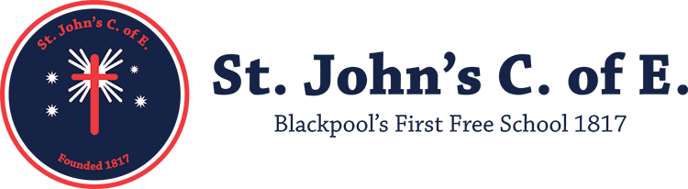
In PSED, I will continue to develop my own personal, social and emotional development. I will be confident to try new activities and speak in a familiar group. I will talk about my ideas, and choose my own resources I need for an activity. I can say when I do or don’t need help.
I will talk about how I feel and how others show feelings. I will talk about my own behaviour and that of others and its consequences. I will know some behaviour is unacceptable. I will be able to work as part of a group or class and follow the rules. I will adjust my behaviour to different situations, and take changes to routine in my stride.
I will play cooperatively and take turns. I will listen to and take account of the ideas of others. I will show sensitivity to the needs and feelings of others and form positive relationships with my peers and adults.

As an Artist, Musician and Designer I will sing songs, make music and dance, and experiment with ways of changing them. I will safely explore a variety of materials, tools, techniques and experiment with colour, design, texture, form and function.
I will use what I have learnt about media and materials in my own way, thinking about its uses and purpose. I will represent my own ideas, thoughts and feelings through design and technology, art, music, dance, role-play and stories.

In Physical Development, this year I will show good control and coordination in large and small scale movements. I will develop my pencil control and grip and handle tools and equipment effectively. I will learn to move in a range of ways, safely negotiating space.
I will know the importance for good health on physical exercise, and a healthy diet and talk about ways to keep myself healthy and safe. I will manage my own basic hygiene and personal needs successfully, including dressing and going to the toilet independently.

