Seaside Vocabulary Mat
Lighthouse  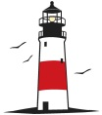  A lighthouse is a tower containing a powerful flashing lamp that is built on the coast or on a small island. | Pier  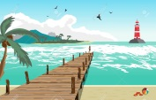  A pier is a platform sticking out into water, usually the sea, which people walk along or use when getting onto or off boats. | Harbour  A harbour is an area of the sea at the coast which is partly enclosed by land or strong walls, so that boats can be left there safely.
Island  An island is a piece of land that is completely surrounded by water. | Tourist  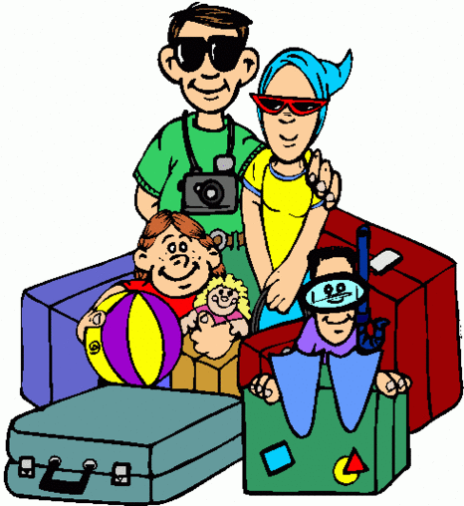  A tourist is a person who is visiting a place for pleasure and interest, especially when they are on holiday. | Marina  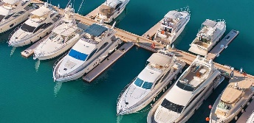  A marina is a small harbour for small boats that are used for leisure.
Fairground  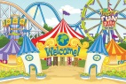  A fairground is an area of land where a fair is held. | 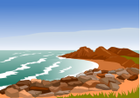  Coast  The coast is an area of land that is next to the sea | Beach  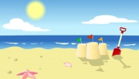  A beach is an area of sand or stones beside the sea.
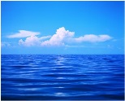  Ocean  An ocean is one of the five very large areas of sea on the Earth's surface. | Sea  The sea is the salty water that covers about three-quarters of the Earth's surface | Cliff  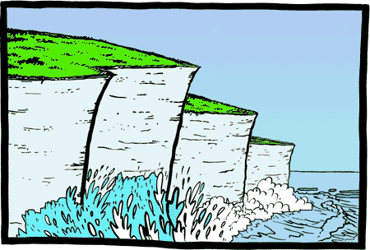  A cliff is a high area of land with a very steep side, especially one next to the sea.

