**English**

**READING**

**Fiction**

The Great Kapok Tree

by Lynne Cherry

**Non-Fiction**

Fact files about indigenous tribes of the Amazon Basin.

**Poetry**

Over in the Jungle: A Rainforest Rhyme

Marianne Berkes

**WRITING**

**Letter Writing**

The animals write a letter to try and dissuade ‘man’ from chopping down their tree.

**Information Writing**

Living in the Amazon Basin.

**Poetry**

Creating images of the rainforest.

**Class 3 – Summer Term 1**

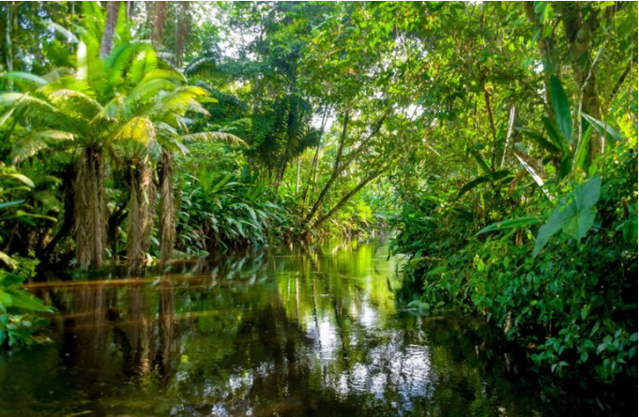

**South America**

Learning Question

**What is life like in the Amazon Rainforest?**

**Geography**

**South America**

To find out where is South America and what is it like

To locate South America on a wide range of maps, atlases and globes

To find out where is the Amazon Basin

To find out where people live in the Amazon Basin

To discover who are the indigenous people of the Amazon Basin

To find out what type of agriculture takes place in the Amazon Basin

To learn about what threats the Amazon Basin is facing.

**Science**

**Plants**

Children will identify and describe the functions of different parts of flowering plants: roots, stem, leaves and flowers.

They will investigate the way in which water is transported within plants.

The children will explore the role of flowers in the life cycle of flowering plants, including pollination, seed formation and seed dispersal.

They will explore the requirements for life and growth and how they vary from plant to plant.

**RE**

**Exploring the Christian rules for living**

The children will have an opportunity to consider the value and purpose of rules.

**Art**

**Drawing and Collage**

Exploring Henri Rousseau’s jungle paintings.