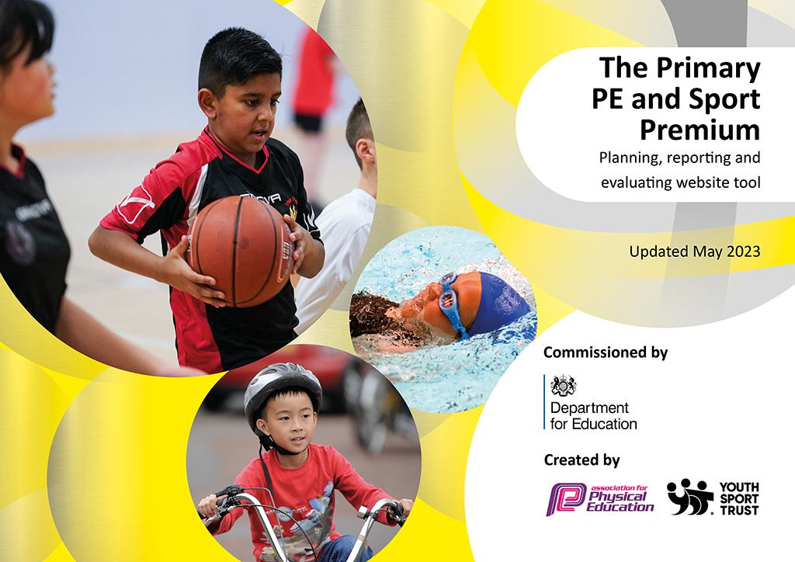
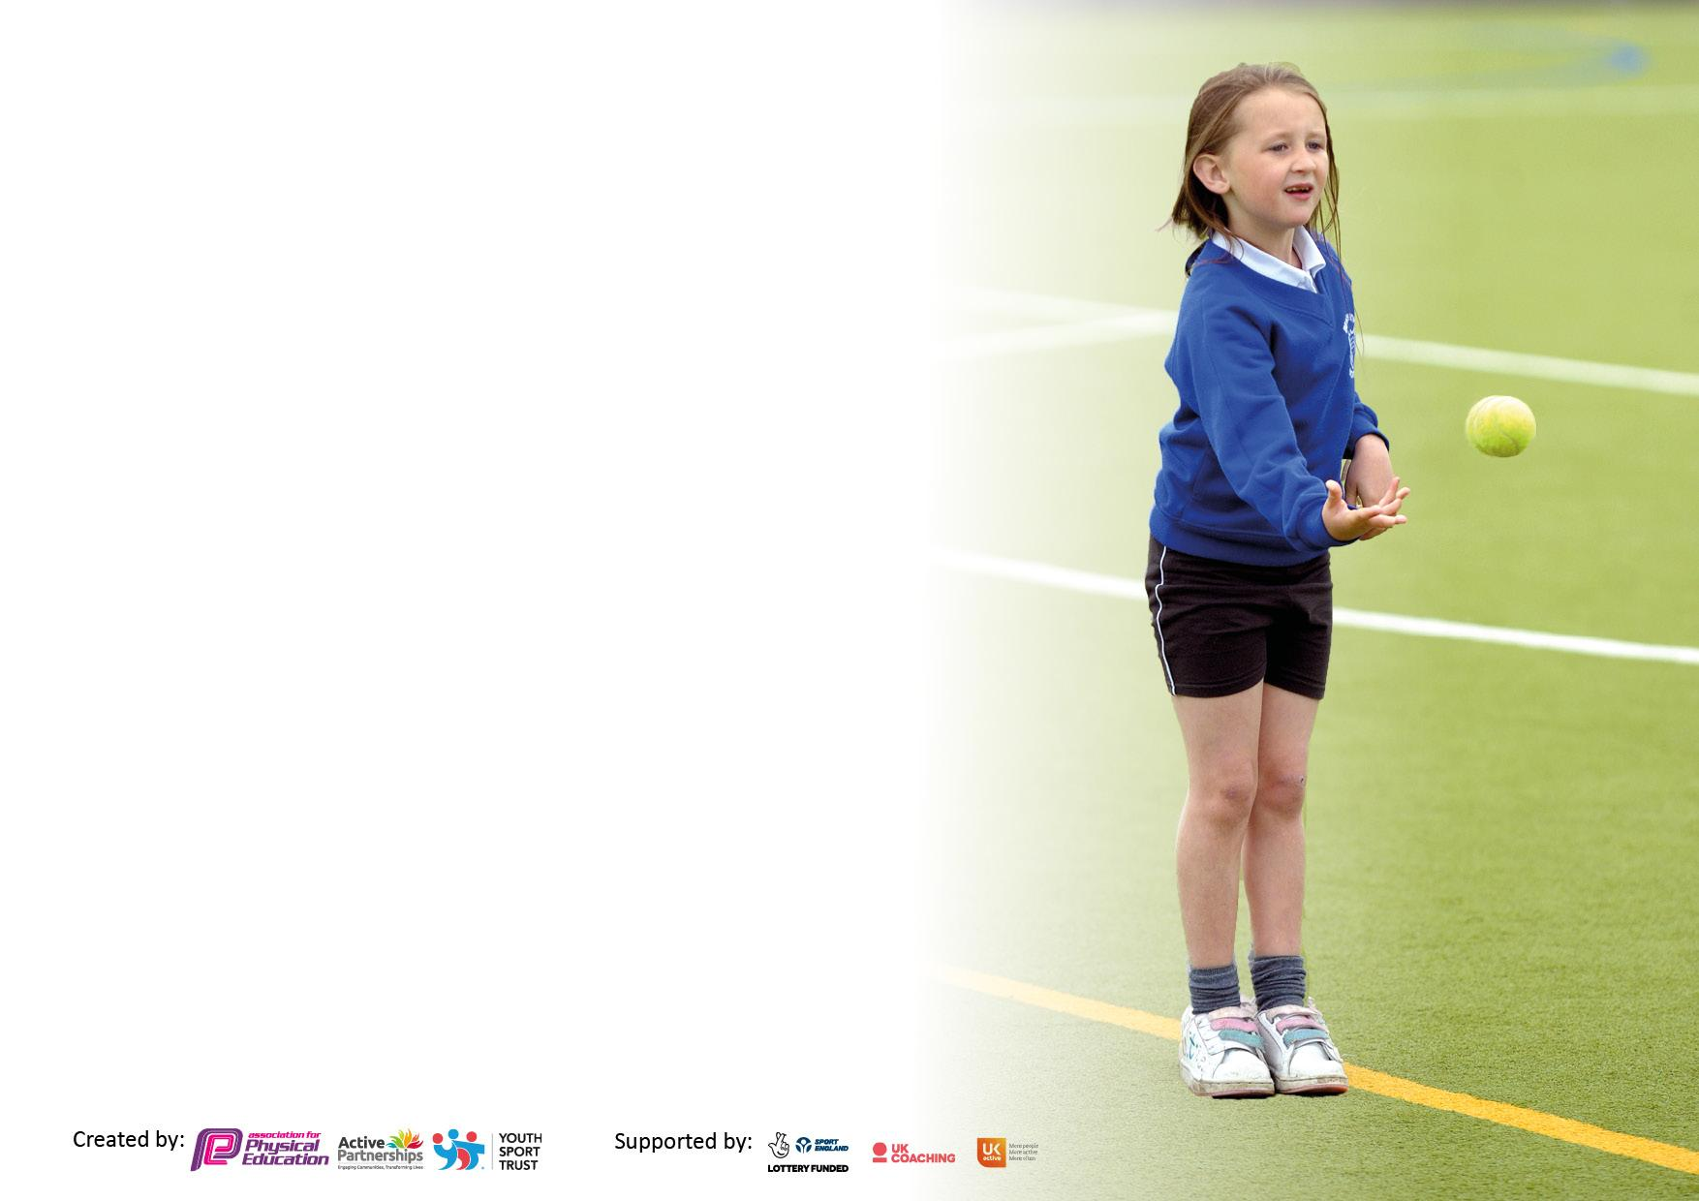

It is important that your grant is used effectively and based on school need. The Education Inspection Framework makes clear there will be a focus on ‘whether leaders and those responsible for governors all understand their respective roles and perform these in a way that enhances the effectiveness of the school’.

Under the Quality of Education judgement, Ofsted inspectors consider:
Intent - Curriculum design, coverage and appropriateness
Implementation - Curriculum delivery, teaching (pedagogy) and assessment
Impact - Attainment and progress

To assist schools with common transferable language, this template has been developed to utilise the same three headings which should make your plans easily transferable between working documents.

Schools must use the funding to make additional and sustainable improvements to the quality of Physical Education, School Sport and Physical Activity (PESSPA) they offer. This means that you should use the Primary PE and sport premium to:

- Develop or add to the PESSPA activities that your school already offers
- Build capacity and capability within the school to ensure that improvements made now will benefit pupils joining the school in future years
- The Primary PE and sport premium should not be used to fund capital spend projects; the school’s budget should fund these.

Please visit https://www.gov.uk/guidance/pe-and-sport-premium-for-primary-schools for the revised DfE guidance, including the 5 key indicators across which schools should demonstrate an improvement. This document will help you to review your provision and to report your spend. DfE encourages schools to use this template as an effective way of meeting the reporting requirements of the Primary PE and Sport Premium.

We recommend you start by reflecting on the impact of current provision and reviewing the previous spend.

Schools are required to publish details of how they spend this funding, including any underspend from 2021/2022, as well as on the impact it has on pupils’ PE and sport participation and attainment.

We recommend regularly updating the table and publishing it on your website throughout the year. This evidences your ongoing self-evaluation of how you are using the funding to secure maximum, sustainable impact. Final copy must be posted on your website by the end of the academic year and no later than the 31 July 2023.
Details with regard to funding
Please complete the table below.

Total amount carried over from 2021/22 | £0
Total amount allocated for 2022/23 | £17 780
How much (if any) do you intend to carry over from this total fund into 2023/24? | £0
Total amount allocated for 2022/23 | £17780
Total amount of funding for 2022/23 to be reported on by 31st July 2023 | £ 17780
Swimming Data
Please report on your Swimming Data below.

Meeting national curriculum requirements for swimming and water safety.

N.B. Complete this section as best you can. For example, you might have practised safe self-rescue techniques on dry land which you can then transfer to the pool when school swimming restarts.
Due to exceptional circumstances priority should be given to ensuring that pupils can perform safe self-rescue even if they do not fully meet the first two requirements of the NC programme of study
What percentage of your current Year 6 cohort swim competently, confidently and proficiently over a distance of at least 25 metres?  N.B. Even though your pupils may swim in another year, please report on their attainment on leaving primary school at the end of the summer term 2023.  Please see note above. | 65%
What percentage of your current Year 6 cohort use a range of strokes effectively [for example, front crawl, backstroke and breaststroke]?  Please see note above. | 74%
What percentage of your current Year 6 cohort perform safe self-rescue in different water-based situations? | 39%
Schools can choose to use the Primary PE and sport premium to provide additional provision for swimming, but this must be for activity over and above the national curriculum requirements. Have you used it in this way? | Yes

Action Plan and Budget Tracking
Capture your intended annual spend against the 5 key indicators. Clarify the success criteria and evidence of impact that you intend to measure to evaluate for pupils today and for the future.

Academic Year: 2022/23 | Total fund allocated: | Date Updated:
Key indicator 1: Increase confidence, knowledge and skills of all staff in teaching PE and sport |  |  |  | Percentage of total allocation:
 |  |  |  | 16.3%
Intent | Implementation |  | Impact
Your school focus should be clear on what you want the pupils to know and be able to do. What do they need to learn and to consolidate through practice: | Make sure your actions to achieve are linked to your intentions: | Funding allocated: | Evidence of impact:  What do pupils now know and what can they now do? What has changed? | Sustainability and suggested next steps:
Staff are equipped to deliver high quality PE lessons and understand the importance of ensuring they maximise opportunities to engage every child in being active.  Introduction of a new scheme of work (Primary PE Passport) to support staff in the planning and delivery of PE. Staff focus on the two areas outlined below:  - Within PE lessons the children learn new skills and develop existing skills. They are given opportunities to apply these skills in different contexts (competition, performance, new challenges).  - Lessons and series of lessons have defined phases to allow children to learn skills, practice the skills and apply the skills. | Staff training led by PE Lead and specialist coaches. Opportunities to team teach to develop teachers’ skill base and confidence.  PE Lead undertook training for the new scheme of work (Primary PE Passport), liaison with the provider to implement the scheme. Training on the new scheme of work led by PE Lead.  PE Lead undertaken CPD during the year led by Lancashire PE consultant.  Staff Training:  - Provided by Blackpool Sports Team accessed by staff e.g. girls football, tennis.  - School took part in a Balance Bikes pilot project. Staff undertook training to enable them to deliver sessions.  - Shooting Stars resources and online training accessed by staff to support an extra-curricular football club for girls.  - Training for whole class football sessions delivered in the curriculum. Staff supported by PE Lead, PE Passport resources and Shooting Stars activities.  - Cyber coach – support dance curriculum, the emphasis is to use the resources to supplement lessons and not to replace teacher input. | Total = £2897  Training  £400  PE Passport  £699  Specialist Coaches  £1599  Cyber Coach  £199 | New scheme of work has supported staff in their delivery of high-quality PE. The scheme has enabled staff to use the bank of resources to enhance their lessons and to support their planning.  The overview for the year has enabled staff and the PE Lead to ensure that a full range of skills and activities is covered during the year.  Teachers have been able to team teach with specialist coaches to develop their skills. Specialist coaches have planned with teachers and supported all areas of PE. This has developed teachers’ confidence and their skills to deliver a range of activities.  PE Lead has accessed training in order to have a greater knowledge of how to deliver high quality PE across the school and how to use PE Passport to facilitate the implementation of scheme of work. | Further develop staff competence of monitoring and assessment of PE through the use of PE Passport. PE staff meetings to support implementation.  PE Lead to support the delivery of two hours of physical activity each week for all classes. Staff meeting time at the start of the new academic year.  PE staff audit to identify strengths and areas for staff development. Liaison with Blackpool Sports Team and LPDS (Lancashire Professional Development Services) in relation to training courses available.  Identify new opportunities to broaden the range of activities available to children and facilitate staff training to support this.
Key indicator 2: The engagement of all pupils in regular physical activity – Chief Medical Officers’ guidelines recommend that  primary school pupils undertake at least 30 minutes of physical activity a day in school |  |  |  | Percentage of total allocation:
 |  |  |  | 22.5%
Intent | Implementation |  | Impact
Your school focus should be clear on what you want the pupils to know and be able to do. What do they need to learn and to consolidate through practice: | Make sure your actions to achieve are linked to your intentions: | Funding allocated: | Evidence of impact:  What do pupils now know and what can they now do? What has changed? | Sustainability and suggested next steps:
The children are offered a range of physical opportunities during playtimes, lunchtimes and at after school clubs.  The curriculum will be skills based enabling the children to learn and develop a range of skills and have the ability to apply these in different activities.  Provide a wide range of activities that will ensure all children can engage in activities that challenge and engage them and that they enjoy. | Blackpool Sports Team provides a coach to provide activities each lunchtime. Through working with the Sports Team, we can access a range of other offers e.g.  - Active Mile has been used on an ad hoc basis to add additional physical activity times over and above curriculum PE.  - WOW (Walk to School) promoted and rewarded in school, the school has worked closely with Living Streets – Blackpool.  Playground resources e.g. a new basketball hoop, football goals, various other equipment.  Each week there are eight different breakfast / after school clubs available to the children. Activities are rotated during the year and are offered to all year groups.  Dance clubs also ran after school, one club ran to rehearse for Schools Alive and another focused on Street Dance which was led by a specialist instructor. | Total = £3993  Resources  £600  Specialist Coaches  £1760  Active Lunchtimes  £1633 | The children now have a wider range of opportunities to engage in.  The children have been involved in deciding the activities they would like to participate in at breakfast clubs.  Due to the fact the children are experiencing a range of sports we have seen that they are more able to apply their skills to different activities or be more confident to take on new challenges.  Rather than having a fixed list of children who can attend a club we have trialed allowing children to turn up at a club on an ad hoc basis (with the necessary parental permissions). This has been successful and has seen numbers increase at these clubs. | Further develop the children’s choice of extra-curricular clubs that are on offer to them in order to develop take up.  Re-introduce Sports Leaders to allow them to have an input into active break and lunchtime activities.  Audit equipment and other resources available to the children.  Embed the Active Mile into the timetable so that this is a regular activity for all classes.

Key indicator 3: The profile of PE and sport is raised across the school as a tool for whole school improvement |  |  |  | Percentage of total allocation:
 |  |  |  | 29%
Intent | Implementation |  | Impact
Your school focus should be clear on what you want the pupils to know and be able to do. What do they need to learn and to consolidate through practice: | Make sure your actions to achieve are linked to your intentions: | Funding allocated: | Evidence of impact:  What do pupils now know and what can they now do? What has  changed? | Sustainability and suggested next steps:
PE and being active plays a key part in day to day life within school.  Children understand the importance of leading an active life and participating in physical activity is a crucial part of a healthy lifestyle.  PE and Sport activities are celebrated across the school e.g. on the school website, Facebook page and during assemblies.  Swimming is promoted not only as a physical activity but also as a life skill.  Links are made to local clubs in order to signpost the children to opportunities outside of school. | Classes have participated in a range of programmes that have physical activity at their heart but also promote other key aspects e.g. healthy diet, team work, healthy choices e.g. Fit2Go, Sport 4 Champions, Rugby & Reading, Team Building Day. These programmes have not only had sessions based in school but also inter-school festivals to reinforce the aims of the programme. These have all elevated the profile of PE as they have been run by high profile organisations e.g. Blackpool FC Community Trust, Fylde Rugby Club.  Engage in inter-school events (competitive and festivals) which then give us the opportunity to celebrate participation within school and on our website/social media and raise the profile of PE/Sport.  The school website is used to promote all aspects of PE/Sport to celebrate achievements and showcase the range of activities that the children engage in.  House Captains collect points earnt by the children on a weekly basis and announce the house points in celebration assembly each week.  The school engaged in an Inclusion Programme which brings in a specialist coach one day a week to work alongside teachers leading PE lessons with the aim to support and engage children with special educational needs those who may not readily engage in PE/Sport.  Develop links to teams, organisations, opportunities outside of school – cricket, rugby, swimming, football, holiday clubs.  Additional swimming instructors bought in to support curriculum swimming. Being a town centre, coastal school in an area of high deprivation many of our children have had little or no experience of swimming when they start their swimming lessons. We place a high priority on ensuring the children learn to swim as we view swimming as a life skill because of all the physical benefits it offers as well as the vital lessons it provides around water safety, particularly as we live on the coast. The children will swim for one academic year and their lessons will be one hour. | Total = £5141  Swimming  £1750  Specialist Coaches  £1758  Active Lunchtimes  £1633 | PE is seen as a central part of school life that offers the children a range of challenges, the benefits of having an active lifestyle, the chance to try out new activities and opportunities to compete and enjoy PE and Sport.  Children make clear links between being active, having a healthy diet with living a healthy lifestyle.  Children make good progress in swimming and are aware of how to be safe around water.  A broad range of opportunities allows all children to participate, be challenged and to be successful. Achievements are celebrated to ensure PE has a high profile in school and continually engages the children. | Develop the role of Sports Leaders to further raise the profile of PE and to allow the pupils to have a voice into all aspects of PE within school.  Further develop a wide range of opportunities to ensure that all children can engage in a range of activities.  Introduce a dedicated PE and Sports display board to celebrate participation and achievements.  Develop the Inclusion Programme to focus on those children with special educational needs and those children who may need to support in specific areas e.g. gross and fine motor skills.
Key indicator 4: Broader experience of a range of sports and physical activities offered to all pupils |  |  |  | Percentage of total allocation:
 |  |  |  | 22.4%
Intent | Implementation |  | Impact
Your school focus should be clear on what you want the pupils to know and be able to do. What do they need to learn and to consolidate through practice: | Make sure your actions to achieve are linked to your intentions: | Funding allocated: | Evidence of impact:  What do pupils now know and what can they now do? What has  changed? | Sustainability and suggested next steps:
A broad range of activities are offered to the children to engage them all levels.  Specialist coaches are used to deliver a broad cross-section of activities.  Extra-curricular clubs are run to allow all children to participate in activities over and above curriculum provision.  Active lunchtimes are led by coaches from the Blackpool Sports Team to offer different activities.  A wide range of resources are available to the children for break and lunchtimes.  Specialist PE Teaching Assistant to deliver and support a range of curricular and extra-curricular activities. | Specialist coaches brought in to deliver a range of sports:  - Rugby – Fylde Rugby Club  - Cricket – Lancashire Cricket Club  - Yoga – Yogi Group  - Specialist Coach – archery, badminton, dodgeball, football  - Specialist PE Teaching Assistant – tennis, netball, football  - Blackpool Sports Team – dance, creative movement, team building activities.  - Forest School Teacher – Classes 2 to 4 each have a six-week programme.  - Dance instructor – street dance  - WOW – living streets, high profile  - Balance Bikes – Blackpool sports team, pilot (training for staff)  - Active Mile – Active Blackpool Team  - Girls Football Club – Shooting Stars  - Year 6 Residential – emphasis on physical activity in a contrasting location i.e. the countryside. Activities include sea traversing, hiking, canoeing, climbing. | Total = £3991  Resources  £600  Specialist Coaches  £1758  Active Lunchtimes  £1633 | Children have been able to access a range of activities that appeal to them e.g. team sports, individual sports, competitive, non-competitive.  Children have been willing to try different activities and evaluate them as to whether they enjoy a particular activity and whether or not they would like to further engage with this.  During playtimes and lunchtimes structured activities led by coaches are offered to the children to enable them to be active. | Further develop the Active Mile to embed this into timetables to ensure regular participation.  Children have a greater say in activities on offer to them during active lunchtimes, house captains to meet with lunchtime coaches.  Continue to trial extra-curricular clubs that children can turn up and try the activity rather than committing to a block of sessions.  Further develop the current relationships we have with external organisations.  Further develop Change 4 Life opportunities, link with Blackpool Sports Team.

Key indicator 5: Increased participation in competitive sport |  |  |  | Percentage of total allocation:
 |  |  |  | 9.8%
Intent | Implementation |  | Impact
Your school focus should be clear on what you want the pupils to know and be able to do. What do they need to learn and to consolidate through practice: | Make sure your actions to achieve are linked to your intentions: | Funding allocated: | Evidence of impact:  What do pupils now know and what can they now do? What has  changed? | Sustainability and suggested next steps:
The children have had opportunities to compete on an intra school level and inter school level.  The children have also taken part in festivals with other schools.  Blackpool Youth Games was used to enable those children who had not had the opportunity to represent the school to take part in competitive sport. | PE Premium was used to run clubs to prepare children to enter inter school events.  Specialist Coaches were brought in to run a series of lessons which then led into a festival to children to apply their skills in a competitive environment e.g. rugby, football.  Youth Games – used to enable children who have not represented the school to participate and compete against other schools. Children identified from club registers. This was also used as a reward for regular attendance and endeavor.  Competitive opportunities aimed at a broad range of children e.g. in Football – KS1 Glow in the Dark Football, Classes 3&4 mixed football entered the Jimmy Armfield Festival, Classes 5&6 competitive events ran by the Blackpool Primary Football Association for both boys and girls teams.  Inter school events – Strictly Come Dancing, Bollywood Dance, Creative Movement, Team Building Day.  Intra sports opportunities – the children are split into houses which they compete in, events have included: athletics, football, gymnastics. | Total = £1758  Specialist coaches  £1718  Primary football entry  £40 | Children practice and develop skills that they can apply in competitive situations.  Children develop confidence to be able to compete with other schools.  They learn to develop resilience from the competitive situations they are in e.g. learn how they can improve their performances, learn how to react to winning/losing.  Children are given the opportunity to discuss their performances to help them to identify their strengths and areas to improve.  Specialist coaches help the children to learn more technical skills and develop a more in-depth knowledge of specific sports.  Children practice skills and then compete against one another at Sports Day in their Houses. | Further develop intra-school opportunities, extend the use of Houses within competitions.  Expand the number of festivals the school enters to allow more children to represent the school.  Engage more children in the Blackpool Youth Games.

Signed off by
Head Teacher: | Nadine Galloway
Date: | 25/07/2023
Subject Leader: | Michael Corser
Date: | 20/7/2023
Governor: | Hayley Aris I Aris
Date: | 10/09/2023

