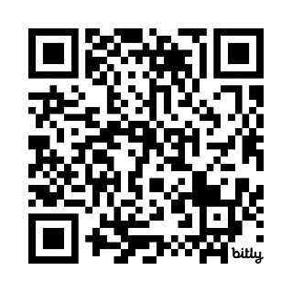

**Stick Man Workshop**

**for Reception, Year 1 and Year 2 Families**



•**Find out more about how your child learns**

• **Learn how to support your child’s development**

• **Children join in the second part of the session**

• **Take part in fun activities with your child**

**based on Stick Man by Julia Donaldson**



**\*\*Due to health and safety we are unable to accommodate younger siblings in the session \*\***

**Due to health and safety we are unable to accommodate younger siblings in the session**