The World
- Show curiosity and ask questions
- Continue to develop an awareness of the changing seasons
- Find out about and identify features of living things
- Look closely at similarities and differences, pattern and change
Maths
- Counting to 10 and beyond
- Subitising using 5 and 10 frames and Numicon
- Begin to understand place value
- Recognising numbers 1-20
- Use the language part and whole
- Practical activities to support addition and subtraction
- Use own methods to work through a problem
- To explain to others their mathematical thinking and reasoning

Communication, Language, Reading and Writing
- To develop a widening vocabulary using talk and books as a stimulus
- Use talk to connect ideas and explain what is happening
- Read and understand simple sentences
- Continue to learn the names of the letters of the alphabet
- To think of, say and hold a sentence in memory for writing.
- Use phonic knowledge to write simple regular words and captions
- To be able to reread their writing to themselves and others
- Match sound to letter in writing
- To begin to write the high frequency words for their phonic phase
- To make phonetically plausible attempts when writing more complex words

Creative Activities
- Work creatively on a small and large scale
- Capture experiences using a variety of media
- Begin to move rhythmically in response to movement
- Talk about personal intentions describing what they are trying to do
- Engage in role play based on own first hand experiences

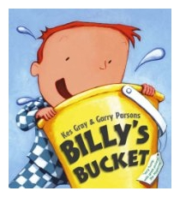
SUMMER 2
Foundation Stage Stage

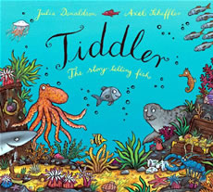
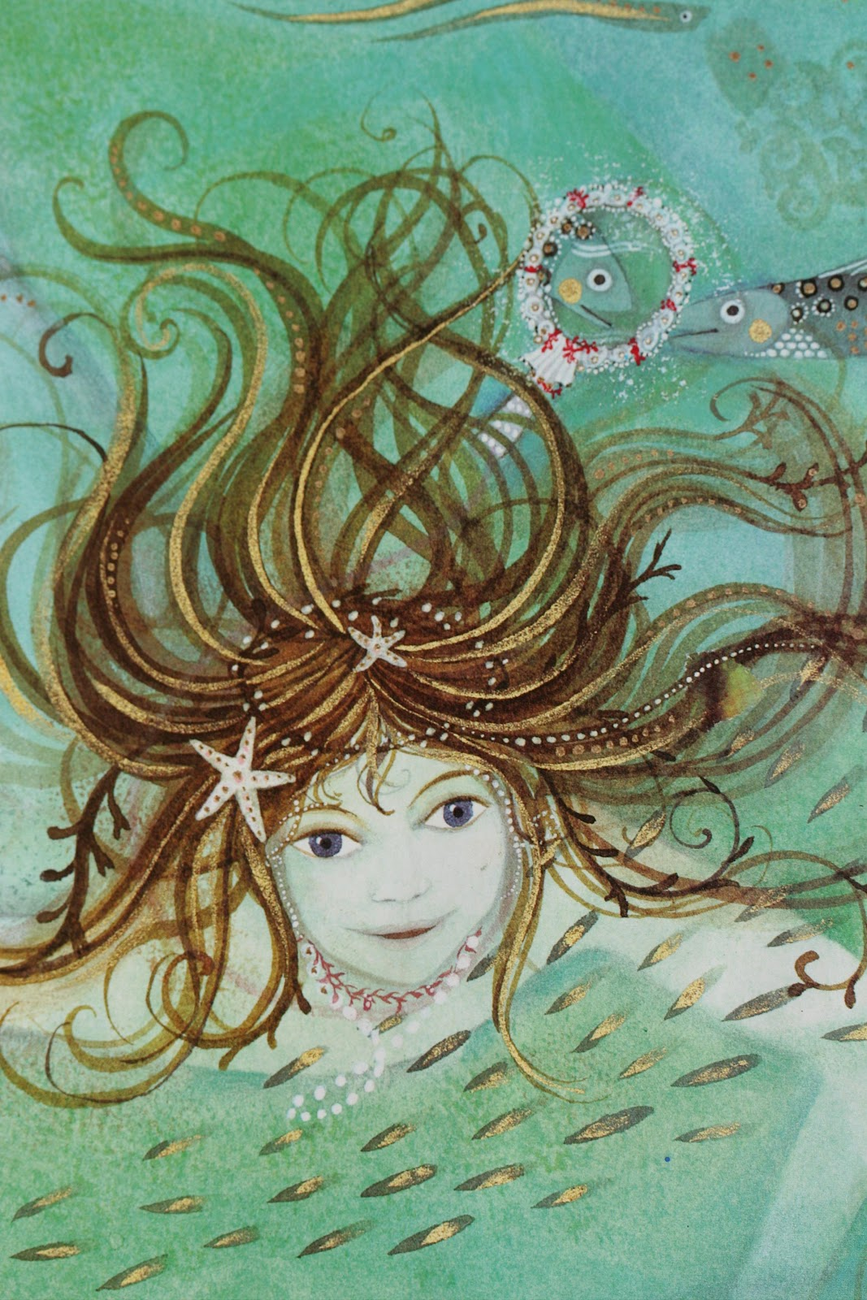

Books we will be sharing together to help us with our learning.
- Tiddler
- Billy’s Bucket
- The Tiniest Mermaid
- Can you Catch a Mermaid?
- Shark in the Park
- Traditional Tale – The Three Billy Goats Gruff

Physical Development
- Move confidently in a range of ways
- Use good control and coordination in large and small movements
- Show some understanding of how to be safe in the sun
- To form letters using the correct formation and orientation

RE ~ Special Places

- To know that church is a special place
- To know that people have other special places

PSED
- To prepare for the changes ahead ~ going to year 1
- Growing and Changing

We will also be following the children’s interests and exploring the things that are of importance to them

