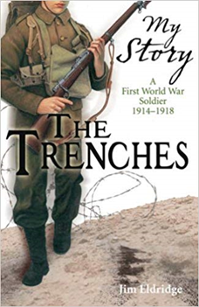

**PSHE**



Transition to High School.

**Science - Evolution and Inheritance**

* To recognise that living things have changed over time and how do fossils provide information.
* To understand that living things produce offspring of the same kind, but normally offspring vary and are not identical to their parents
* To identify how animals and plants are adapted to suit their environment in different ways and that adaptation may lead to evolution.

**English**

**Sustainability and Palm Oil**

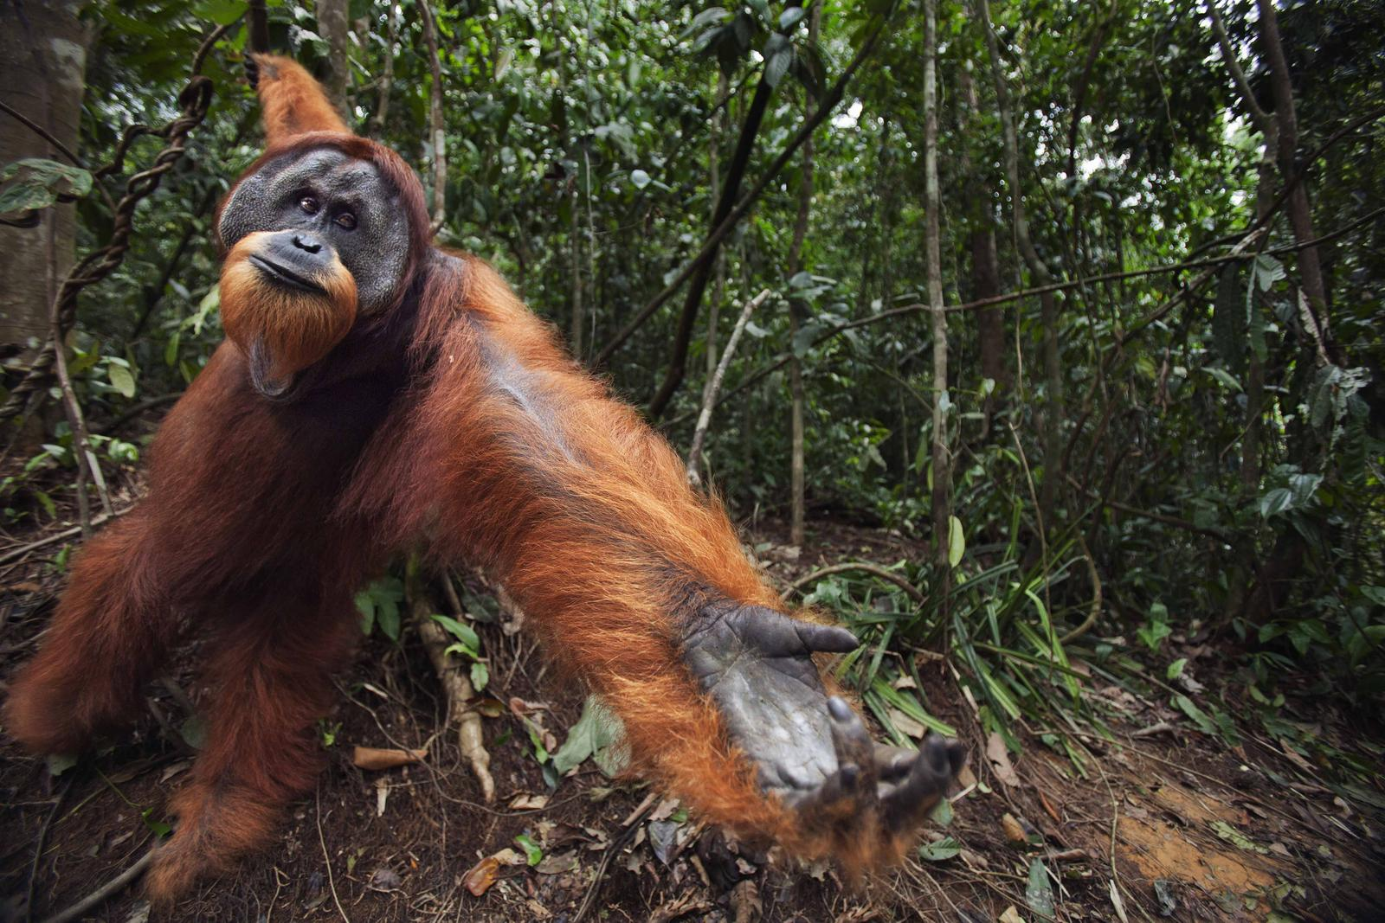

* To create a non-chronological report.
* To write a letter of complaint.

**Kensuke’s Kingdom by Michael Morpurgo.**

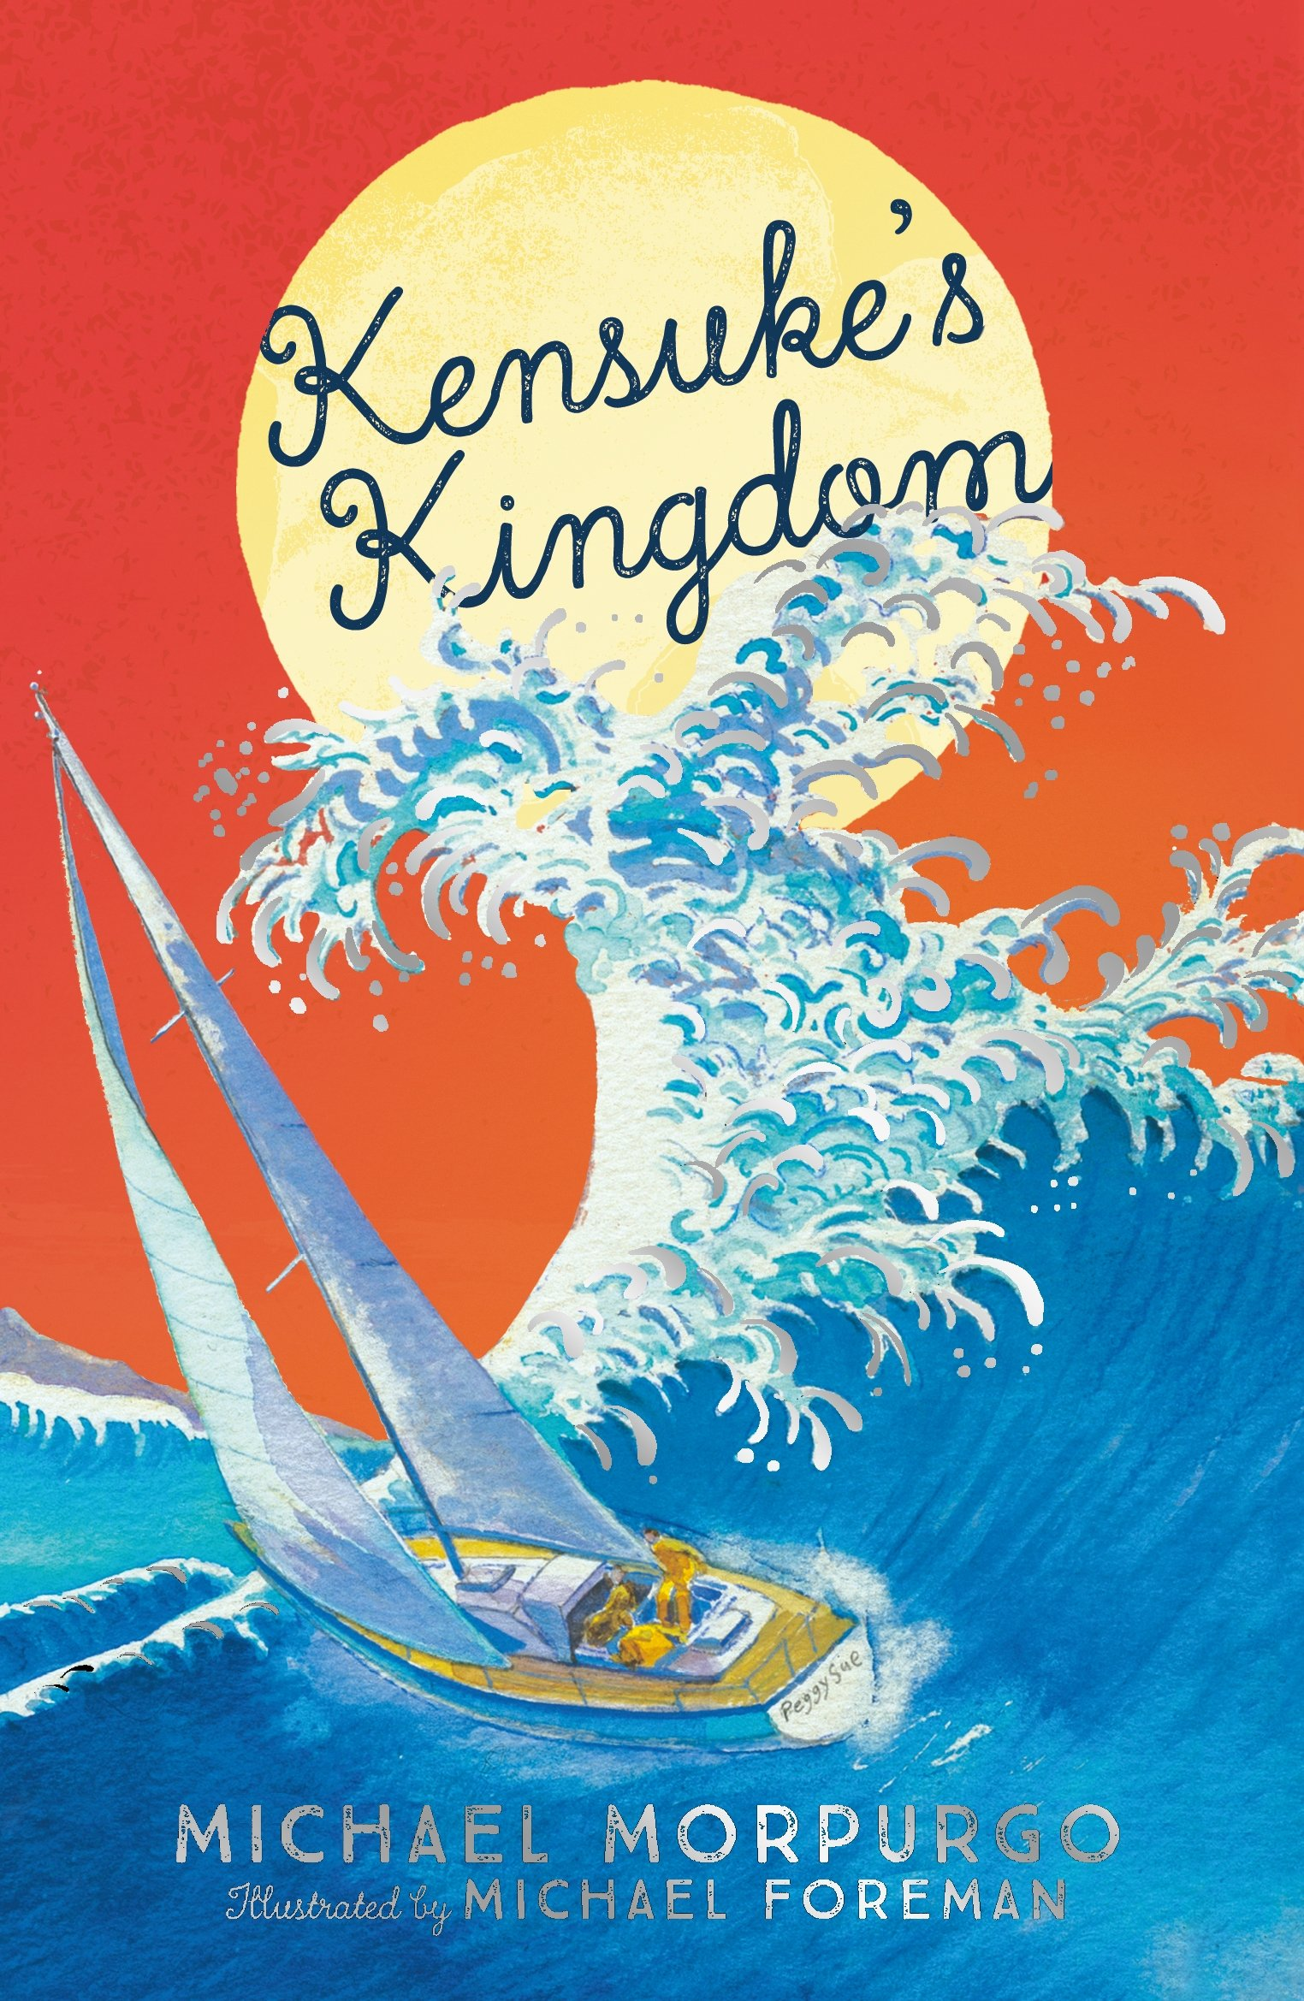

* To write a detailed character description.
* To write in the style of a diary entry.

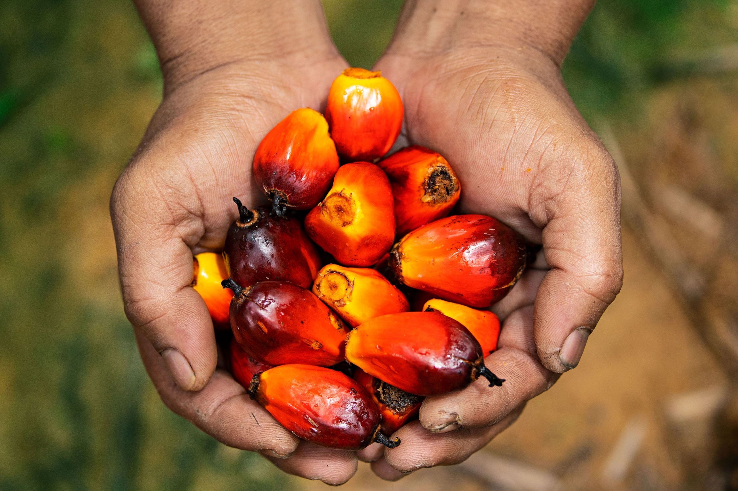

**Sustainability and palm oil**

***Should we be using so much palm oil?***

* What does sustainability mean?
* What is palm oil? Where is it grown? Why is it important?
* What are the economic benefits of palm oil plantations?
* What are the social impacts of palm oil production?
* What are the environmental impacts of palm oil production?
* Is there a better way? Can palm oil be sustainable?

**Visit:**

Stanley Park

Castlehead – Residential stay.

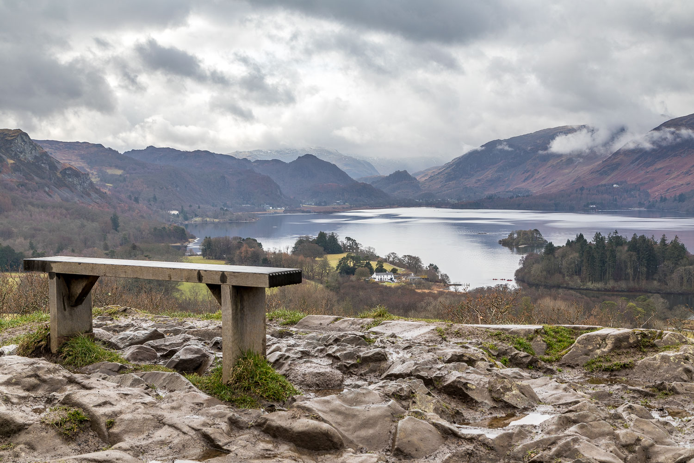

**Class 6 - Summer 2**

A region in the United Kingdom.

*What makes the Lake District attractive for tourists?*

**Geography : Lake District**

* Where is the Lake District and what is it like?
* What is the physical geography of the Lake District like?
* What is the human geography of the Lake District like?
* What impact does tourism have on the Lake District?

