Summer clubs/activities/free events 2022:

Holiday clubs Blackpool Football Club Trust:
- Stars inclusion camp
- Multi activity sports camp
- Football camp
https://www.bfcct.co.uk/programme/holiday-camps/

Book Blackpool FC Football Courses & Soccer School Sessions (officialsoccerschools.co.uk)

Blackpool Sports Centre – Activity Camp:
https://www.fyidirectory.co.uk/directory/sports-and-physical-activity-camp

Ascent school holiday camp:
http://www.ascenttrampolinepark.co.uk/sessions/half-term-holiday-camps/

The Boathouse:
https://www.fyidirectory.co.uk/directory/the-boathouse-youth

The Magic Club (Claremont)
https://www.fyidirectory.co.uk/directory/magic-club-claremont

Bugs 2 Butterflies
At the Seasiders Bar at Blackpool FC on Bloomfield Rd.Club nights give children and young people chance to play, work with crafts, catch up with friends and see visitors we have organised to come in. We want to provide recreational, educational and leisure opportunities to children and young people aged 5 – 16 years, living primarily in the Revoe area of Blackpool.
B2B meets on Monday (6-8pm), Wednesday (5-7pm) and Friday (6-8pm) for
Club Night. We keep prices as low as we can to ensure as many children as possible can attend. Current costs Monday and Wednesday £2 and Friday £1
http://www.bugs2butterflies.org.uk/

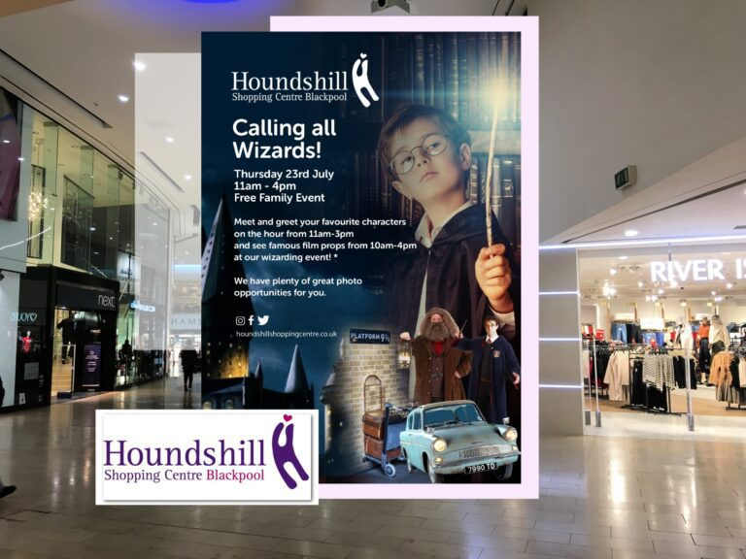
Free events:
Moor park swim sessions (free):
https://www.blackpool.gov.uk/Residents/Sports-and-leisure/swimming/moor-park-holiday-swimming.aspx

Palatine Leisure Centre swim sessions (free):
https://www.blackpool.gov.uk/Residents/Sports-and-leisure/swimming/palatine-holiday-timetable.aspx

Blackpool Air show (free):
Blackpool Air Show will return on the 13 – 14th August with some of the world’s finest military and civilian aircraft performing over the iconic seafront.
Blackpool Air Show | VisitBlackpool | Visit Blackpool

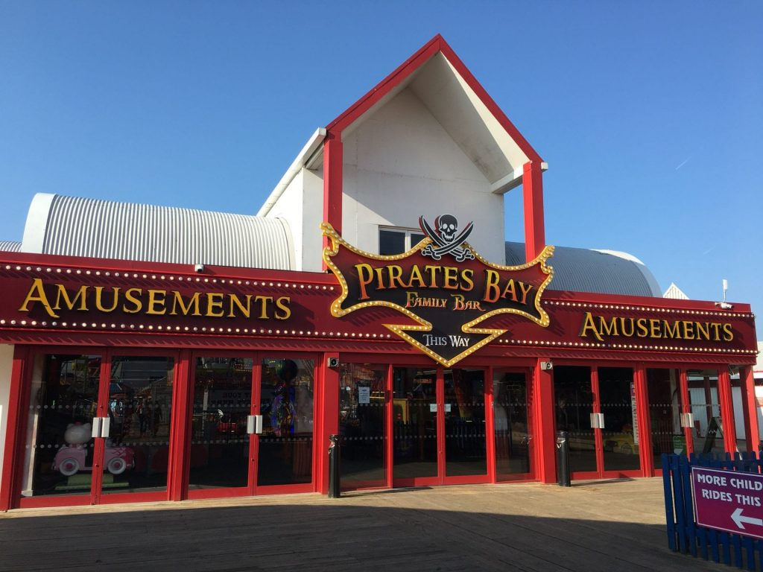
Free Family Entertainment at Pirates Bay on Central Pier:
Every weekend and every day during the school holidays, there’s FREE entertainment here for children!
With its own amusement area, a toy shop and Captain Cook’s food kiosk it’s the perfect place for an afternoon or evenings fun for the whole family. Enjoy magic, games, disco, singing, kids karaoke and a whole lot more, with the Pirate’s Bay entertainment team
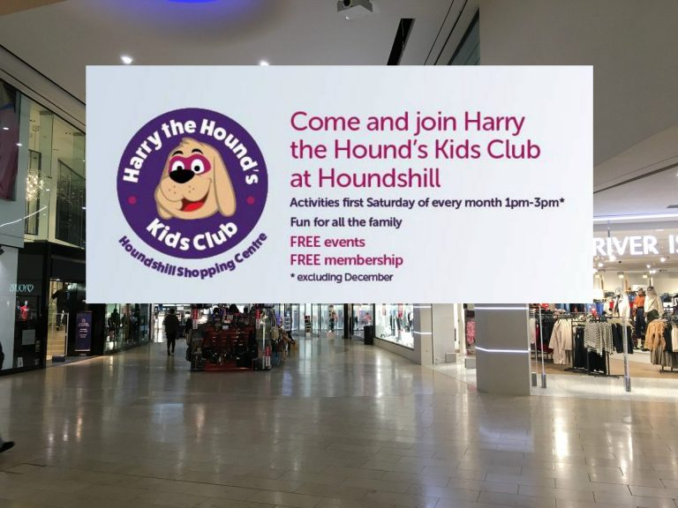
Harry the Hound Kids Club at Houndshill (6th Aug, 3rd Sept, 1st Oct – 1-3pm)
Harry the Hound is the Houndshill Centre mascot. And you’re invited to join him at his club! Make and take different crafts and have a fun time – and it’s FREE! First Saturday of the month from 1-3pm.

Ride the lights:
30th August, the popular Ride the Lights event will also return to Blackpool Promenade.
Enjoy the Lights and promenade from Starr Gate to Bispham – while it’s closed to traffic for one night only. Come along on your push bike or on foot for an evening of fun in the Lights!
Literally tens of thousands of people turn up, dressed in all kinds of trimmings, lights, costumes and fancy dress (or maybe not!) for an evening of great family fun on the sea front.
The Promenade will be closed for the full length of the Illuminations, usually between 6pm and 10pm on the night.
Blackpool light switch on:
Friday 2 September - The concert and Switch-On moment will once again be live streamed to a global audience across MTV and VisitBlackpool channels, and event organisers are also exploring the possibility of streaming the event to an outdoor audience on the Tower Festival Headland

Free activities at the Libraries across Blackpool:
https://www.blackpool.gov.uk/Residents/Libraries-arts-and-heritage/Libraries/Library-events.aspx

Free activities and groups for children aged 0-5:
https://blackpoolbetterstart.org.uk/family-events-blackpool/
Activity timetable for 0-5 years in North, Central and South hubs:
https://blackpoolbetterstart.org.uk/families/

EXPLORE: Showtown’s comedy workshop for young people (Free)
Event times - Saturday 9th July 2022, 1pm - 3pm, FREE, booking necessary, 20 places for ages 11-20.
Grand Theatre Studio, Blackpool, FY1 1HT
To book: https://www.showtownblackpool.co.uk/whats-on/activities/explore-showtowns-comedy-workshop-for-young-people

FUN: Clowning Around - family workshop (£2)
Event times - Saturday 9th July 22, 10am - 11am
Tickets - £2
Winter Gardens - Derham Lounge, Carter Street, Blackpool, FY1 1AA
To book: https://www.showtownblackpool.co.uk/whats-on/activities/fun-clowning-around-family-workshop
SHOW: Jonny Awsum’s Kids Show
Event times - Saturday 9th July 2022, 1pm - 2pm
Tickets - £4
Winter Gardens - Derham Lounge, Carter Street, Blackpool, FY1 1AA
To book: https://www.showtownblackpool.co.uk/whats-on/events/show-jonny-awsums-kids-show

You are stuck inside a live-action video game! How will you escape?!
Event times - Saturday 9th July 2022, 4pm Doors, 4.30pm start (1 hour)
Tickets - £4
Grand Theatre Studio, Blackpool, FY1 1HT
https://www.showtownblackpool.co.uk/whats-on/activities/show-the-dark-room-for-young-people

