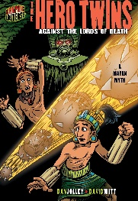 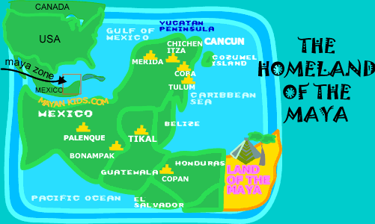

**SCIENCE**

Earth & Space

*Earth, Sun and Moon and their movements.

*Planets

*Phases of the moon and Seasons

*Shadows and how they link with the sun.

*Shadows

**ENGLISH**

**Texts:**

**‘*Rain Player’* by David Wisniewski**

**‘*Hero Twins*’ (Graphic Novel)**

**Non-Fiction**

**‘*History In Infographics: The Maya’* by Jon Richards & Jonathan Vipond**

*Instructions for a game of ‘POK A TOK’

*Writing the next part of the story

*Discussion “What have The Maya ever done for us?”

*Comic Strips, speech and thought bubbles

***CLASS 5***

**HISTORY**

* Who were the Maya? Where and when they lived.
* Finding out how The Mayans lived successfully in the rainforest.
* What daily life was like for a Mayan.
* Mayan food and culture.
* Worshipping the Mayan Gods and human sacrifice.
* Other Mayan achievements and their legacy. Why we remember the Mayans today.
* Compare the Vikings to the Maya-who were the greater people?

***Summer Term 1 2021***

***History Learning Question***

*WHO WERE THE GREATER PEOPLE:*

*the Vikings or the Maya?*

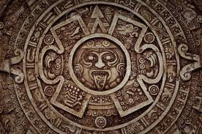

**ART**

**Drawing**

**Digital Media**

*Arne Olav Gurvin Fredriksen*

*Linked to ‘Living things and their habitats’*

**Drawing and Painting**

Planets & The Solar System

