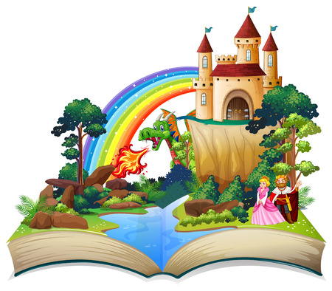

**Twisted Tales course**

**for Year 3 families**

**Free 5 week course**

**starting Thursday 2 March 9.15-11.15**

**at St John’s C of E Primary School**

**Increase your confidence, knowledge and skills**

**Find out more about how to**

**support your child’s learning**

* **Discover ways to support your child’s writing**
* **Find out what your child learns in English at school**
* **Work with your child to plan, write and edit**
* **Use a tablet to record your own twisted tale**
* **Children join the second hour of each session**

**Book your place by filling in the form**

[**bit.ly/FLTT23**](https://bit.ly/FLTT23)



**Adult, Community and Family Learning**