**HISTORY:**

**\*Time-line-When was the Victorian era? How long did it last for?**

**\*What was life like for a poor child in the 1840’s?**

**\*Life for children working in a Victorian factory/mill.**

**\*Daily life for a child being a mill apprentice.**

**\*How Dr Barnardo and Lord Shaftsbury improved the lives of Victorian children.**

**\*School life at the end of the nineteenth century.**

**\*Being a rich child in Victorian times.**

**\*How did life change for children living in Victorian Britain?**

**ENGLISH:**

**-Class Text-‘Street Child’ by Berlie Doherty.**

**-Non-Chronological Report-Victorian Workhouses/Victorian mills**

**-List poem**

**-Historical story- based on Street Child. -**

**SCIENCE:**

**\*Micro-Organisms-illnesses and diseases in the Victorian times.**

**\*Electricity**

**D.T:**

**\*Bread making (linked to science micro-organisms topic)**

**\*Victorian street lights**

**THE VICTORIANS**

**(AUTUMN TERM 1)**

**CLASS 6**

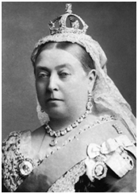

**Learning Question:**

**What was life like for children during the Victorian times?**

**Class Visit:**

*Quarry Bank Mill Victorian Visit*

