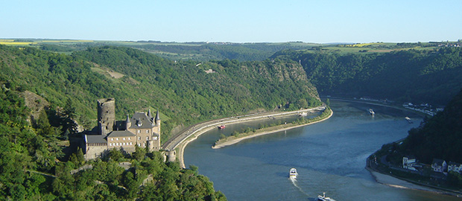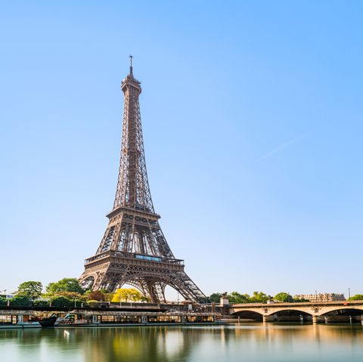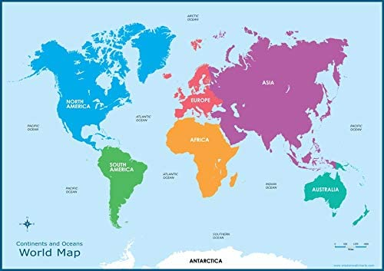 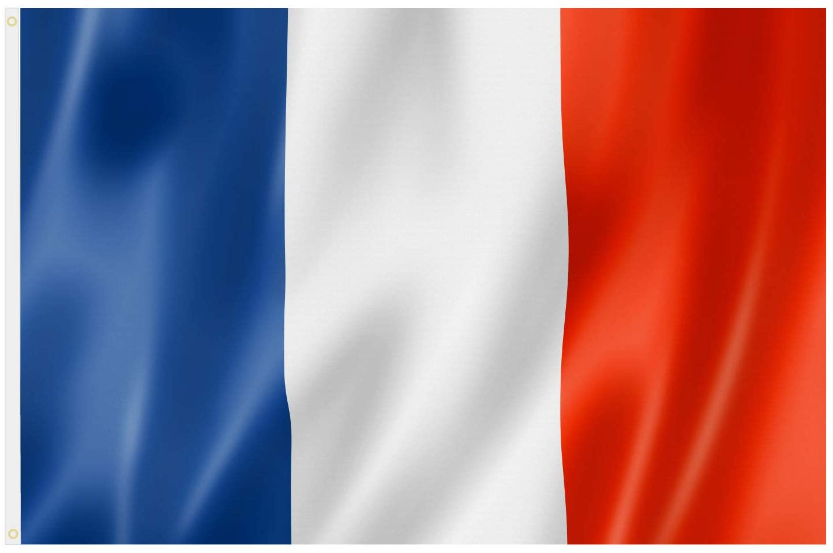

**Key Geographical Terms**

Agriculture

Climate

Coastlines

Equator

European Union

Greenwich meridian

Human features

Latitude

Longitude

Mining

Northern Hemisphere

Physical features

Region

**Key places**

France

Mount Blanc (highest peak)

Paris

Poitou-Charente

River Rhine (longest river)

France

**5 Oceans**

Arctic Ocean

Atlantic Ocean

Indian Ocean

Pacific Ocean

Southern Ocean

**7 Continents**

Africa

Antarctica

Asia

Australia/Oceania

Europe

North America

South America