What impact do the Illuminations have on Blackpool?
Tourism  Tourism is travel for pleasure.  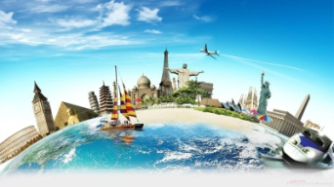 | Tourist  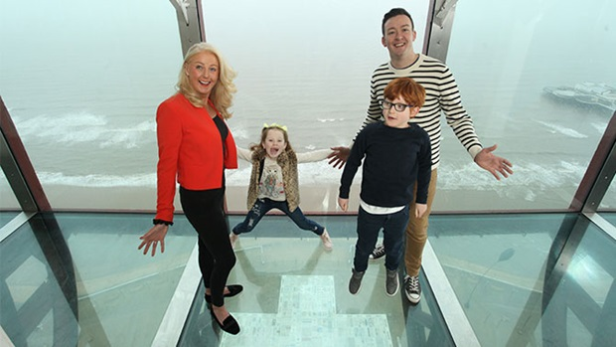  A person who is visiting a place for pleasure. | 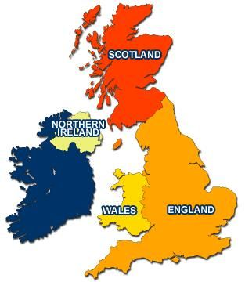  Atlantic Ocean  Irish Sea  Celtic Sea  English Channel  North Sea
Resort  A place that people go to for holidays.  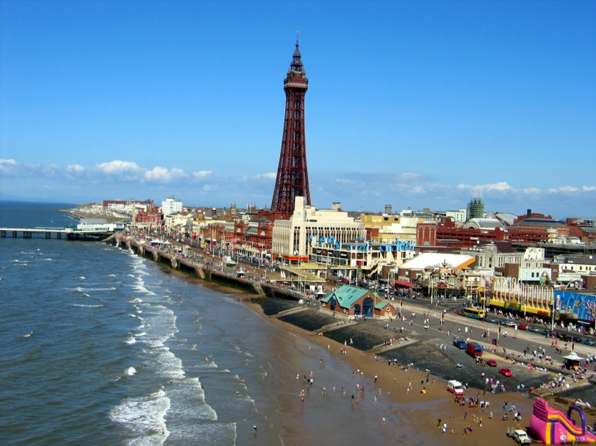 | Attraction  A place of interest where tourists visit.  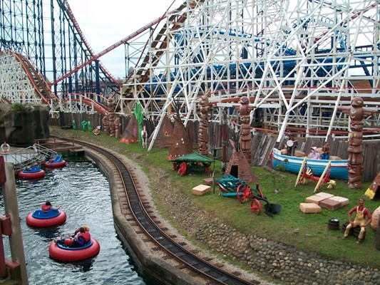
Services  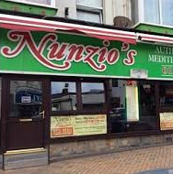  Activities that people and businesses do for others. | Route  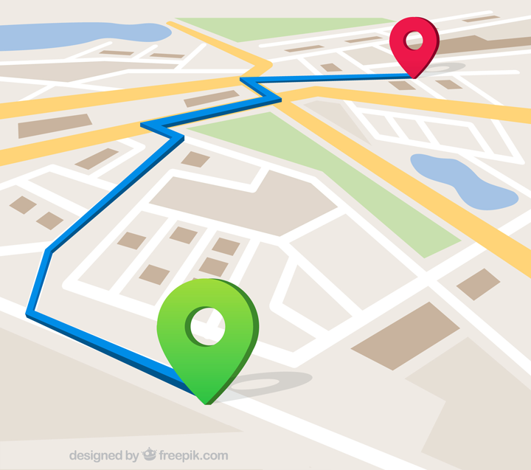  The course taken from a starting point to a destination. | Destination  The place where someone is going.  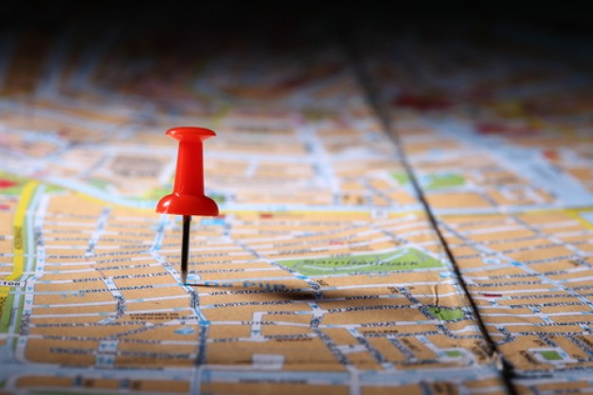 | Population  All the people who live in a particular place.  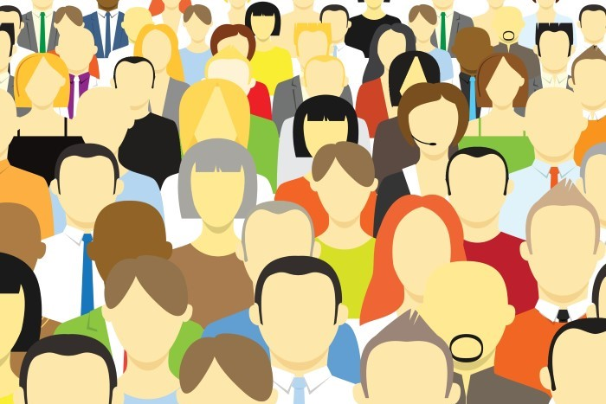
Fieldwork  Collecting information about something in a real environment, not the classroom.  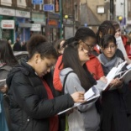 | Economy  How money is made and spent in an area.  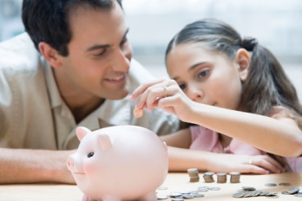 | Regeneration  The process where a place is improved.  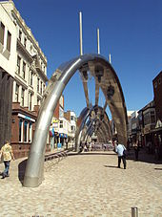 | Council  A body of people elected to manage the affairs of a town.  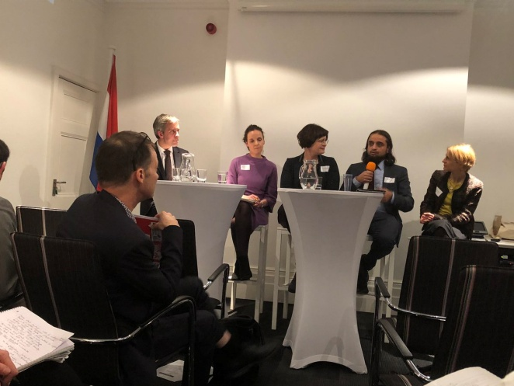
Human features  The changes humans have made e.g. piers, bridges, railways  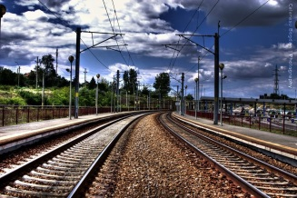 | Physical features  The natural environment e.g. rivers, mountains, oceans  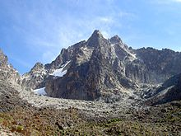 | Grid reference  Tells you the location of a point on a map.  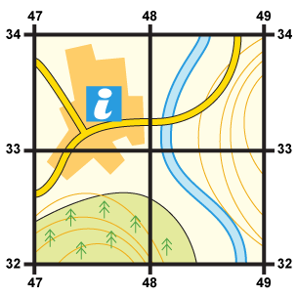 | Ordnance Survey symbols  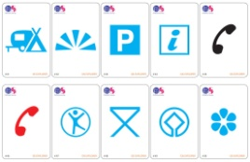  Symbols that label real life features and make maps easier to understand.
