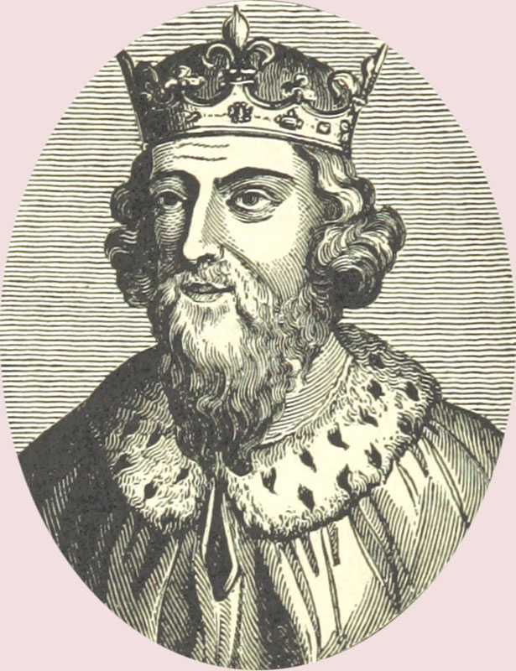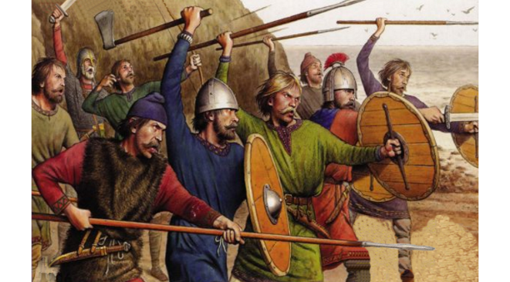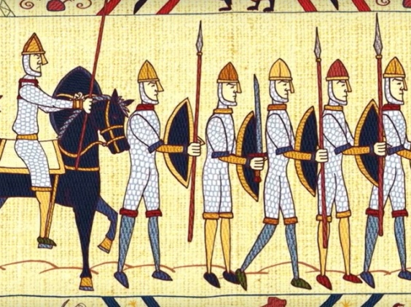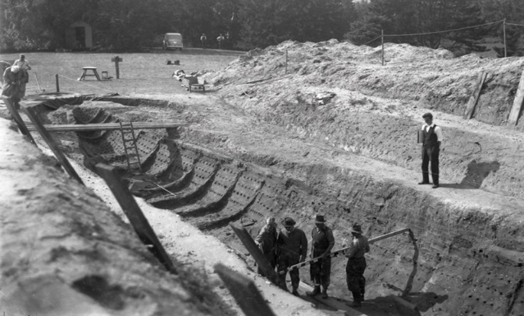

**Key Vocabulary**

Chronology

Primary source

Secondary source

Invasion

Migration

Kingdoms

Tribes

Chieftan

Warriors

Farmers

Monastery

Cathedral

Monk

**Significant People**

Vikings

Picts

Saxons

Jutes

Romans

Saint Columba

Saint Augustine

Saint Aidan

King Ethelbert

Queen Bertha

Alfred the Great

**Significant Places**

Europe

Germany

Scandinavia

Canterbury

Sutton Hoo