Dinosaur Vocabulary Mat
A carnivore is an animal that eats the flesh of other animals.  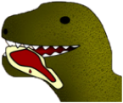 | A herbivore is an animal that only feeds on plants.  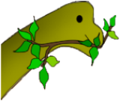 | An omnivore is an animal that feeds on plants and other animals.  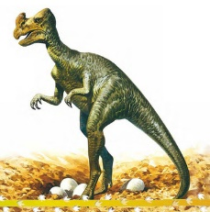
Fossils are the remains or traces of plants and animals that lived long ago.  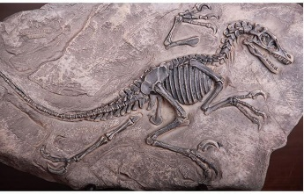 | Bones are the hard tissue that forms the skeleton of a person or animal.  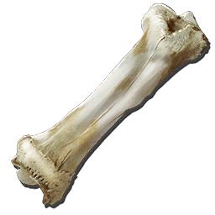 | The skeleton is the structure of bones that supports the body of a person or animal.  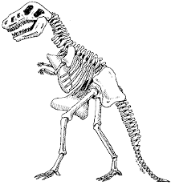
Ancient means very old, or having existed for a long time.  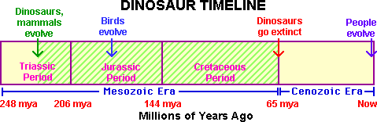 | Camouflage means to hide by colouring or covering to look like the surroundings.  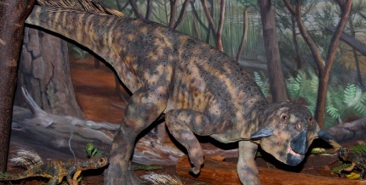 | Extinct means no longer existing.  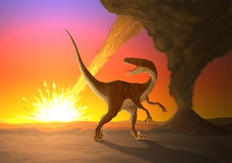
A Palaeontologist is someone who studies the past, with the help of fossils.  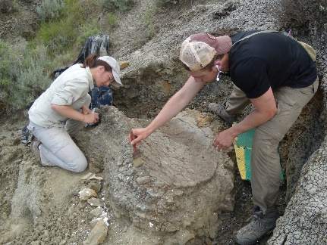 | The word dinosaur means “terrible lizard”, and, like lizards and snakes, dinosaurs were reptiles.  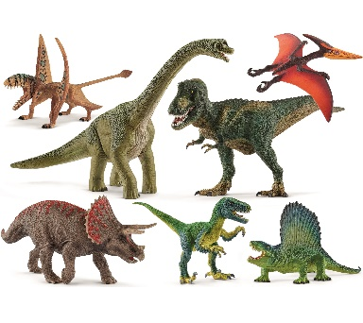 | Reptiles are a group of cold-blooded animals which have skins covered with small hard plates called scales and lay eggs. Snakes, lizards, and crocodiles are reptiles. 