Why was the Classical Age of Ancient Greece so important?
Artefact  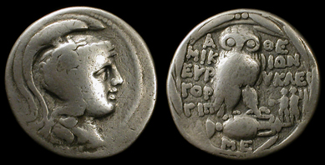  Something made by humans, especially one from the past. | Primary Source  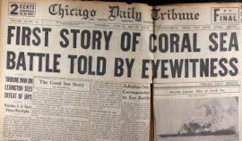  An original artefact that hasn’t been changed in anyway, created during the time period studied | 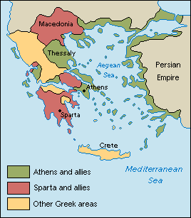
Secondary Source  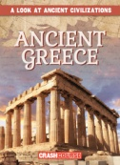  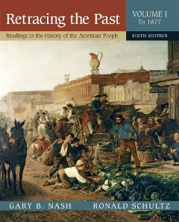  An artefact based on a primary source, created after the time period studied. | Ancient Greece  A civilization belonging to a period of Greek history from 800BC to 31BC.  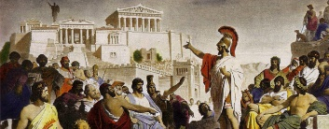
Classical Age  A period of around 200 years in Greek culture from 480BC – 323BC.  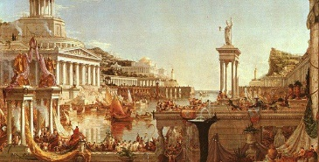 | Chronology  The study of exactly when things happened. When historians put events in chronological order they put them in the order that they happened. | City State  Ancient Greece was made up of many city states. At the centre of each city state was a powerful city. Each city state had its own government. | Sparta  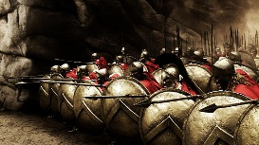  A powerful city state. Citizens considered themselves Spartan first and Greek second.
Athens  A powerful city state. Athens is now the capital city of Greece.  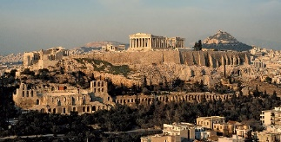 | Hoplite  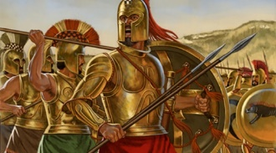  The main Ancient Greek soldier was a foot soldier called a hoplite. | Peloponnesian War  An Ancient Greek war fought between Athens and Sparta.  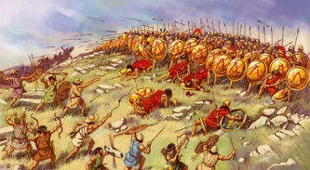  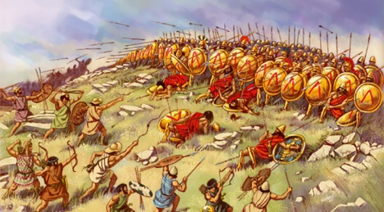 | Battle of Marathon  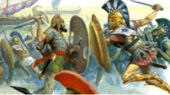  The battle took place in 490BC when the Persians invaded Ancient Greece. The citizens of Athens fought.
Persia  A historical region of SW Asia which is now modern day Iran.  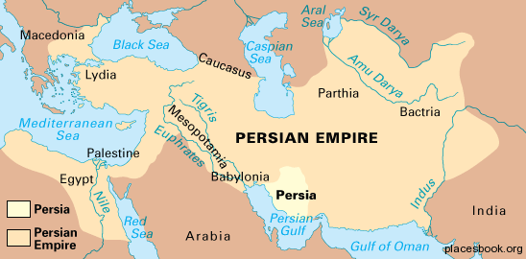  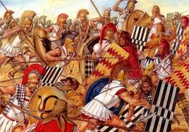 | Culture  Culture is a pattern of behaviour shared by a society. Many different things make up a society's culture e.g. food, language, clothes, music, arts, customs, beliefs, religion. | Philosophy  The word philosophy comes from the Greek language. It means “love of wisdom.”  Philosophy is the study of some of the most basic questions about human life. | Legacy  Something that is passed down from ancestors or someone who came before.
