What impact does plastic have on our oceans?
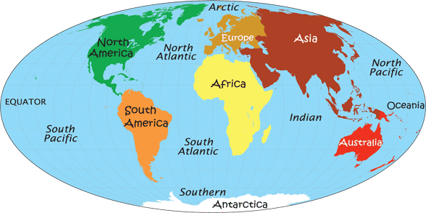
Oceans and Continents

Plastic  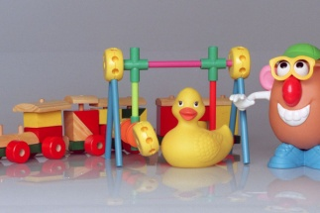  A type of material that is made by people and can be formed into any shape. | Pollution  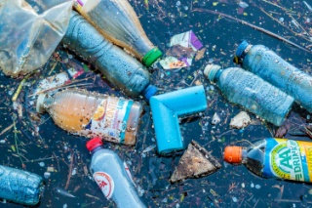  When the environment is contaminated or dirtied by waste, chemicals and other harmful substances. | Landfill  Huge holes in the ground that we fill with rubbish and cover with soil.  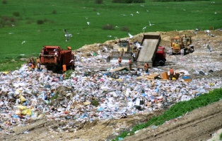 | Gyres  Rotating ocean currents.  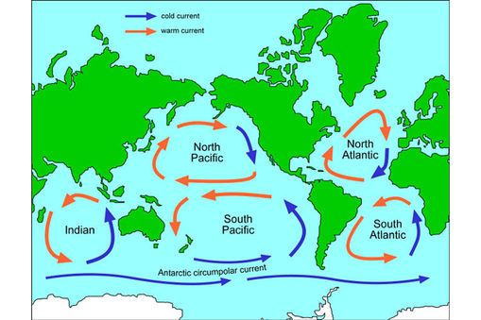
Biodegradable  Is able to break down into very small harmless parts by the action of living things e.g. bacteria.  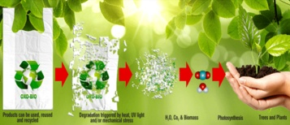 | Bioplastic  Biodegradable plastic that is made from biological materials.  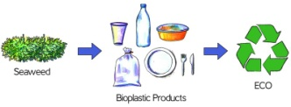 | Microbead  Tiny pieces of plastic that are less than 1mm in size. Found in some cosmetics and toothpastes.  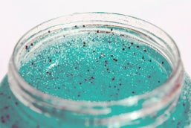 | The 6 Rs  Reduce the amount of plastic you use.  Refuse to buy plastic where you can.  Reuse items that can be used over and over.  Repurpose items and turn them into something new with a long term use.  Redesign designers are responsible for creating products using recyclable material.  Recycle as much as possible.  Recover turn plastic waste into fuel or into new plastic.
Microplastics  Tiny pieces of plastic less than 5mm across. A major cause of ocean pollution.  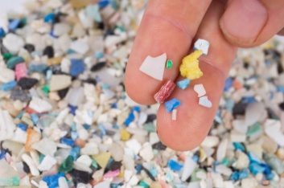 | Single use plastic  Plastic products that are only used once before they are thrown away.  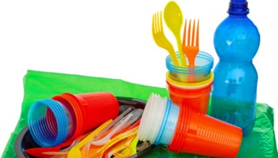 | Henderson Island  A British Island in the South Pacific. It is the most polluted place on earth with 38 million pieces of plastic on its beaches.  