Learning Project - Under the Sea
Weekly Reading Tasks | Weekly Phonics Tasks
Monday- Share the story ‘The Snail and the Whale’. If you don’t have a copy at home watch this online reading. | Monday- Ask your child if they can hear the sounds that come at the beginning of snail and whale. Can they think of/ or find other things that begin with the same sound? They could create a poster, write a list or draw items.
Tuesday- Children to read to parents daily. Visit Phonic Bug for books and games that link to your child’s book band.  If you are unsure of your login details please message on Tapestry and I will send the details. | Tuesday- Buried Treasure: Write out some real words (jam, vet, ham)and made up words (e.g. tud, jup, fub). Place these in a pile and using 2 containers, label one as ‘Treasure’ and the other as ‘Bin’. Can your child read the word and decide if it is real? If it is real it goes in the treasure chest, if not it goes in the bin.
Wednesday- Read a variety of books at home in different places. Favourites can be repeated. Hearing the patterns of language in a story will support your child’s language development. Traditional tales are always great to hear again and again! | Wednesday- Play Buried Treasure online on Phonics Play.  Phase 2 – Mrs Blinkhorn’s and Mrs Johnson’s group  Phase 2 or 3 – Mrs Shearman’s group – Any from phase 2 and Ph3 including ch, sh, th, ng, ai,ee,igh,oa, oo
Thursday- Watch the online storybook- ‘Sharing a Shell’. Discuss how the crab felt in the story at each stage. Your child could draw a picture to represent the crab’s feelings. | Thursday- Sing ‘1,2,3,4,5 Once I caught a fish alive’.  Click here for the words. Can your child learn this by heart?
Friday- Ask your child to look at the books you have in your house. Can they find any other books about creatures that live under the sea? Can they group the animal books or any toy animals they have e.g. farm animals, jungle animals, in the sea animals? Animals with wings, 2 legs 4 legs or no legs. Animals that go on the land, air or water | Friday- Play Fish for Sounds – write out some letter sounds or use your flashcards. You could add some of your high frequency words. Place them in a bowl and fish one out. If you get it right you get a point. First to 5 points is the winner! Think about how to keep a score - will you use paper and make marks or numbers or collect objects to keep a score
Weekly Writing Tasks | Weekly Maths Tasks- Making Simple Patterns
Monday- Ask your child to draw a picture and talk to you about their favourite underwater creature. They could label the picture too. | Monday- Can your child join in with tongue twisters: red lorry, yellow lorry, red lorry, yellow lorry?
Tuesday- Have a try at Snail Writing. Using a thin layer of paint on a tray, show your child how to form the letter ‘s’ using your finger. If your child can, ask them to try the word ‘snail’. Repeat for other words e.g. sun, sit, Sam, set, sip, CHALLENGE: snap, sand, stop | Tuesday- Ask your child to make a simple shape pattern or a colour pattern by visiting String of beads (scroll down o the page to find this game)  CHALLENGE: Make your own pattern o paper with beads or draw a pattern of your own .
Wednesday- Talk about a trip to the beach with your child. Ask your child to close their eyes and imagine being at the beach. Can they draw a picture or write a list and if they are able, use their phonics to write a word list of all the things you can see, taste, touch, smell and hear? Maybe take a trip to the beach! | Wednesday- Can your child make a repeating pattern using objects around the house/garden i.e. apple, banana, apple, banana.  CHALLENGE: Ask your child to build on the above to create more complex patterns e.g. apple, apple, banana, apple, apple, banana.
Thursday- Use the letter rhymes to help your child practise letter formation. You can select those they find most challenging. | Thursday- Ask your child to create repeating patterns with actions: Clap hands, tap knees, clap hands, tap knees. Make your own action patterns. CHALLENGE: one person makes the action pattern, the other person is to listen and repeat. This is great for listening skills.
Friday- Listen to the song Henry the Crab- Ask your child to draw a picture of what they think Henry the crab looks like. Perhaps add a label  CHALLENGE- Can they find out more about crabs – how do crabs move? | Friday- Draw the outline of a fish for your child to make a pattern in. Could they make the pattern out of 2D shapes? Can they make a repeated pattern?

Learning Project - to be done throughout the week
The project this week aims to provide opportunities for your child to learn more about life in and around the sea. Learning may focus on the strange and wonderful creatures and plants that occupy our oceans, their habitats and how human beings affect this environment.

- Watch part of this video of the coral reef. Talk about the animals you can see. What are the animals called?
- Use junk modelling or craft items you have around your house to create the scene. You could even add in natural objects e.g. grass as seaweed.

Counting Undersea Creatures
- Show your child how to play this game. There is a simpler version with amounts to 5 and a more challenging version with amounts to 10.
- CHALLENGE: Support your child to create a record in their own way how many of each creature there were.
#TheLearningProjects
in collaboration with
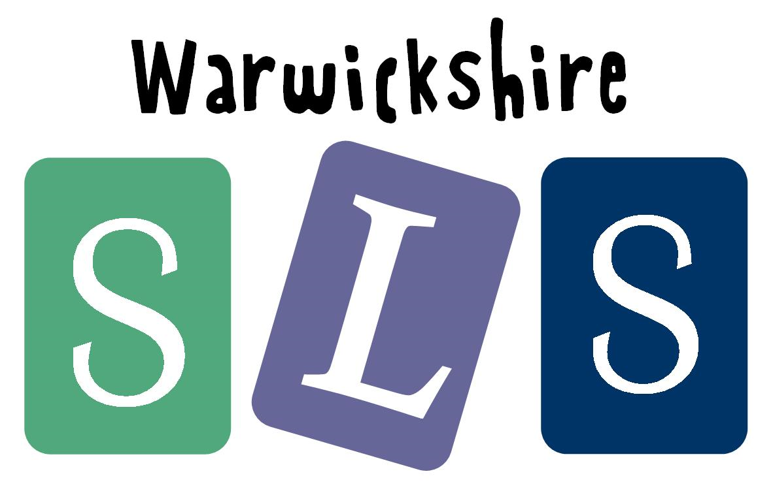
www.robinhoodMAT.co.uk

