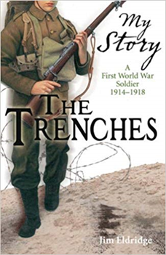

**Visit:**

Blackpool Cenotaph

Museum of Lancashire

**History: World War One**

**Learning Question:**

**Why do we still remember World War One?**

*What is remembrance and why is it important?

*How and when did WW1 begin?

*What was it like in the trenches in WW1?

*Is it right to fight?

*How shall we respond to what we found out about WW1?

*Who won WW1?

*What happened during the Christmas truce?

**Class 6 - Autumn 2**

***2021***

**WORLD WAR I**

**Art**

**Drawing, Painting and Printing**

-Draw pencil sketch scenes from WW1 inspired by the work of Paul Nash/John Nash.

-Create soldier silhouette printing blocks and print onto charcoal drawn backgrounds.

-Create explosion 3 layer prints inspired by Flower of Death, Claggett Wilson, add smoke and other detail using pens, paints…

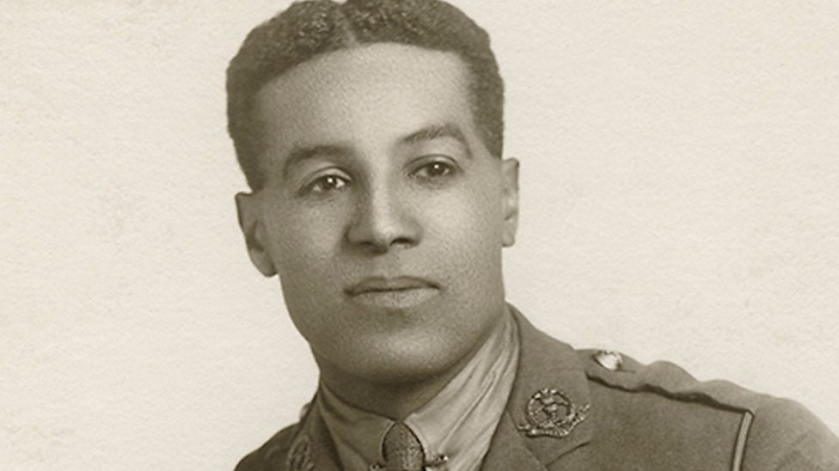**Learning Question:**

**Who was Walter Tull and why is he significant today?**

*Who was Walter Tull?

*What can we find out from the historical sources about Walter’s early years?

*Who were the people in Walter’s family?

*What can we find out about the ‘football years’?

*What happened to Walter Tull during WW1?

*How shall we commemorate Walter Tull?

**English**

**“The Trenches”**

**By Jim Eldridge**

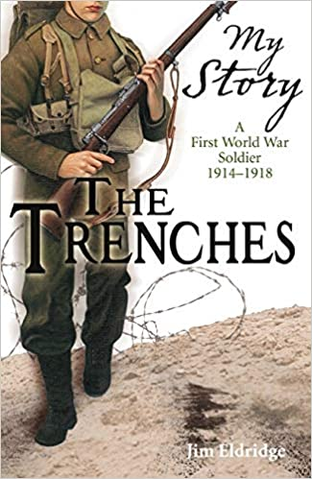

**‘War Horse’**

**By Michael Morpurgo**

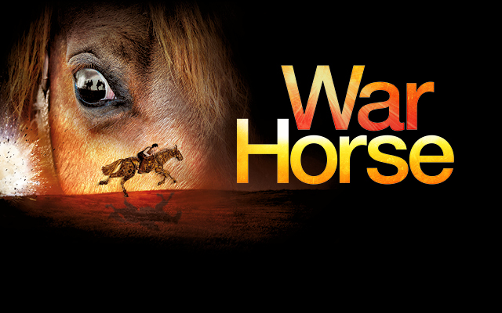

**Writing**

Descriptive language to describe the characters and setting.

Use of dialogue to develop the story.

**World War I Poetry**

“For the Fallen”

“In Flanders Fields”