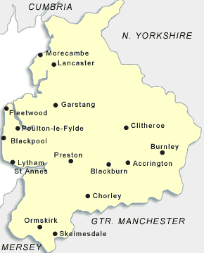

**Geography**

Lancashire

country

county

region

city

town

physical

human



**Science**

human

animal

nutrition

food

healthy

energy

protein

carbohydrates

vitamins

minerals

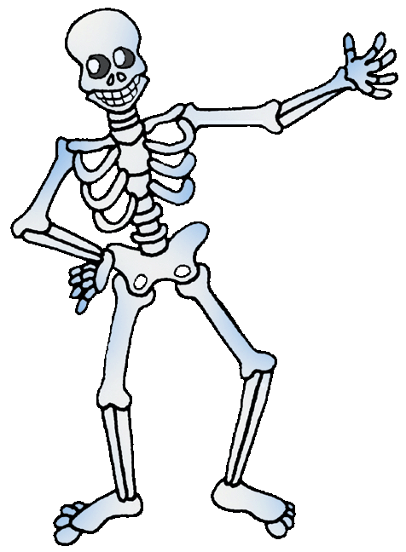

skeleton

bones

endoskeleton

exoskeleton

**R.E.**

**Harvest**

**Festival**

**Thankfulness**

**Sukkot**

Our Value

*“Kindness”*

Word Mat

Class 3 Autumn 1