**History** **Stone Age**

**Star Carr**

**Skara Brae**

**Stonehenge**

**Carleton Elk**

**Orkney Islands**

**Palaeolithic**

**Mesolithic**

**Neolithic**

**archaeologists**

**excavating**

**hunters**

**gatherers**

**pigment**

**ochre**

**charcoal**

**agriculture**

**farming**

**settlement**

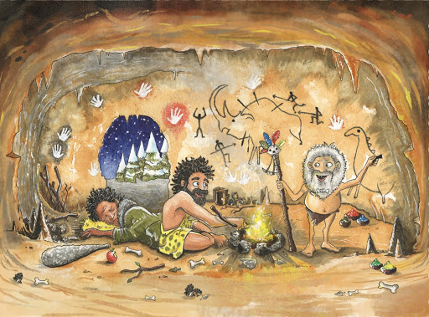

**Science**

**Rock**

**bedrock  
magma**

**igneous  
sedimentary**

**metamorphic  
silt**

**mineral**

**permeable**

**impermeable**

**porous**

**non-porous**

**erosion**

**Soil  
topsoil**

**sandy**

**loam**

**clay**

**peat**

**organic material**

**Fossil**

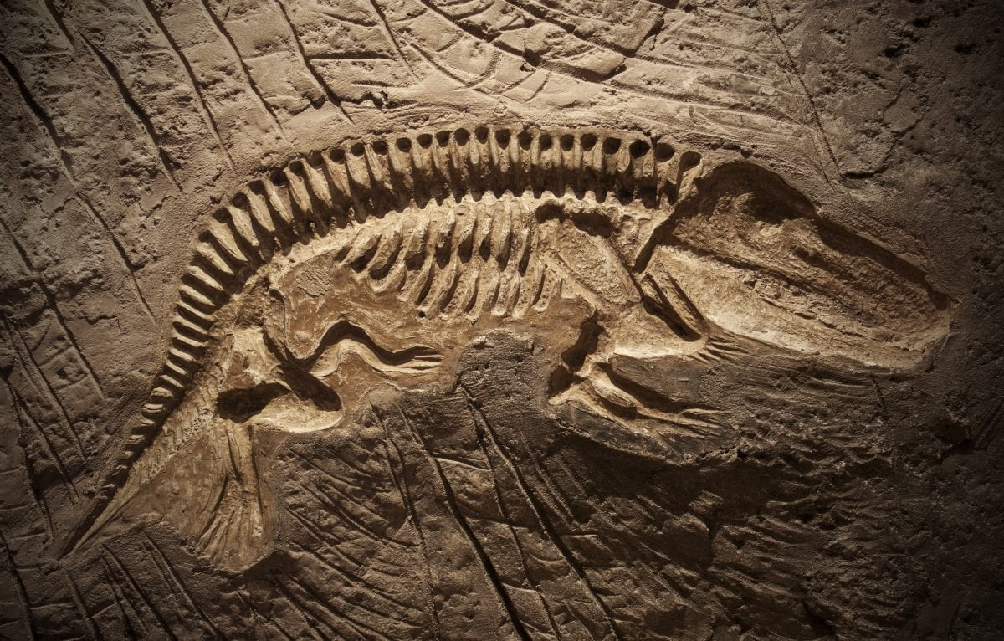

Learning Question

How did life change during the Stone Age?

Our Value

*“Peace”*

Word Mat

Class 3 Autumn 2