Exploring the sadness and joy of Easter.

**Word Mat**

**Class 3**

**Spring 2**

Learning Question

**Why was the River Nile so important for Ancient Egyptian civilization?**

**Science**

# light

# dark

# spectrum

# refraction

# light source

# surface

# sun

# eyes

# energy

# reflector

# reflect

# reflective materials

# mirror

# reflection

# concave

# convex

# opaque

# transparent

# translucent

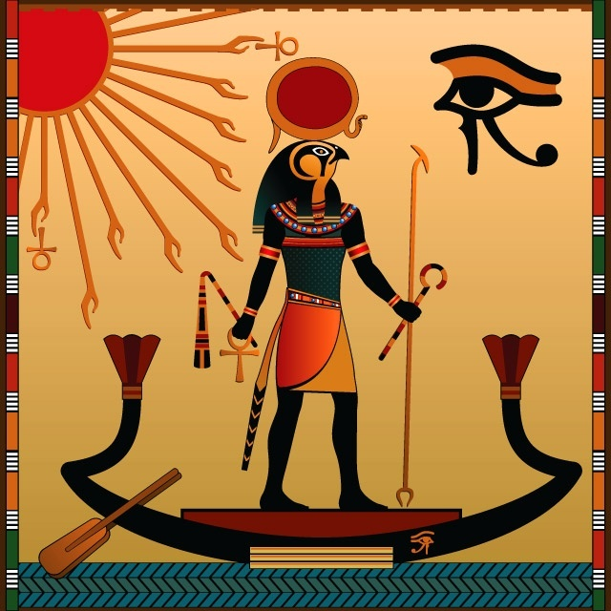

**History**

**Ancient Egyptians**

**Ancient Egypt**

**River Nile**

**Sahara Desert**

**Irrigation**

**Shaduf**

**Plough**

**Oxen**

**Papyrus**

**Mud bricks**

**Sandstone**

**Limestone**

**Trade**

**Pyramids**

**Giza**

**Pharaoh**

**Khufu**

**Embalmer**

**Mummification**

**Afterlife**

**Canopic jars**

**Amulets**

**Sarcophagus**

**Hapi**

**Ma’at**

**Ra**

**Osiris**

**Isis**

**Hathor**

**Khnum**