Learning Question

**Which significant people from Blackpool should be given a blue plaque and why?**

# History

# Local History

# significant

# famous

# similarities

# differences

# commemoration

# recognised

# celebrated

# plaque

# legacy

# Henry Banks

# William Henry Cocker

# John Bickerstaffe

**Science**

**Revision Time**

**Forces and Magnets**

**Magnetic force**

**Distance**

**Contact**

**Repel**

**Attract**

**Poles**

**Resistance**

**Light**

**Transparent**

**Translucent**

**Opaque**

**Light source**

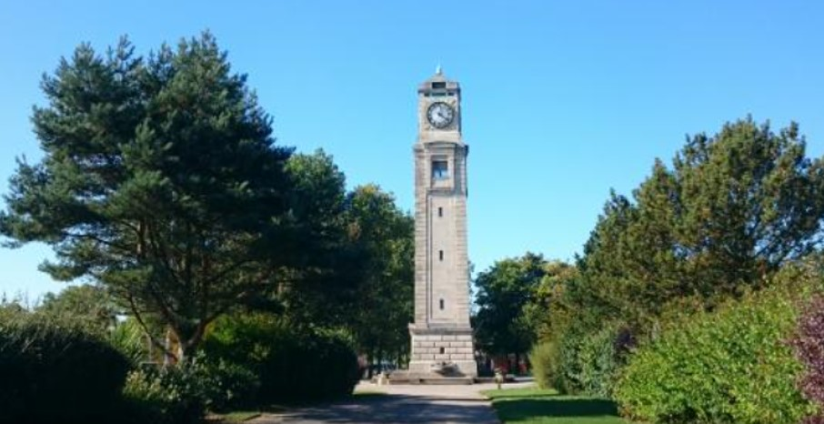

**Word Mat**

**Class 3**

**Summer 2**