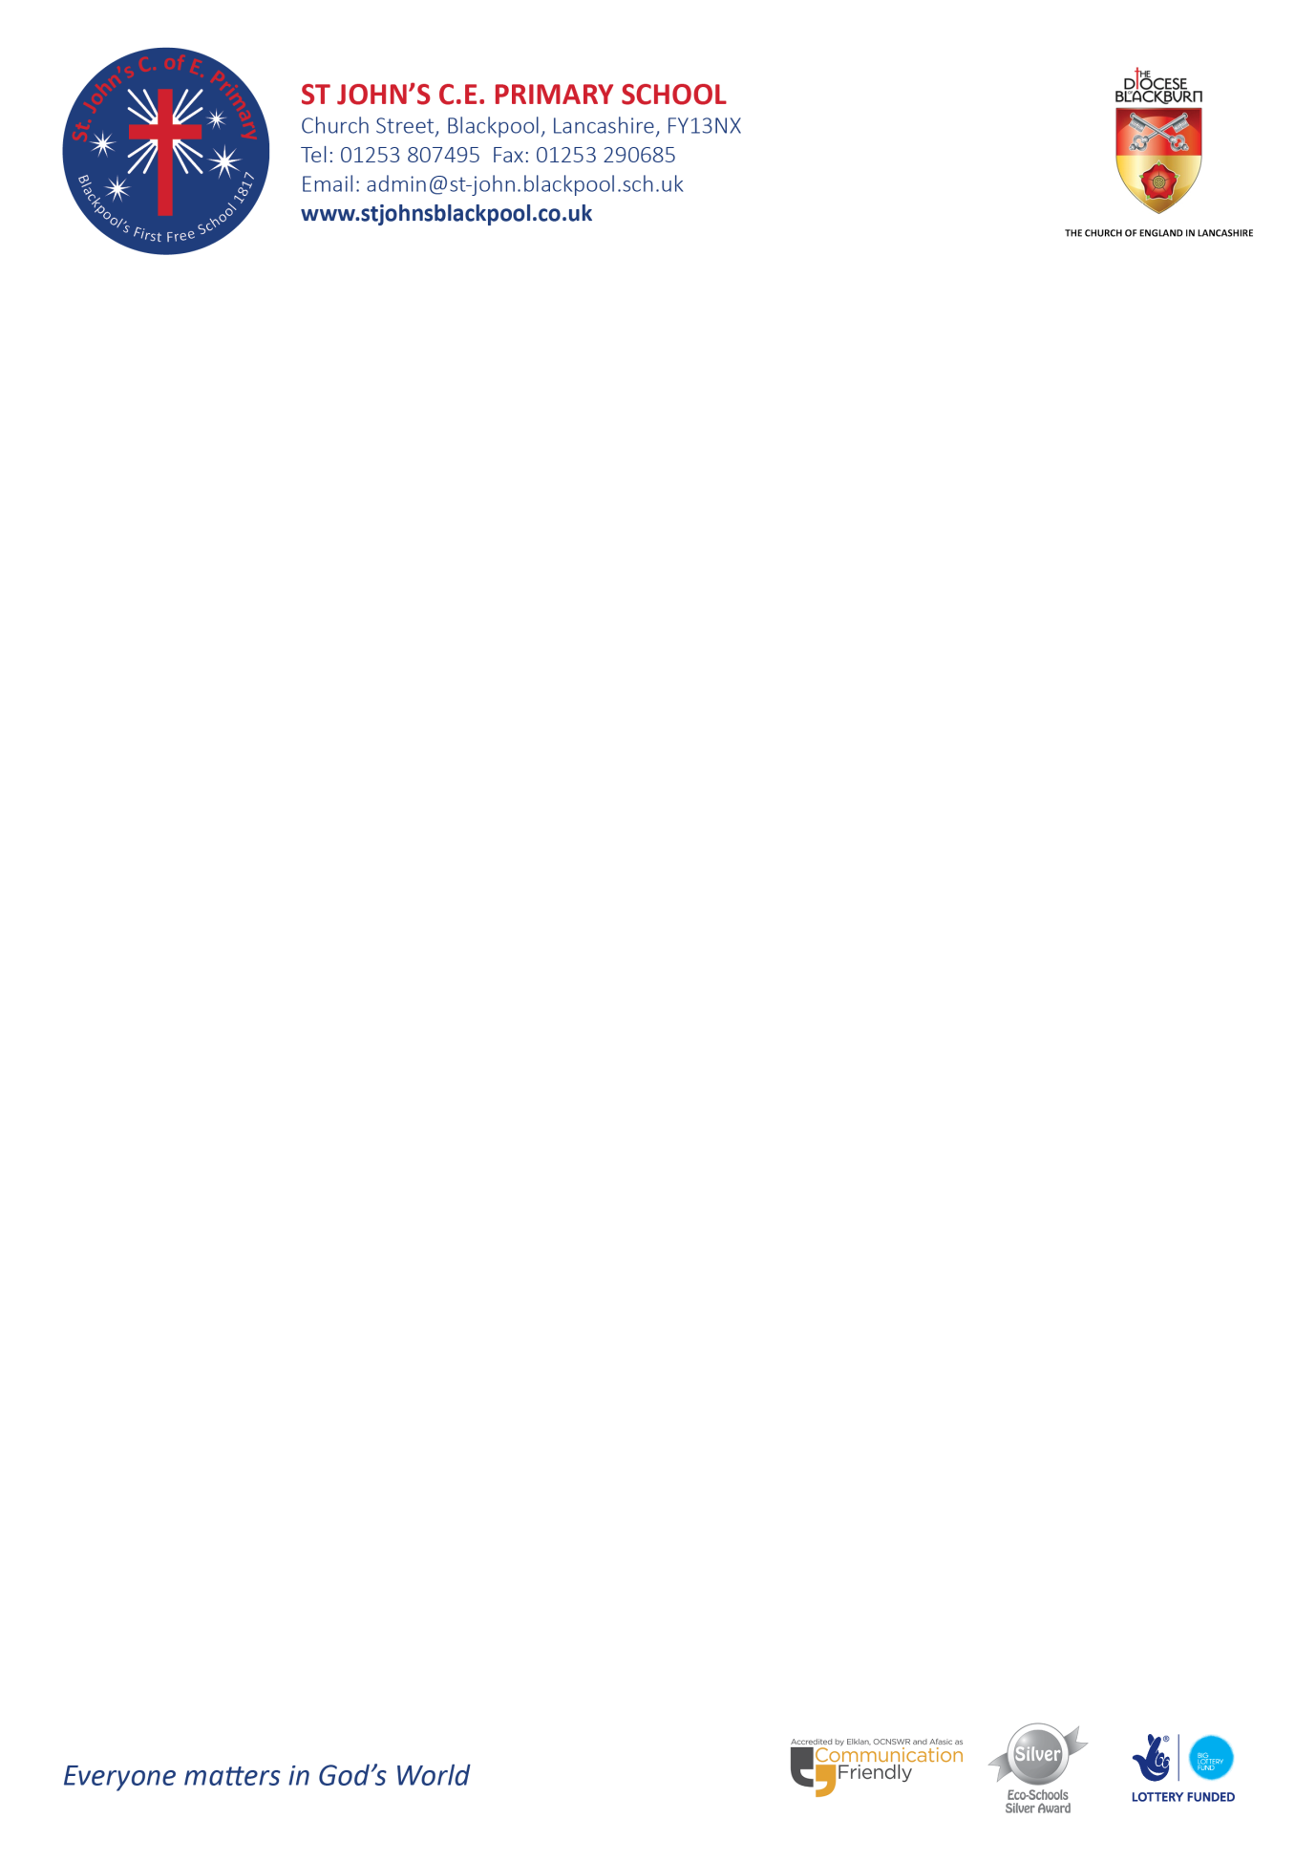
World Book Day 2025 - Thursday 6th March
Dear Parents/Guardians,
We will be celebrating World Book Day on Thursday 6th March. World Book Day is an excellent worldwide event to encourage children to read and enjoy reading! As a school we continue to strive to ensure the children in our school choose to read, knowing the satisfaction that they will get from the act of reading.
This year we are asking the children to make a Mr or Mrs Potato Book Head Character in the most creative way they can think of. The children will need to dress up a potato as a character from a book of their choosing, using fabric, paper, recycling bits and pieces. Background and props are encouraged. Your child’s teacher will also be giving them ideas in class, but the choice is ultimately theirs.
To encourage as many children as possible to enter, we will be rewarding the best designs in each class with a new book as a prize and recognition for their effort. The children will need to bring in their finished creations to school on World Book Day (Thursday 6th March).
Also, on World Book Day each class will have a guest reader. A teacher from another class will share an exciting new text of their choice with the pupils. Research shows that reading for pleasure improves children’s ability to read, write and progress at school, as well as having a positive impact on their mental wellbeing and empathy.
There are also lots of other exciting events and activities taking place throughout next week to promote reading; each class will receive a free book whilst visiting Waterstones and the children will also have the opportunity to take part in quizzes and listen and watch famous authors talk about their love of reading.
Finally, the children will need to be in uniform and a donation will not be required.
We look forward to seeing the potato characters the children create.

Many thanks for your continued support,

Mr Giles & Mrs Shearman

