Animals including humans Vocabulary Mat
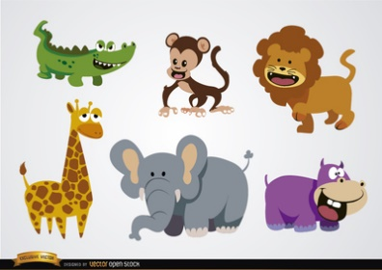
Animal
Animals are living things, that need food and water to live. There are lots of animals on the Earth, we are also an animal.

Mammal  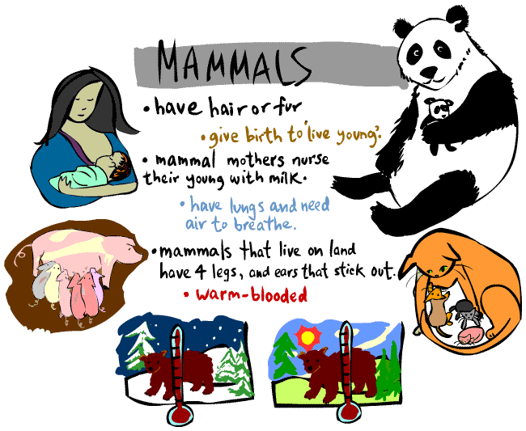 | Reptile  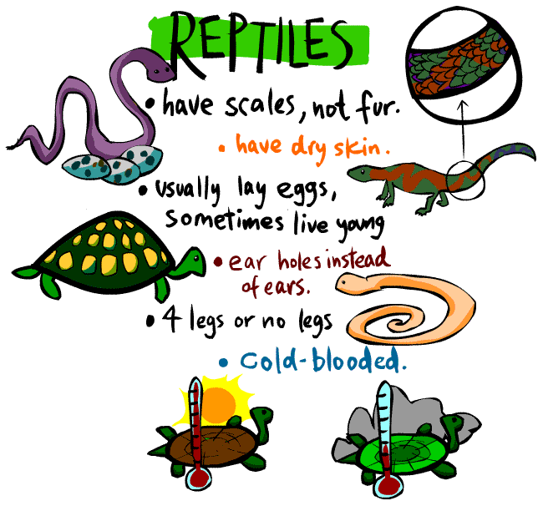 | Fish  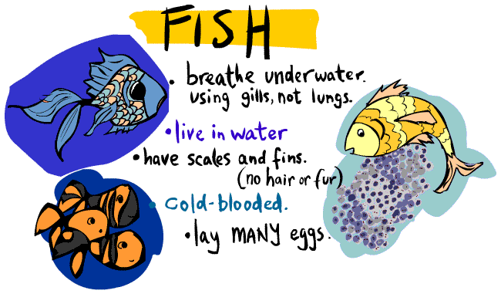
Bird  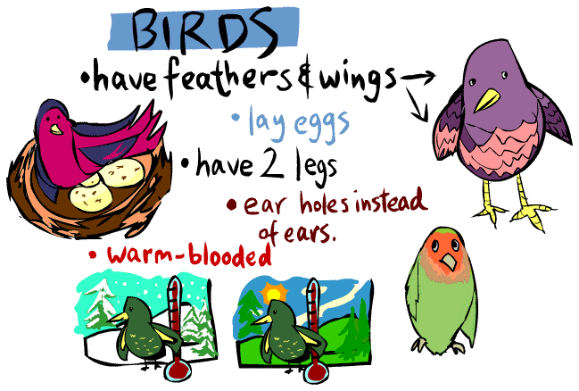 | Amphibian  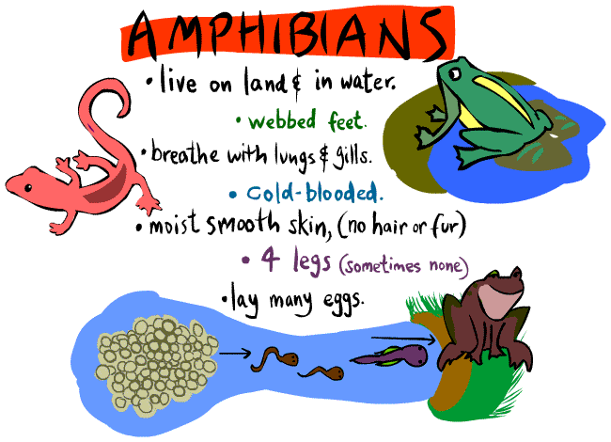 | Carnivore  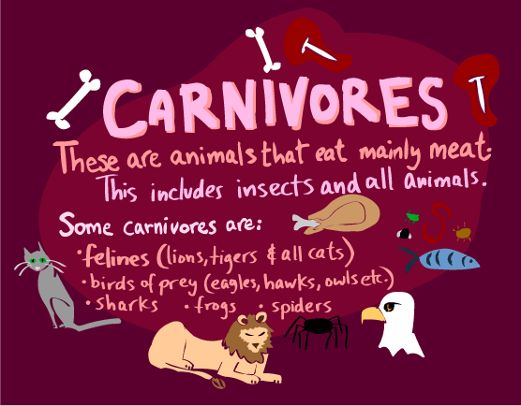
Herbivore  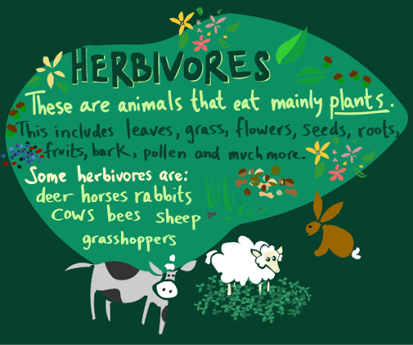 | Omnivore  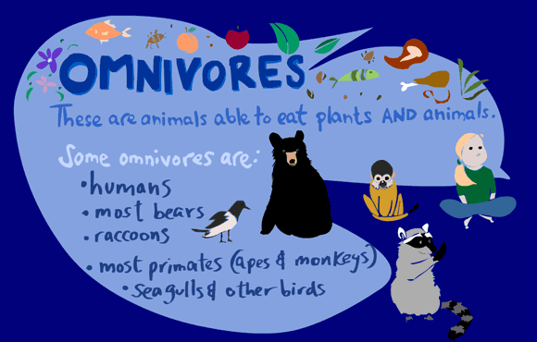 | Human  