|  |
| --- |
| **English**  * Use contents page and index to find information in non-fiction texts * Write information book about dinosaurs * Write a description of a setting based on work on habitats. * Dinosaur stories – Tom and the Island of the Dinosaurs |

|  |
| --- |
| **Class 2**  **How does the work of Mary Anning help us to learn more about dinosaurs?** |

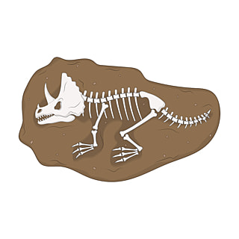

|  |
| --- |
| **Art**  * Make dinosaur skeletons from art straws * Create large dinosaur paintings using sponge printing, marbling, bubble painting to decorate * Drawing with a variety of media, looking at tome and texture * 3D work – clay – sculpt dinosaur head, eyes and teeth * 3D – look at the work of Benjamin Waterhouse Hawkins * 3D – make large scale models of dinosaurs using junk |

|  |
| --- |
| **Science** What is a palaeontologist?  What is a fossil?  **Living things and their habitats.**   * Looking at similarities and differences in diet, size, body parts and teeth of dinosaurs. * Investigate different habitats * Investigate how dinosaurs eat their food |

[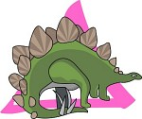](http://classroomclipart.com/cgi-bin/kids/imageFolio.cgi?action=view&link=Dinosaurs&image=27-5-07-1.jpg&img=30&tt=)**[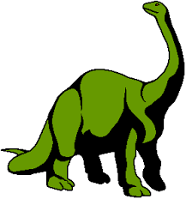](http://www.google.co.uk/imgres?imgurl=http://www.bry-backmanor.org/dinosaurs/colordino8.gif&imgrefurl=http://amisvfrustie.blogspot.com/2010/06/dinosaur-clipart.html&h=298&w=278&sz=4&tbnid=vaAup1XwpH9jiM:&tbnh=116&tbnw=108&prev=/images?q=dinosaur+clip+art&hl=en&usg=__aIW97HEXBXLQn3FuByhhIrjnqMg=&sa=X&ei=bzBZTOjyPIX-0gStsrTZCA&ved=0CCMQ9QEwAg)**

|  |
| --- |
| **History**  * Why do we remember Mary Anning * What was Mary like and what made her so special? * How do we know that Mary did all those clever things? * Why and how should Mary be remembered? * Who has followed in Mary Anning’s footsteps? |

|  |
| --- |
| **Mathematics**  * Measure out life sized dinosaurs. |

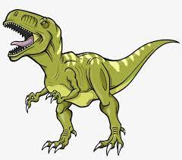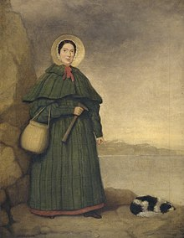

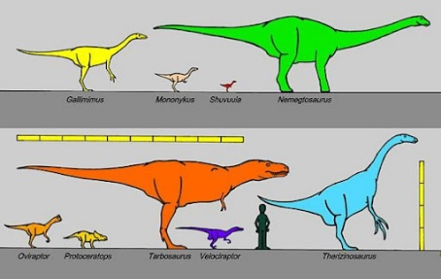

[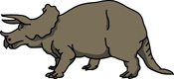](http://classroomclipart.com/cgi-bin/kids/imageFolio.cgi?action=view&link=Dinosaurs&image=07-10_S_01b.jpg&img=&tt=)