## **Science**

* Materials – uses of everyday materials
* What are toys made out of?
* Fit for purpose – suitability of materials
* Changing the shape of materials

**Class 2 - Spring 1**

**How have toys changed over the years?**

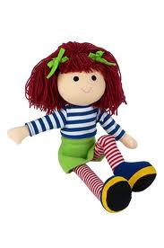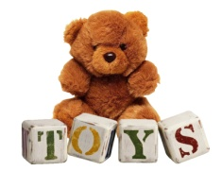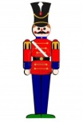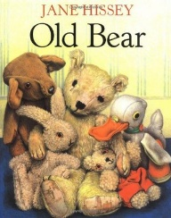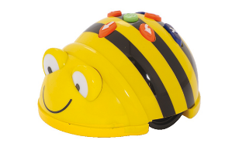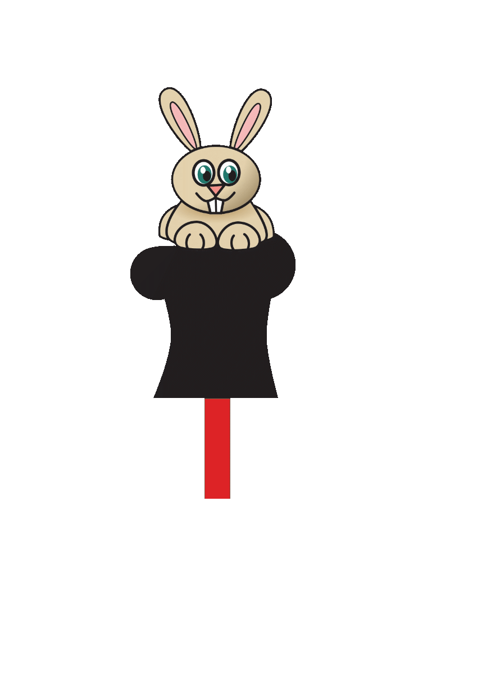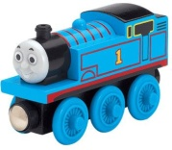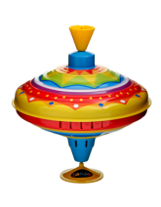

## **PE**

* Games and ball skills
* Dance - Toys

## **Computing**

* Programming - giving instructions

## **Art/Design Technology**

* Charcoal and pencil drawings of old/new teddy bears
* Design and make a moving picture - levers and sliders

## **History**

* What makes a favourite toy?
* What are other people’s toys like?
* How do we know if this teddy is old or new?
* How have toys changed over time?
* How do we know about toys from the past?

## **English**

* Story writing based on *Old Bear* by Jane Hissey
* Information text – Toys