English
Writing our own story with a beginning, middle and end!
- Identify and discuss characters and settings in story books

Poetry –
‘The Teddy Bears Picnic’ 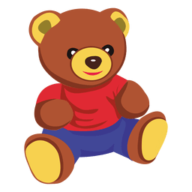

Science
Animals including humans
We will how to group animals into mammals, reptiles, birds, fish and amphibians.
We will learn what animals need to survive and that most animals are herbivores, carnivores or omnivores.
Living and non-living things - Plants
Identify the basic structural parts of common flowering plants and trees, including root, stem, stalk, leaves, flowers, bulb, fruit, seeds and trunk.
Identify and name common flowers and trees – including understanding of deciduous and evergreen trees.

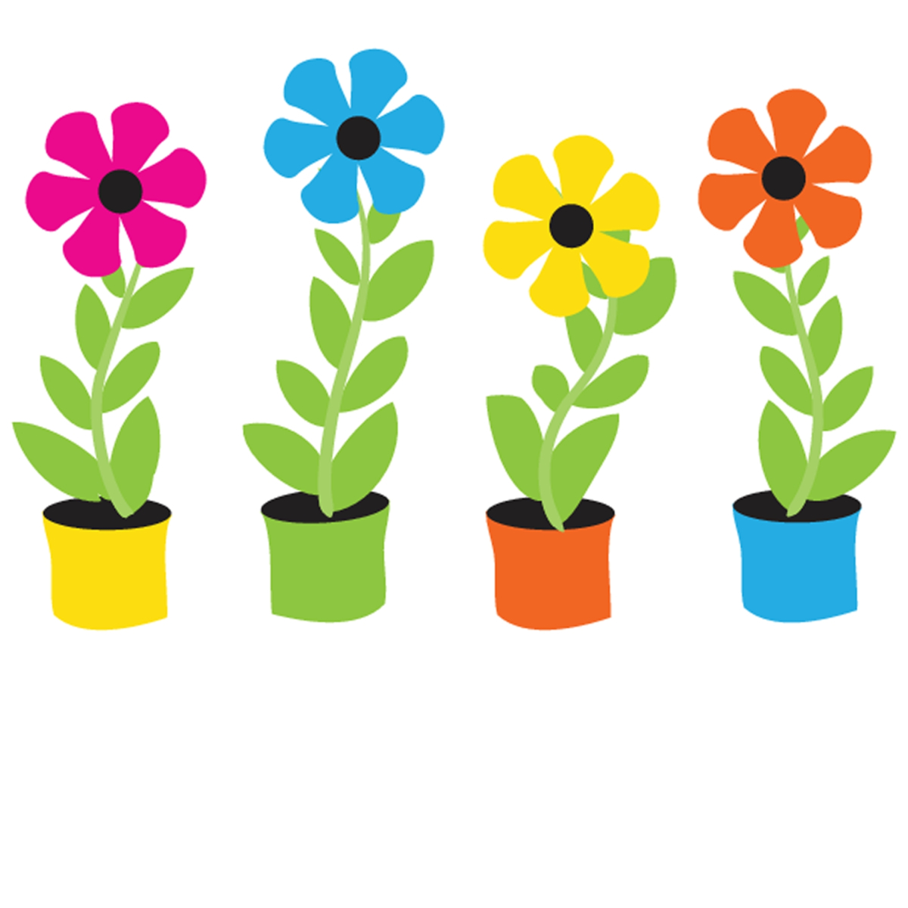
Art and DT 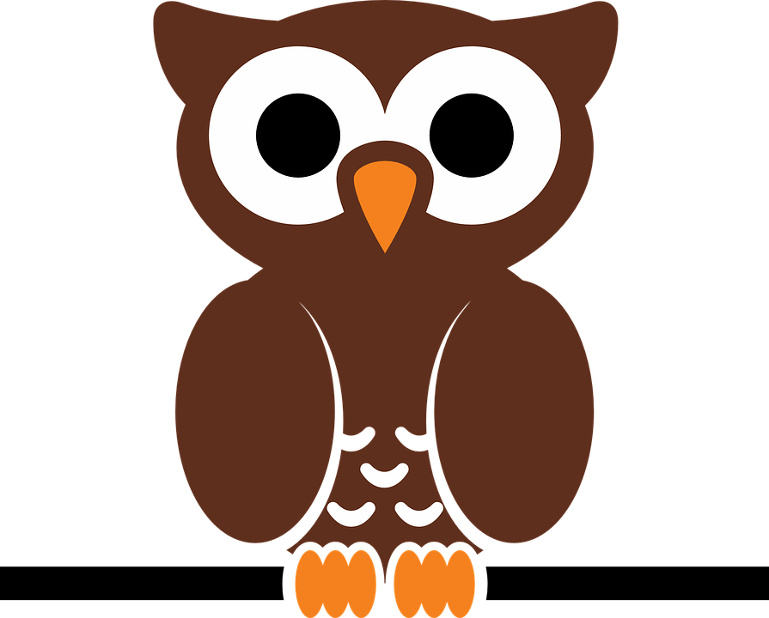
- Drawing – woodland creatures (using different media)
- Making a woodland mobile
- Design and make a fairy Garden

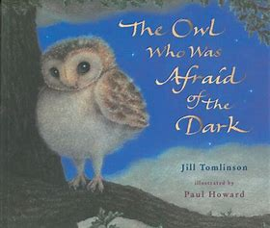
Class 1

What surprises will be found if we go down to the woods today?

Geography
Wonderful weather –
How does the weather affect us?
Hot and cold climates
Seasonal changes



