Hot and Cold Places Class 1
Subject Specific Vocabulary |  | 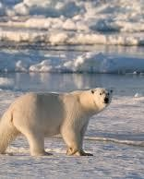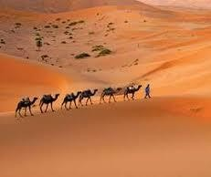 | Exciting Book
North Pole | The North Pole is the northernmost place on Earth. When at the North Pole all directions point south. |  | 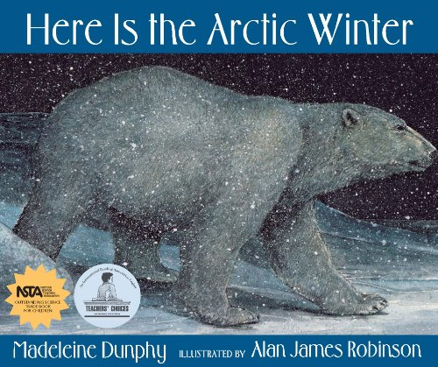
South Pole | The South Pole is the southernmost place on Earth. When at the South Pole all directions point north.
Equator | Is an imaginary line around the centre of the Earth. It is very hot at the Equator. It divides the Earth into the north and south hemispheres.
continents | The seven areas of land in the world (Asia, Africa, North America, South America, Antarctica, Europe, and Australia). | Fun Facts about Hot and Cold places
climate | The weather conditions in an area in general or over a long period. | - Not all deserts are covered by sand, only 20% of all deserts are covered with sand.
 |  |  | Animals that live in the polar regions
 |  | - During the South Pole winter (mid March to mid September) it is dark all the time. During the summer it is light all the time.
regions | A part of a country, of the world, etc., that is different or separate from other parts in some way. |  | - Penguins polar bears  - Arctic fox seal  - reindeer  - walrus
 |  | - Even though we think they should be, not all deserts are hot. Two of the world’s biggest deserts are in the North and South Poles.
desert | A desert is a very dry place that experiences little rain and therefore plants don’t grow there. It is difficult to find water in a desert.
 |  | - Polar bears and penguins are able to keep warm because they have blubber inside their skins.
hemisphere | It is half the Earth divided into north and south by the equator. Britain is in the northern hemisphere.
 |  |  | Animals that live close to the equator
- The largest hot desert in the world is the Sahara and the
largest cold desert is Antarctica
humid | When there is a lot of moisture in the air it is said to be humid. Hot countries often are very humid.
- meerkats
- lizards
- scorpion
- coyote
- camel
 |  | - Hot desert are usually very hot during the day but can get very cold at night. Some hot deserts can reach freezing point at night.
scorching | To burn slightly or to cause a change in colour because of the heat.
camouflage | When an animals markings helps it to blend in with its environment.
 |  | - Despite the low temperatures over 4 million people live in the polar regions.

